LEGENDARY PORTUGESE TECHNO/DEEP HOUSE PRODUCER M. RODRIGUEZ RELEASES NEW SINGLE “YOU UNDERSTAND”

OUT NOW VIA BIG BEAT RECORDS

LISTEN/SHARE: https://youtu.be/aDpqK9-AKs4
BUY/STREAM: https://BigBeat.lnk.to/MRYPR

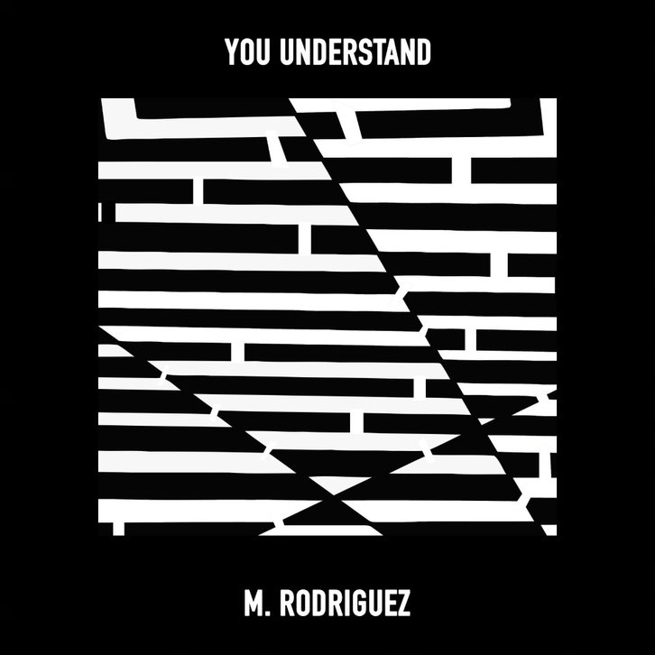
DOWNLOAD IMAGE HERE

M. Rodriguez might not be a household name (yet!), but his name always turns true dance music fans’ heads. The prolific Portugal-based producer’s career harkens back to the early 90’s and ever since, he’s become legendary in techno and deep house circles around the world. Big Beat Records is thrilled to be releasing his single alongside iconic like-minded international artists like David Guetta, Skrillex, Chromeo, Galantis, Mr. Oizo, The Knocks and more. Listen HERE.

Today sees the release of “You Understand”, a track that combines his worldly influences with skittering percussion, resulting in a groove-oriented 7-minute techno/deep house banger that takes flight halfway through. This track is a proper introduction to American dance music fans at long last, as well as a track that’s sure to appeal to longtime fans.

Constantly in search of new grooves and exciting frequencies to experiment with, this search has led him on a journey beyond borders and cities, beyond language and symbols. It’s a journey where music and ideas are the only passport one needs in order to experience true feelings, unconditional passion, and the power of suggestion. Keep an eye out for more from M. Rodriguez in 2019!

PRESS ASSETS: http://press.wearebigbeat.com/singles/you-understand-m-rodriguez/

CONNECT WITH M. RODRIGUEZ:
Spotify

FOR MORE INFORMATION:
Paige Rosoff – Publicity, Big Beat Records
Paige.Rosoff@atlanticrecords.com

