LIVERPOOL DJ/PRODUCER KYDUS TEAMS UP WITH
CAMDEN COX FOR SULTRY NEW SINGLE, “DESTINY”

LISTEN HERE: https://BigBeat.lnk.to/DESTINYPR

OUT TODAY VIA BIG BEAT RECORDS!

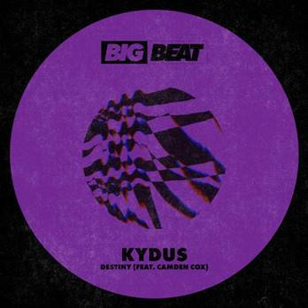
DL art

After releasing “Aftermath” on Big Beat Records and racking up over 1.2M streams, techno/house DJ and producer Kydus is back with another smash single called “Destiny,” a sultry collaboration with the London-based singer Camden Cox. The single features shimmering synths set against a classic house beat with Cox’s silky vocals - LISTEN HERE!

Kydus has released on some of the world’s most revered labels including Circus, Toolroom, Saved and Knee Deep in Sound and has launched his own label, Kinetic. He has also received support from the likes of Carl Cox, Luciano, Yousef, Hot Since 82, Joris Voorn, Skream, and Radio 1’s Pete Tong, who selected four of Kydus’ records as his ‘Essential New Tune’.

Camden Cox is an emerging voice from London’s influential electronic music scene, having written or already been featured on tracks with Friend Within, Jaded, George Kwali, Digital Farm Animals, Alex Adair, Kideko, and Just Kiddin'. Her collaborations with Basada on “Gold” and Embody on “Dreamin” have amassed over 25M streams.

CONNECT WITH KYDUS:
Instagram | Facebook | Twitter

CONNECT WITH CAMDEN COX:
Instagram | Facebook | Twitter

PRESS ASSETS: http://press.wearebigbeat.com/singles/kydus/

Press contact: gabrielle.reese@atlanticrecords.com

