MUSIC PRODUCER AND DJ
KRYSTAL KLEAR
DELIVERS “THE DIVISION” EP

OUT TODAY ON RUNNING BACK/PARLOPHONE/BIG BEAT RECORDS

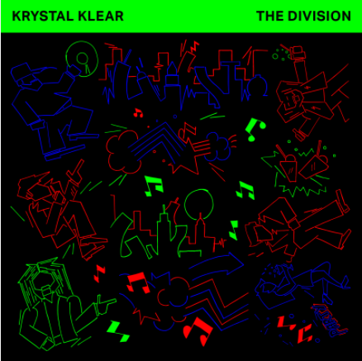

Artwork by Krystal Klear
Written & Produced by Declan Lennon

LISTEN/POST THE SINGLE
“NEUTRON DANCE”:
https://youtu.be/oRVeF5KPngE

STREAM & DOWNLOAD “THE DIVISION” EP:
https://BigBeat.lnk.to/KRYKK

A1 : Neutron Dance
A2 : Division Ave
B1 : Shockzoid
B2 : Moonshake Miner

You remember that Kung Fu kid movie, where he had to wash the motorcycles for years and then…whatever, constant dripping wears away the stone. Dublin-Manchester-NYC’S finest Krystal Klear (Cold Tonic, All City, Tooth Pick) has been honing his skills as a dress man for years and also made a name for himself as an expert in all things (electronic) boogie.

“The Division” is Declan Lennon’s dapper debut EP out today on Running Back/Parlophone/Big Beat Records. Custom-made club studies shifting between sound factories, hot haciendas, heavenly lagoons and chrome-plated dance floors: fast, slow, hard and soft.

A love letter to dance music written with pink ink. Oh, and there is “Neutron Dance” on it as well…yes, the euphoric fun one. Once again: dance!

Connect with Krystal Klear:

Instagram: @krystalkleezy
Facebook: https://www.facebook.com/krystalklearfanpage/
Twitter: @KrystalKlear
Soundcloud: https://soundcloud.com/krystalklear
Press tools: http://press.wearebigbeat.com/singles/krystal-klear-the-division-ep/

For more information or press inquiries:

Jordan Danielle Frazes
Head of PR, Big Beat Records
Jordan.Frazes@atlanticrecords.com

