KREAM RELEASE NEW VIDEO FOR BREAKOUT SINGLE “TAPED UP HEART” FEATURING CLARA MAE
Watch: https://youtu.be/XikZDwqOhuA
Stream + Purchase: https://BigBeat.lnk.to/TpdUpHrtAY

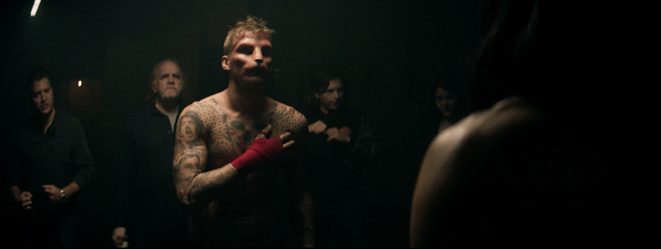

Norwegian brothers KREAM are ready to set the tone for 2017 in a big way. They closed out the last year with their hit single “Taped Up Heart” which brought the pair into the forefront of dance music as one of the most exciting up-and-coming acts of 2016. The Big Beat Records single reached #22 on Billboard's Hot Dance/Electronic Songs chart, has over 38 Million plays and counting on Spotify, charted in the Top 100 tracks streaming Globally and in the U.S and has been on Spotify's "Today's Top Hits" for the last three months. The pair most recently announced they will be making their SXSW debut this coming March!

Daniel and Markus, aka KREAM, are kicking off 2017 with an official video for “Taped Up Heart,” pulling inspiration from David Fincher’s Fight Club. Taking place in an alternate reality, the Samy Mosher directed video (Adele, Matoma, Hot Natured, and XYconstant) explores the idea of finding your place in the world. With some humans on our planet taking on animal forms and not being fully accepted, the video finds balance in giving those that are considered different or strange a place they can call their own.

“This song is all about dealing with your inner demons and Samy did an amazing job bringing “Taped Up Heart” to life. Everyone has had that feeling of being an ‘other’ and wanting to find their place or purpose. Maybe it’s through music, maybe it’s joining an underground fight club,” shares KREAM.

Be on the lookout for an upcoming remix package for “Taped Up Heart” featuring Lash, Joe Mason, and Disto, the package is due out on January 27th via Big Beat Records.

More about KREAM
Made up of two brothers from Bergen, Norway, KREAM is a project focused on energetic dance music with an emphasis on classic songwriting. Daniel and Markus Slettebakken began producing at a young age, each developing their own role in the process. The duo has already seen several remixes reach streams in the multi-millions, racking up 40+ million plays on SoundCloud alone. The pair quickly found a home at Big Beat/Atlantic where they've been releasing numerous originals including "Love You More, "Another Life" featuring Mark Asari, and their latest single "Taped Up Heart" featuring Swedish singer Clara Mae. "Taped Up Heart" has already garnered over 38 million streams on Spotify, reaching the Top 100 tracks streaming Globally and in the US.

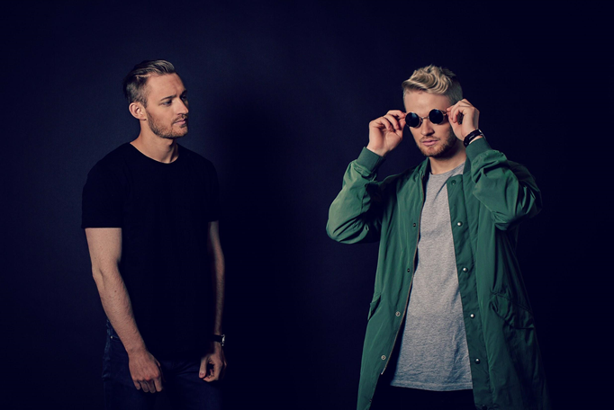

Press Assets: http://press.wearebigbeat.com/artists/kream/

Connect with KREAM
https://www.wearekream.com/
https://www.facebook.com/wearekream
https://soundcloud.com/kreamofficial
https://instagram.com/wearekream
https://twitter.com/wearekream/

For more information please contact:
Jordan Danielle Frazes
Head of Publicity, Big Beat Records
jordan.frazes@atlanticrecords.com
Lindsay Herr
lindsay@thewanderlvst.com

