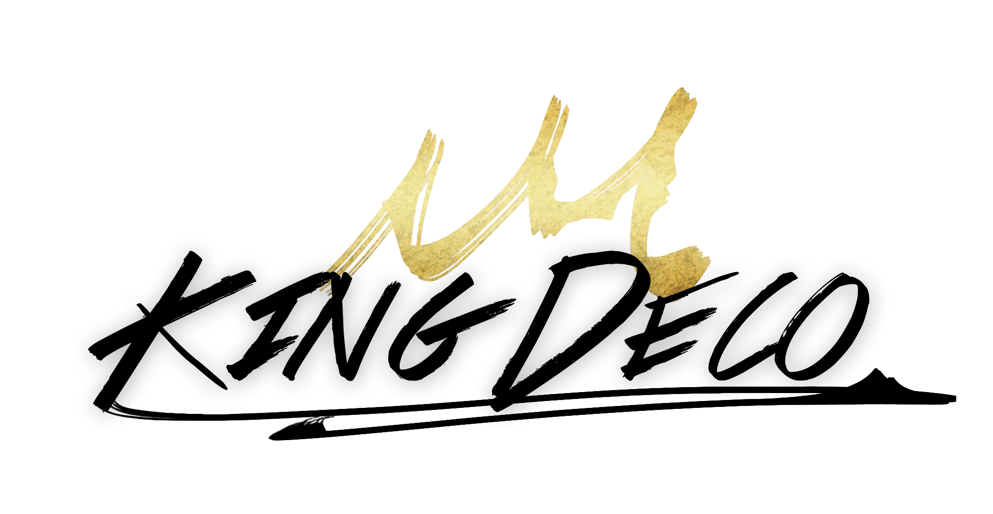

In order to find her footing in the music industry, indie pop newcomer King Deco had to step onto a new continent...

Born and raised in the Middle Eastern country of Jordan, without any real outlet for music, her career struggled to take shape. So at 17 she chose to expatriate to the United States where she spent time honing her craft, and emboldening the vision for what would become King Deco. Growing up under a small kingdom and in the shadow of ancient remnants of the Roman Empire, Deco became fascinated with the concepts of regal power, hence her royal moniker. She found her voice by way of collaborations with the likes of Larzz Principato (Halsey’s “New Americana”), Kinetics & One Love (B.o.B’s “Airplanes”) and Felix Snow. As cited by MTV Buzzworthy, she “perfectly encapsulated her hypnotic aesthetic, blending dreamy vocals and rich underwater tones with atmospheric electronica and worldly chants.”

With two critically acclaimed singles and over 2 million streams under her belt, King Deco is well and truly underway to solidifying her status as one of the music industry’s most exciting new talents.

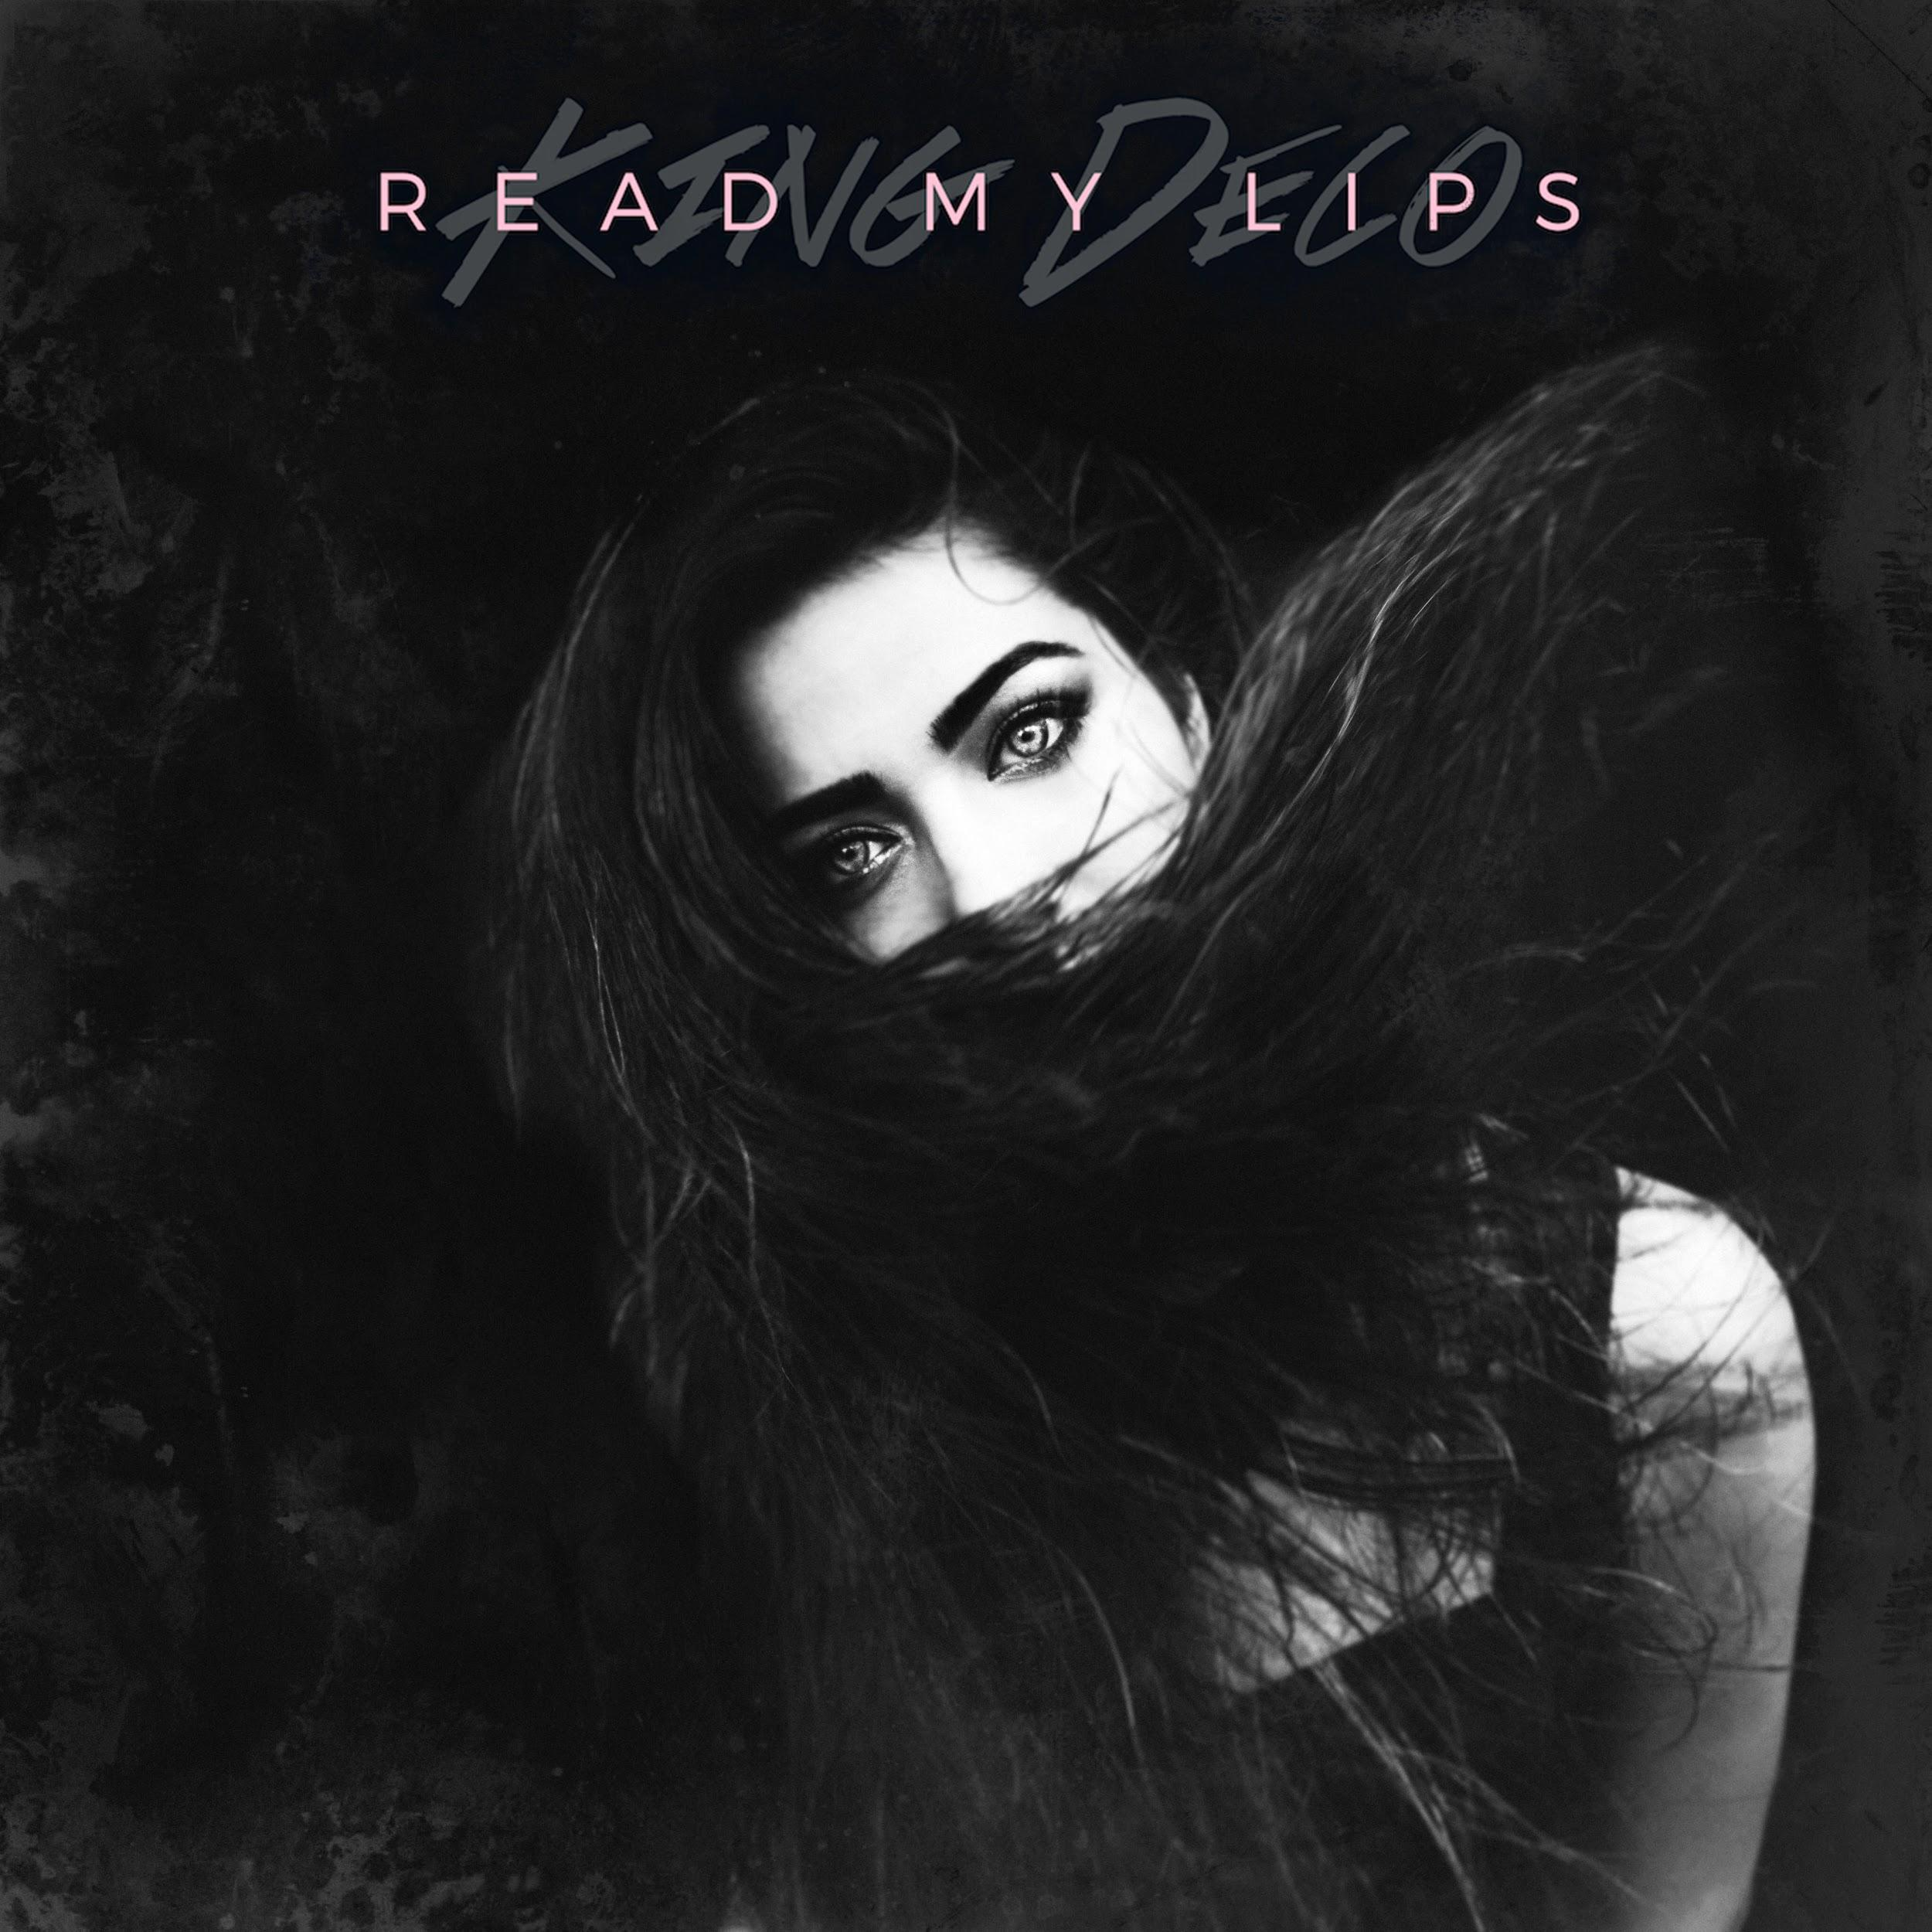

King Deco’s second single “Read My Lips” produced by Kinetics & One Love (B.o.b.’s “Airplanes” and Melanie Martinez’s “Dollhouse”) is a “dance-like-nobody’s-watching power anthem” - Wonderland Magazine
The sound of “steel drums, tropical synths, and her bouncy vocals” all come together in Deco’s “breezy new single Castaway.” - Billboard

