KRYSTAL KLEAR SHARES NEW VIDEO FOR ONE OF SUMMER 2018’s MOST CRITICALLY-ACCLAIMED
RECORDS, ‘NEUTRON DANCE!’

OUT TODAY ON BIG BEAT RECORDS/FFRR

THE TUNE COMES ALIVE IN VIDEO THAT BEAUTIFULLY CAPTURES THE SPIRIT OF THE NEW YORK CITY UNDERGROUND

WATCH/POST: https://youtu.be/vGp-y1wRTmM
BUY/STREAM ‘NEUTRON DANCE’’: http://ffrr.ec/NeutronDance
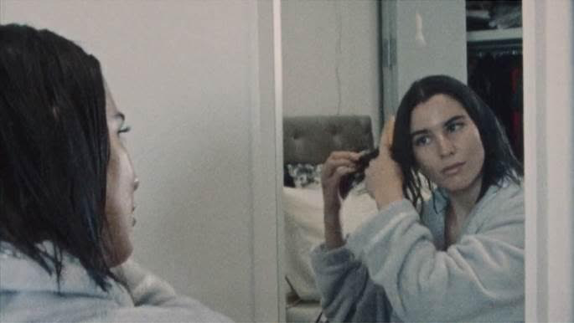

Irish, NYC-based producer Krystal Klear has continuously proven himself to be an innovator within the dance music underground and beyond. His latest nu-disco, 80’s-inspired banger “Neutron Dance,” is quickly becoming one of the most impactful dance tracks of Summer 2018. The music video for “Neutron Dance,” out today, is a narrative based on Krystal Klear’s life around the city. The visual portrays an engaging mix of city life in a series of scenes strewn across subway lines, downtown streets and the Brooklyn underground until night turns into morning.

“Neutron Dance” has proven to be a highly reactive single, receiving endorsements from critics and industry tastemakers. The track has remained on Radio 1’s Specialist Chart for over 9 weeks, reaching #1 four times. The track has received 100+ radio plays to date, including Radio 1 Annie Mac Hottest Record, Pete Tong Essential New Tune and Radio 1 Annie Mac Tune of The Week, as well as plays from Danny Howard and Monki.

On June 20, the song was named Radio 1 Nick Grimshaw’s Tune of The Week. “I was away at the weekend and just played this over and over and over. I felt proud that it was my tune of the week like I’d made it myself. I was playing it to friends like, ‘here, listen to my tune of the week,’” said Grimshaw.

The record has also garnered overwhelming support from nearly every A List DJ including Dixon, Skream, Sven Vath, Jackmaster and Paul Woolford, receiving 100% positive feedback and plays across all Ibiza opening parties as well as Lost & Found’s daytime pool party in Malta.

On top of the strong media and industry support, streaming platforms have also taken notice of “Neutron Dance.” Since its release, Spotify has added “Neutron Dance” to their Happy Dance Beats (250K followers), Fresh Electronic (1.7M followers) and New Dance Revolution (36K followers) playlists.

The success of “Neutron Dance” comes down to the fact that it’s simply a quality tune. Numbers don’t lie, and plays from fans have been rolling in proving the track to be a crowd favorite through and through. So far, the track has garnered almost one million streams on Spotify and continues to rise each day. “Neutron Dance” placed in the top 100 -150 for over a month off specialist plays alone on Shazam. It’s evident that dance music lovers will be looking out for this one all summer long.

***

Connect with KRYSTAL KLEAR:
Soundcloud | Facebook | Instagram | Twitter | YouTube | Spotify I Press Assets

For more information:

For “Krystal Klear” press inquiries:
Lindsay Herr: Publicity, The Wanderlvst
Lindsay@thewanderlvst.com

For Big Beat Records inquiries:
Jordan Frazes: Head of Publicity, Big Beat Records
Jordan.Frazes@atlanticrecords.com

