DANISH POP STAR KING DELIVERS A SLICE OF ‘MANGO’
WITH CUBA-INFLUENCED NEW SINGLE

OUT NOW ON BIG BEAT RECORDS

WATCH/SHARE: https://youtu.be/P-wQryf35R4
BUY/STREAM: https://BigBeat.lnk.to/MangoPR

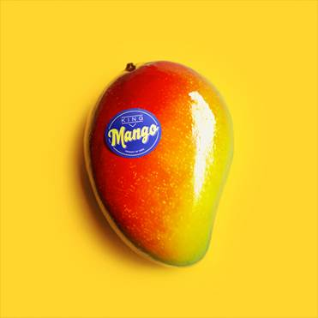

KING has always been a fighter. A fiercely determined artist with a clear vision of her musical trajectory, her previous singles have ranged from dark, sultry R&B-inflected cuts to out-and-out pop bangers.

Her latest single ‘Mango,’ out now on Big Beat Records, is an instantly catchy, Latin-influenced record that screams summer with KING singing its Cuban-referencing hook in Spanish.

“In Cuba, a hot guy is often called a ‘mango’. I’ve been wanting to make a record that celebrates my Cuban heritage for a while now, so when I hooked up with one of my writers and he played me this melody, the line “Tu eres mi mango” just came into my head and the song wrote itself from there. I had to fight hard to get this record made, and I can’t wait to share it with you” says KING.

Despite KING’s unwavering belief in the record, the record label was initially unconvinced when she first played them the demo. The confidence to fight her corner however was provided by her father – “a cynical old musician” – who immediately picked it out from a bunch of demos she played him, saying simply “that’s the one.”

After battling to secure studio time to record the single, she returned to the label with the finished version of ‘Mango’, and received an overwhelmingly positive reaction.

The results are unlike anything she has released so far. Authentically steeped in Cuba’s rich musical history yet unwaveringly modern in its production aesthetic, ‘Mango’ will bang hard all summer long.

On ‘Mango’ KING has once again teamed up with Christian Nilsson who produced her hit ‘Only U’, with Theodor Ekblom joining Christian on production duties.

Gritty and rebellious, KING makes nuanced pop music with genuine emotional heft. Born in Copenhagen in 1990 to a Cuban mother and a Chilean father, at 11 she began honing her performance skills by dancing with local street dance outfits and quickly joined a Copenhagen urban dance academy. By 15 she was earning her living as a professional dancer and dance teacher. KING first announced herself on the world stage in late 2016 with the release of debut single ‘Promise’, a record that released a steady stream of head-turning singles as her discography grows more fascinating with every release.

Connect with KING:
www.instagram.com/beholdiamking
https://twitter.com/beholdiamking
www.facebook.com/beholdiamking

For press assets: http://press.wearebigbeat.com/singles/mango-king/

Jordan Danielle Frazes
Head of Publicity, Big Beat Records
Jordan.Frazes@atlanticrecords.com

Lindsay Herr
Director, The Wanderlvst
Lindsay@thewanderlvst.com

