HEDIA RELEASES NEW VIDEO FOR INTERNATIONAL BREAKTHROUGH TRACK ‘YOUR MIND’ FEAT. KRISTEN MARIE VIA BIG BEAT RECORDS

WATCH/POST: https://youtu.be/gKdIeb018rw

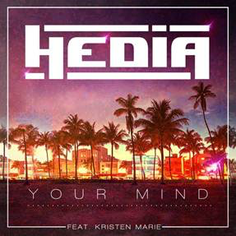

Originally released by Big Beat Paris in December, HEDIA’s breakthrough track ‘Your Mind’ has made a phenomenal start with 2.3 million streams at Spotify and 1.2 million views at YouTube. Now the track is set to be discovered by an even bigger audience through Big Beat Records US with its official video, a journey to the lush landscapes of Colombia.

‘Your Mind’ is a track rooted in both the contemporary and classic house scenes. HEDIA’s production sizzles with uplifting summery harmonies and pop-infused beats – an atmosphere that’s complemented by featured vocalist Kristen Marie’s timeless topline. Part of its immediacy comes from HEDIA channelling Crystal Waters' classic ‘Gypsy Woman’ which became a major worldwide hit in the early 1990’s.

The track’s reputation developed quickly with the support of viral video influencers including Fortafy, Tonio Skits, Arthur Vines, Donte Hall and Chrissy McDaniel.

Born in 1998, HEDIA is a French DJ / producer from Nice. Self-taught as both a pianist and as a producer, HEDIA was captivated by music at a young age and started his career by performing in clubs before specializing in remixes. Along the way, he has enjoyed long association with the Paris-based independent label Juston Records and also wrote ‘Binta’, a track from Marseille rapper Alonzo which now stands at 54 million plays at YouTube.

HEDIA is currently working on his debut album.

Connect with HEDIA:
https://www.facebook.com/hediaofficial/
https://twitter.com/HediaOfficial
https://www.instagram.com/hediaofficial

For more information please contact:

Jordan Danielle Frazes
Head of Publicity, Big Beat Records
jordan.frazes@atlanticrecords.com

Lindsay Herr
lindsay@thewanderlvst.com

