HERCULES & LOVE AFFAIR DELIVERS MUSIC VIDEO FOR
“ARE YOU STILL CERTAIN?” FT. MASHROU’ LEILA

PLUS “OMNION LIVE PART 1” NORTH AMERICAN TOUR ANNOUNCEMENT

WATCH THE VIDEO: HERE
BUY/STREAM: HERE

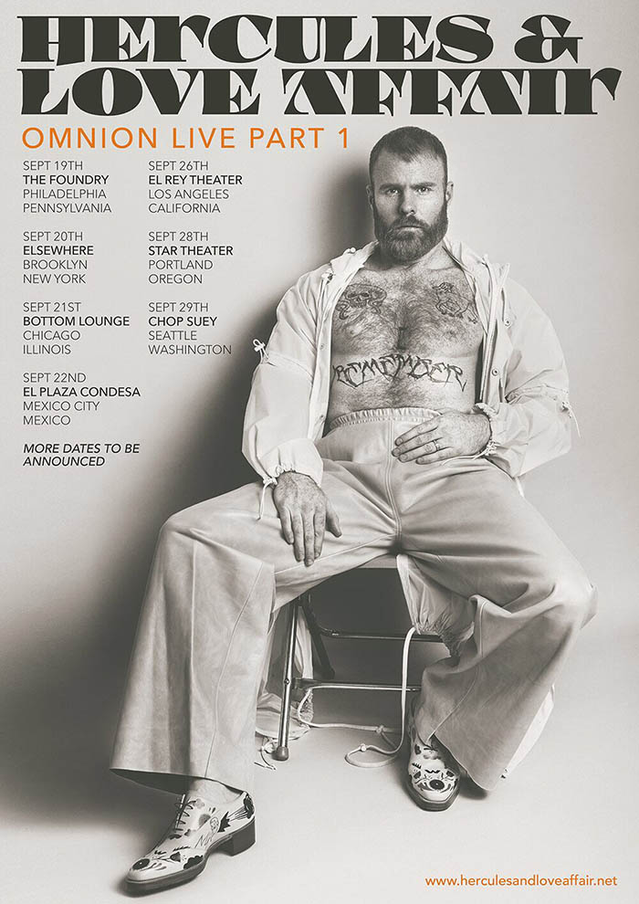
(Hi-Res Download)

Hercules & Love Affair unveils the official music video the deeply melodic and danceable “Are You Still Certain?,” the latest single from the music collective led by Andy Butler’s critically acclaimed fourth studio album ‘Omnion’ out now on Big Beat Records – WATCH HERE! The band will also kick off their “Omnion Live Part 1” North American tour starting on September 19 at The Foundry in Philadelphia and concluding at Chop Suey in Seattle on September 29th – full details enclosed -- with more dates to be announced soon.

“Are You Still Certain?” is an emotional appeal for truth and understanding, featuring Hamed Sinno from Mashrou’ Leila; the video directed by Joie Iacono and Andy Butler under their Hoarder alias (in collaboration with Robert Fox) pitches the cold hand of the law, the spectra of violence and innocence lost, as a timeless ever-present human struggle. Sinno performs against a series of vignettes that illustrate the ego’s blind pursuit of ‘truth’. ‘Are You Still Certain?’ is at once a balm to cultural tensions and a challenge to misconception and prejudice, written by Andy Butler and Mashrou’ Leila with additional vocals by Rouge Mary.

“As an American of a certain age, the idea of the shadowy, dangerous Muslim has been around for much of my life,” sighs Andy, “After chatting with Hamed at length, it cemented my hunch that I had a lot to learn from him and this collaboration. It was an opportunity to get perspective amid a lot of fear-mongering. I bought books about Islam and Islamophobia. Hamed and I, a few months later, were sitting in the studio, dealing with notions of spirituality. The lyrics for that song say, in Arabic essentially ‘You, who say you know the truth, how is the truth working for you? Are you still certain?’.”

“For a lot of people, faith and belief are the root of so many problems, so much so that there is more of stigma around believing today than not nowadays… We hear the argument that “faith" compels people to fly planes into buildings and blow themselves up in the middle of markets just as it put people on “divine” missions to plunder foreign lands and superimpose “superior” cultures on indigenous peoples. However, real faith also brings people together to greet each other in peace on a weekly basis, to listen to age old truths and lessons that run parallel in many cultures, and it prompts sincere self-reflection and growth in a lot of individuals. This song really tempers any notion of absolutism when it comes to truth. Working with Mashrou' Leila was an amazing process, as they are a band of brothers from different backgrounds. I went to Lebanon and took something of a back seat and learned and listened.”

Hamed Sinno from Mashrou’ Leila comments: “Hercules’s music was largely formative for us, and getting to finally work with Andy on this project was tremendously gratifying. It was especially wonderful to get to pick each other’s brains before and throughout the writing process, and recognizing the numerous ways in which our world-views overlapped, which provided that sense of empowered solidarity that really cuts through the music and lyrics.”

Mashrou’ Leila is a rapidly emerging band from Lebanon now receiving international recognition. The loose collective of students who began jamming together in 2008 at the American University of Beirut has gradually focused into an ambitious, fiercely articulate quartet: vocalist/lyricist Hamed Sinno, guitarist/multi-instrumentalist Firas Abou Fakher, violinist Haig Papazian, and drummer Carl Gerges. And the music they make has focused, too, into a charged, atmospheric version of pop that is geographically impossible to place. The lyrics draw on their collective experiences, which the band shares with the youth of the Middle East, and addresses the need for self-expression and a judgment free culture— a notion often stifled in a conservative society. Through their relevant and charged lyrics, their music has resonated with fans all over the globe. CNN has described Mashrou’ Leila as “The voice of their generation” while the Financial Times have called them “The Arab world’s most influential independent band”.

Released last year, Butler’s latest album ‘Omnion’ has a message of faith and tolerance delivered by a world class act of singers and collaborators including, The Horror’s Faris Badwan, Mashrou’ Leila, New York singer-songwriter Sharon Van Etten and Icelandic sister act Sísý Ey, alongside regulars Rouge Mary and Gustaph. ‘Omnion’ hits the zeitgeist with eleven songs that sparkled with faith and tolerance as a response to our troubling times.

HERCULES & LOVE AFFAIR
“OMNION LIVE PART 1” TOUR DATES
September 19 -- The Foundry -- Philadelphia, PA
September 20 – Elsewhere – Brooklyn, NY
September 21 – Bottom Lounge – Chicago, IL
September 22 – El Plaza Condesa – Mexico City, MX
September 26 – El Rey Theatre – Los Angeles, CA
September 28 – Star Theatre – Portland, OR
September 29 – Chop Suey – Seattle, WA

CONNECT:
http://herculesandloveaffair.net/
https://www.facebook.com/herculesandloveaffair/
https://twitter.com/HerculesLA
https://www.youtube.com/user/HerculesALA
https://www.instagram.com/herculesandloveaffair/
Download assets: http://press.wearebigbeat.com/artists/herculesandloveaffair/

PRESS CONTACT:
Jordan Danielle Frazes
Head of Publicity, Big Beat Records
Jordan.Frazes@atlanticrecords.com

