GANJA WHITE NIGHT X BOOGIE T
DELIVER NEW SUMMER JAM
‘FLAVA’
OUT TODAY ON BIG BEAT RECORDS!

LISTEN/POST: https://www.hive.co/l/gwnytv
STREAM/BUY: https://BigBeat.lnk.to/gwnfPR

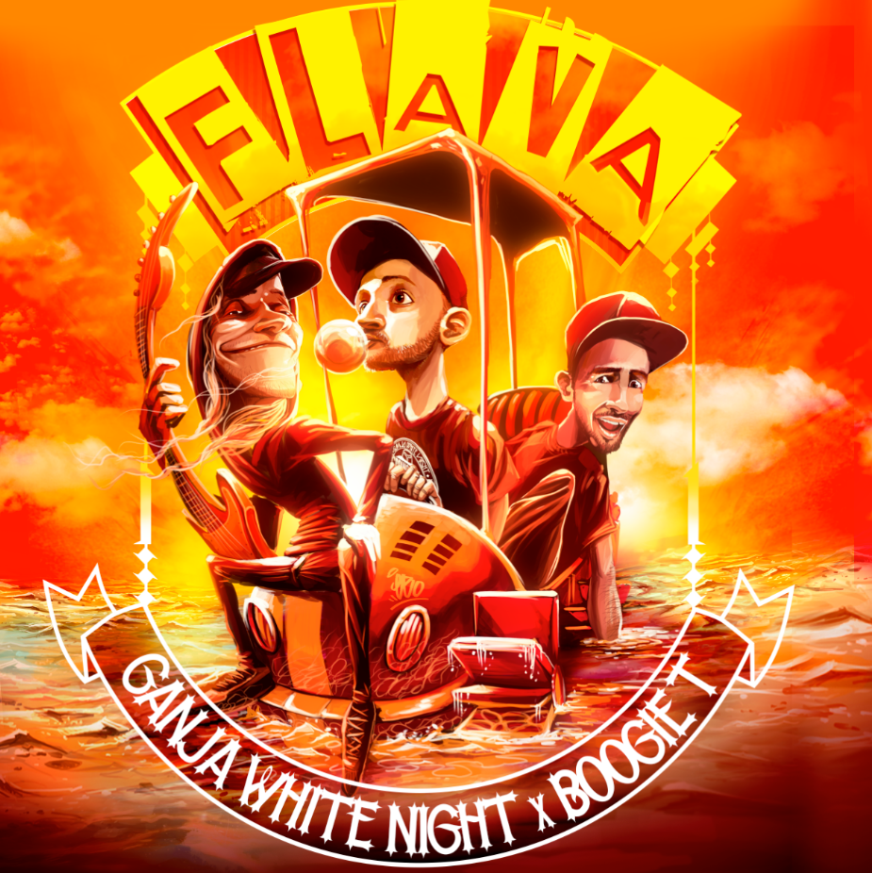

“Heavily inspired by dub, the production is both forward-looking and a throwback — ensuring it’ll be popular this summer festival season…With a classic, guitar-laden intro — along with some horns sprinkled on top — “Flava’s” groove is immediately evident and undeniable.” – DANCING ASTRONAUT

Belgium- based electronic production duo Ganja White Night team up with Louisiana singer/producer Boogie T on a brand new bassy summer jam ‘Flava’— LISTEN HERE — arriving today via Big Beat Records.
Ganja White Night’s early influences are found at the roots of "Bass-Music". During the past decade, the duo has cemented their position in electronic music with their hybrid, genre-bending production & live performances, 6 albums & multiple international tours & festival circuits. The band recently took a new creative direction tinted with hip-hop and more generally hybrid electronic music after the release of their fourth album "Addiction" in 2014.
Born and raised in the swamps of Louisiana, Brock Thornton aka Boogie T has been playing and writing music since the tender age of eight. Hailing from the South, the cradle of soul, it is easy to hear this influence in his music. Riddim, Dubstep, Bass, whatever you want to call it, Boogie T has always been about entertaining. Whether singing, playing guitar/keys/bass, acting, DJ’ing or producing. Boogie T's goal is simple: make great music and connect with people by taking risks and pushing boundaries.
Belgian Street Artist Ebo works on all Ganja White Night’s artworks and videos – opening up a whole new fantasy world for their fans. Check out this visual teaser made by Ebo below. – WATCH HERE

##

Connect with GANJA WHITE NIGHT:
https://twitter.com/GanjaWhiteNight
https://www.facebook.com/GanjaWhiteNight/
https://www.instagram.com/pnbrock
https://www.youtube.com/channel/UC1x1ByFJYFA8cGie8hDQDkQ
https://soundcloud.com/ganjawhitenight
http://ganjawhitenight.com/

Connect with BOOGIE T:
https://twitter.com/boogietmusic?lang=en
https://www.facebook.com/boogietmusic/
https://www.instagram.com/mrboogiet/
https://www.youtube.com/channel/UCVf8v_9zc1-tDd94xCMx1kg
https://soundcloud.com/boogie-t

Connect with BIG BEAT:
http://www.wearebigbeat.com
https://www.facebook.com/wearebigbeat
https://www.instagram.com/wearebigbeat
https://soundcloud.com/wearebigbeat

For more information please contact:
Jordan Frazes (Head of PR): jordan.frazes@atlanticrecords.com
Catherine Corkery (Online): catherine.corkery@atlanticrecords.com

