DANISH DJ & PRODUCER FAUSTIX ROUNDS OUT THE YEAR WITH A TRIBUTE TO CLUB MUSIC –
“OMG It’s LIT” EP

WATCH/POST “BONFIYAH”: https://www.youtube.com/watch?v=6jdBOxk8_cU
BUY/STREAM “OMG IT’S LIT”: https://faustix.lnk.to/OMGitslit

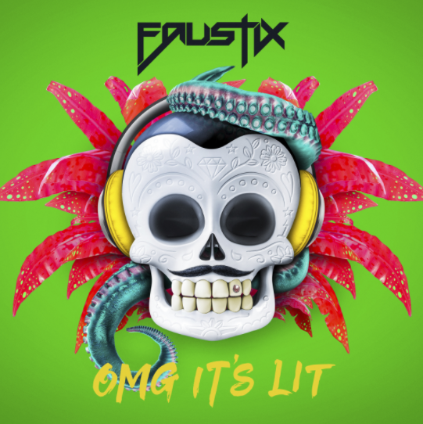

Out now, “OMG It’s LIT” the new EP from Danish DJ and producer Faustix is a tribute to the music that lights up the clubs. From start to finish, the EP is focused on channeling good energy and vibes through music, and reflects the feeling Faustix had himself after choosing the tracks. The tracks on “OMG It’s LIT” were produced over a relatively short period of time, in order to best capture the current energy of the moment, and to create a fresh and unique sound.

The sound leans heavily towards the hard electronic genre – a genre that has always proven very influential on Faustix’s sound. It is easy to detect, however, the producer’s later inspirations on tracks such as “Bonfiyah” ft. Hedegaard & Captain MacKay (listen here).

Of this evolution, Faustix explains: “I’ve tried to combine the ‘old’ sound of Faustix but with a new twist. It is always a challenge to renew yourself but I feel that I have made a sound that reflects where I am today as a producer.”

Faustix invited other producers and artists he admires to join as features on selected tracks and help capture the essence of the EP.

“I’ve worked with the vocalist Captain MacKay before on the track ‘Don’t U Worry’ and it has been amazing to have him join me again as the energy in his voice is so unique. Besides that, I’ve had some young guys joining me as well; Maxius and More Plastic. They are both really talented artists and I’m very excited to be able to present them to everyone”

In addition to these artists, Faustix also worked with the Danish producer Hedegaard (who previously produced Lukas Graham’s “Happy Home”) on the track “Bonfiyah.”

With the release of “OMG It’s LIT,” Faustix rounded out 2017, a year that brought him more than 30 million streams on the tracks “Watching You” and “Somebody New” as well as several festival and club gigs in Denmark and Scandinavia.
“OMG It’s LIT” Track Listing:

1. Whine Up Gyal
2. Beat Goes Like (feat. Maxius)
3. I Like 2 Shuffle
4. Bonfiyah (feat. Hedegaard & Captain Mackay)
5. Bad Man Selecta
6. Down Di Place (feat. More Plastic)

For Press Inquiries:

Jordan Danielle Frazes
Head of Publicity, Big Beat Records
Jordan.Frazes@atlanticrecords.com

