FLYBEAR SHARES NEW SINGLE “HOLLOWED” TAKEN FROM DEBUT EP ‘NIGHT HIKE’ VIA BIG BEAT WHITE LABEL
LISTEN/POST: https://soundcloud.com/flybearbeats/hollowed
PURCHASE: https://BigBeat.lnk.to/hollowedPR

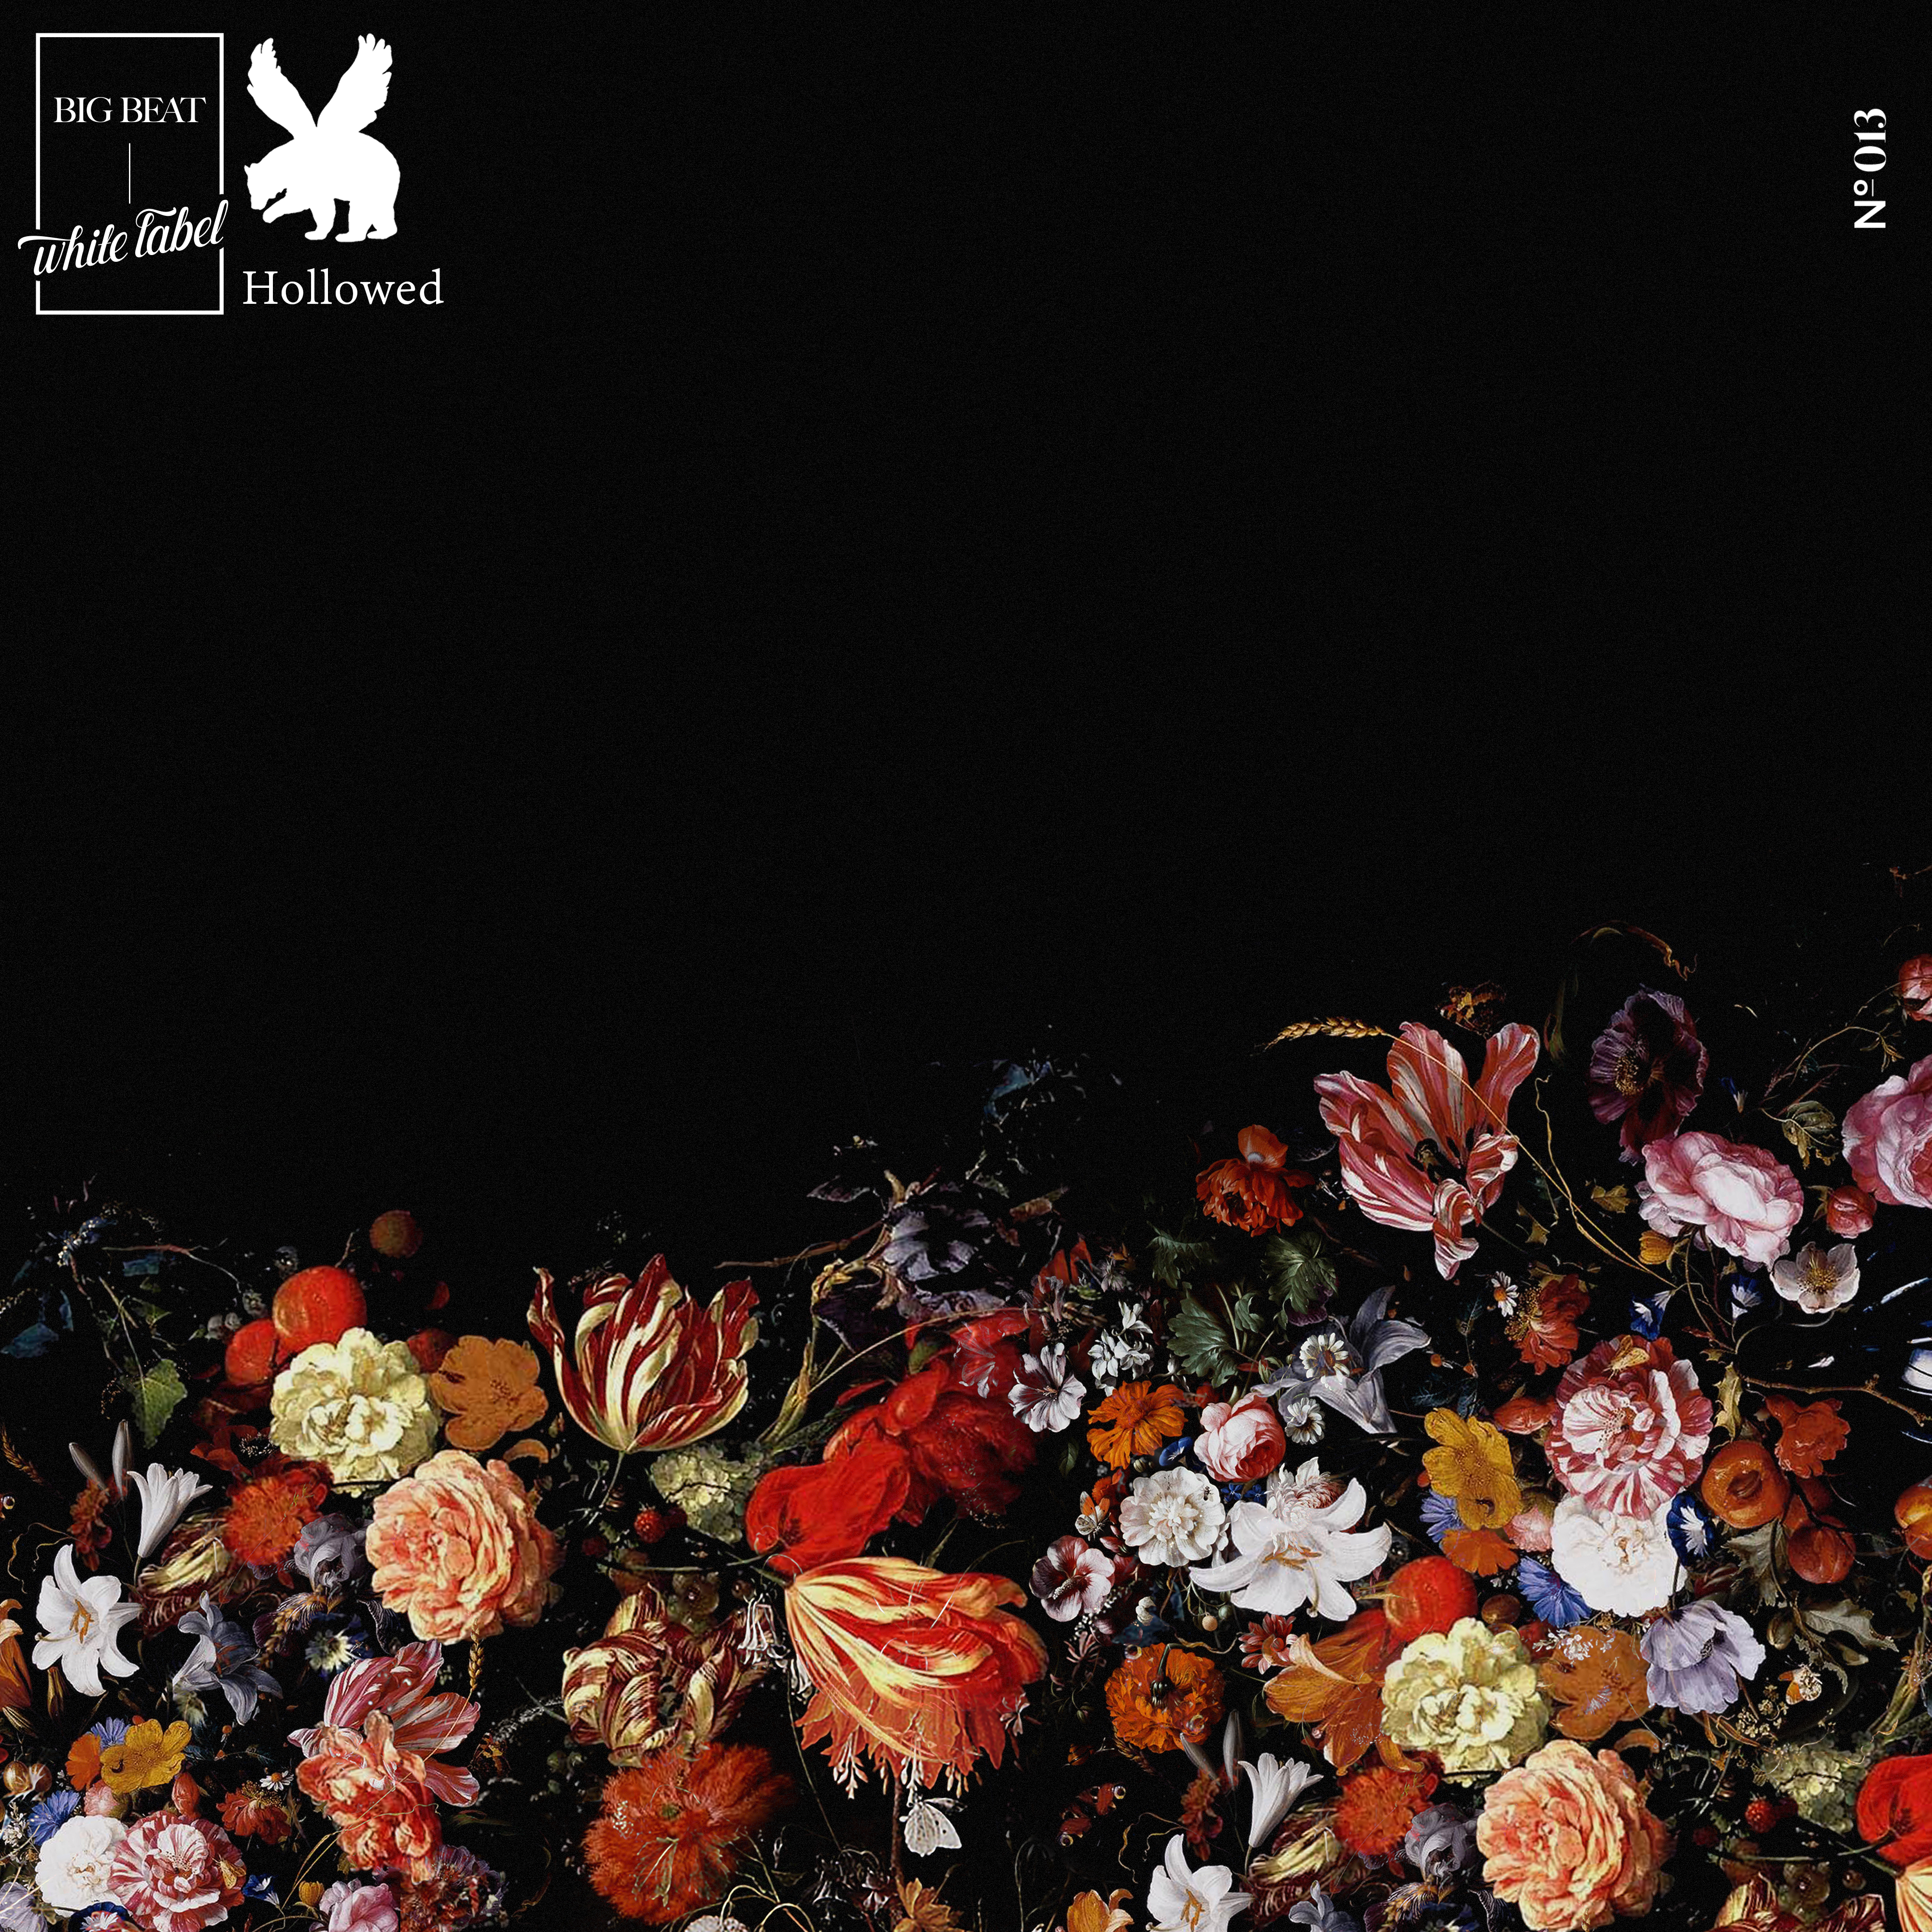
“The song is truly a breath of fresh air and we're excited to see what else this young up-and-comer has in store for us.” – This Song Is Sick

Today 20-year-old producer Flybear is sharing a new track “Hollowed,” via Big Beat White Label, the first piece of music for 2017 and the third single to come from his forthcoming debut EP ‘Night Hike’ due out later this year. Textured beats, pulsating synths, and organic instrumentation are what make the young producers sound and style. With a background in music theory, the multi-instrumentalist producer has developed a sound advanced beyond his years, pushing the boundaries of electronic music, and developing a style that's wholly unique. His intricate fusion of self-recorded samples and electronic creations flows flawlessly together into adventurously layered beats that reward the attentive listener.

”Hollowed is a collage piece I put together over the past year or so. It has some vocal samples from me and my brother and some guitar and some piano and some imaginary instruments I made on the computer. You should probably listen to it when it’s raining,” shares Flybear.

His music continues to cut through the noise as he turns out one of the coolest electronic sounds this year. ‘Night Hike’ was created with the intention of serving as the soundtrack to a midnight adventure. Stay tuned for the full EP.

Connect with Flybear:
https://soundcloud.com/flybearbeats/
https://www.facebook.com/flybearbeats
https://twitter.com/flybearbeats
https://www.instagram.com/flybearbeats/
http://vsco.co/flybearbeats/

For more information please contact:

Jordan Danielle Frazes
Head of Publicity, Big Beat Records
Jordan.Frazes@atlanticrecords.com

Lindsay Herr
lindsay@thewanderlvst.com

