**Elderbrook announces forthcoming *Innerlight* EP**

**New Single ‘I Will Find My Way To You’ with Emmit Fenn out now**

*Innerlight EP due for release October 8th*

*Fall 2021 North American headline tour features multiple sold-out shows*

**[Buy / Stream ‘I Will Find My Way To You’ Here](https://elderbrook.lnk.to/IllFindMyWayToYou)**

[**Watch video starring Elderbrook + Emmit Fenn Here**](https://www.youtube.com/watch?v=RjroutPDOxU)

[**Buy Tickets Here**](http://www.elderbrookofficial.com/index.html)

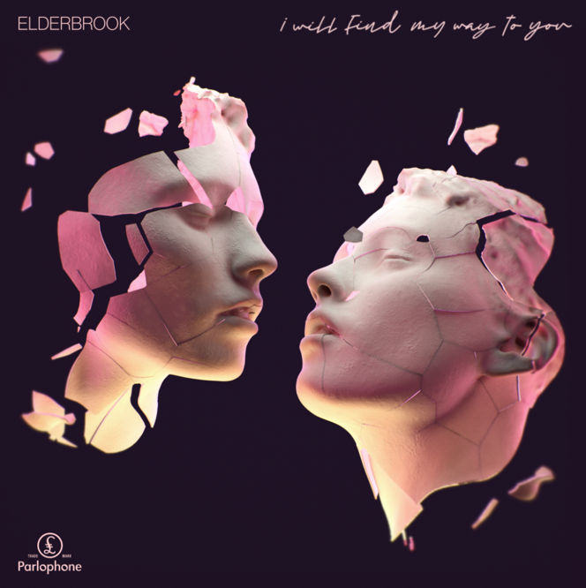

**Grammy-nominated** UK electronic artist **Elderbrook** has unveiled details of his forthcoming ***Innerlight*** EP and shares brand new single **‘I Will Find My Way To You’** with LA-based artist **Emmit Fenn**. The track arrives with a visual of the two artists performing the track from a New York rooftop ([watch here](https://www.youtube.com/watch?v=RjroutPDOxU)).

‘I Will Find My Way To You’ follows his recent release ‘Inner Light’, a collaboration with electronic duo **Bob Moses**. Both tracks will feature on Elderbrook’s upcoming *Innerlight* EP, due out October 8th. The four-track EP will also include ‘Dominos’ - his collaboration with electronic duo **Louis The Child** and ‘Broken Mirror’, produced by Danish DJ/producer **Kölsch**.

*“The EP is all about how important it is to trust your instincts and believe that you do have the right ideas,”* Elderbrook explains. *“That it’s important to follow your own inner light. It represents the journey of self-discovery that I have been on since becoming a father and learning how to navigate that and trust in myself.*

He continues: *“The last few years I've toured the US many times and met and played shows with some amazing artists. Whilst stuck in the UK during lockdown, I wanted to see if I could make some records with some of the artists I love from over there, and all the collaborations on this EP came about by working via a combination of zoom and phone calls and emails.”*

A live phenomenon, self-taught multi-instrumentalist, producer and singer-songwriter, Elderbrook arrived on the global stage in 2017, lending his vocals and co-writing the Grammy-nominated, platinum-selling smash ‘Cola’ with Camelphat. He then dropped his debut album *Why Do We Shake In The Cold?* last year, which has amassed over 200 million streams, and has collaborated with the likes of Rudimental, Black Coffee and Diplo.

Having kicked off North American Tour with performances at **Lollapalooza** and **2 sold-out nights at Red Rocks**, Elderbrook will embark on a series of dates across the US and Canada – including The Novo in LA and the iconic Irving Plaza in New York. Multiple dates on the run have already sold out, with second nights added in Vancouver, Denver, and Santa Barbara (full dates below).

A singer, songwriter and producer, Emmit Fenn burst onto the scene with 'Painting Greys' in 2017, a debut single that hit #1 on the Spotify ‘Global Viral’ charts. In the years since he has produced tracks ‘bitches broken hearts’ and ‘Untold’ for Billie Eilish and Ry X respectively, dropped debut album *Far From Here* back in April, and will embark on his first-ever headline tour this fall.

Elderbrook’s second stunning collaboration in quick succession, ‘I Will Find My Way To You’ not only taps into the moving electronic sound the UK multi-hyphenate is quickly making his own, but also further heightens the anticipation for what promises to be one of the best EP releases of the year.

***Innerlight* EP Tracklist**

1. Elderbrook & Bob Moses – ‘Inner Light’
2. Elderbrook & Emmit Fenn – ‘I Will Find My Way To You ‘
3. Elderbrook – ‘Broken Mirror’ (produced by Kölsch)
4. Elderbrook & Louis The Child – ‘Dominos’

**Elderbrook North American Tour Dates - Tickets Available Now**

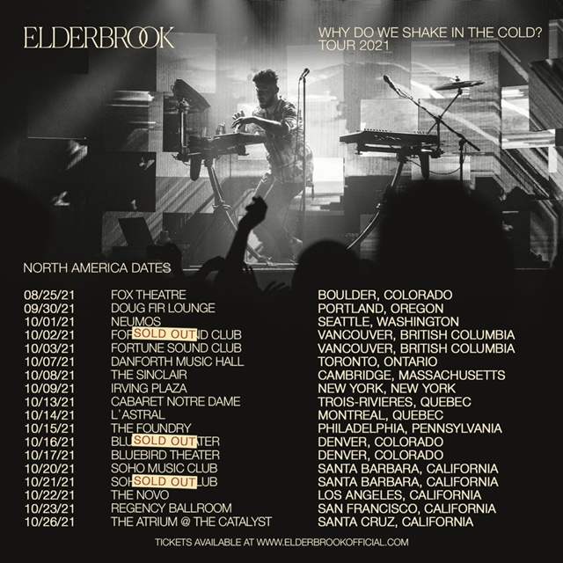

**# # #**

For more information on **Elderbrook**, please visit:

[Instagram](https://www.instagram.com/_elderbrook/) | [Twitter](https://twitter.com/_elderbrook?lang=en) | [Facebook](https://www.facebook.com/Elderbrookmusic/) | [Spotify](https://open.spotify.com/artist/2vf4pRsEY6LpL5tKmqWb64?si=BVe_HNJCSMGwCCUbhnpdaA)

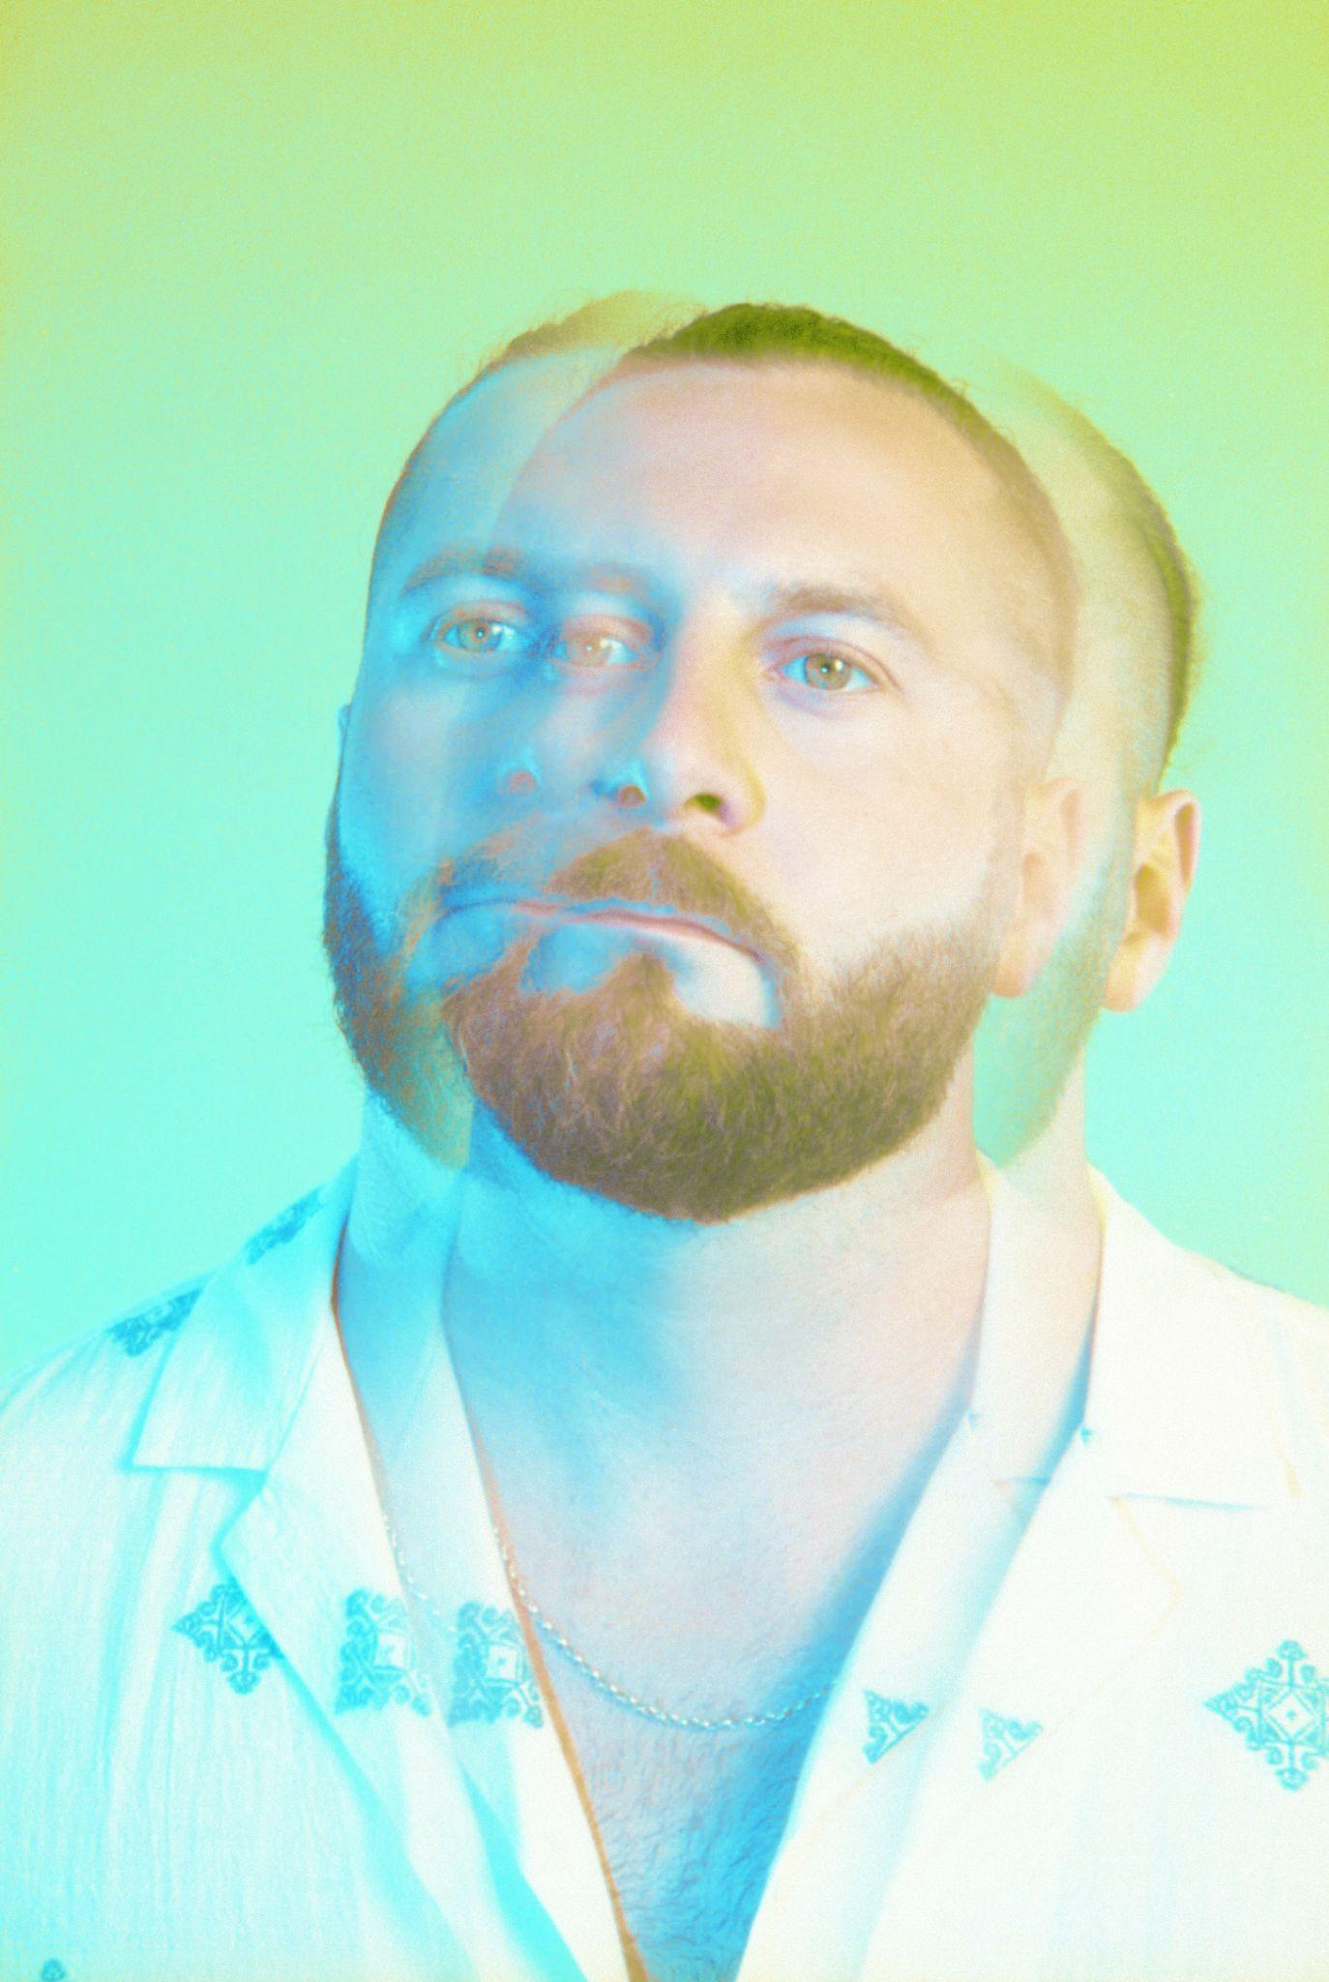

[hi-res press images here](https://warnermusicgroup.app.box.com/s/thqfas8ggs0qj11h48dyze0t689zu7e9/folder/144292725078)