GRAMMY-NOMINATED ELDERBROOK ANNOUNCES NEW SINGLE + VIDEO "NUMB"

FIRST SINGLE OFF HIGHLY-ANTICIPATED DEBUT ALBUM,
DUE SUMMER 2020

FOLLOWS 2019 GLOBAL SMASH + #1 DANCE RADIO HIT
“SOMETHING ABOUT YOU”

WATCH HERE:
https://www.youtube.com/watch?v=5FVhN8F8qxs

BUY/STREAM:
https://BigBeat.lnk.to/NUMBPR

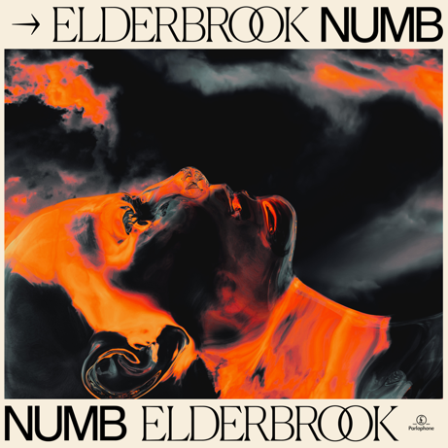

Grammy-nominated UK singer-songwriter, producer, and multi-instrumentalist Elderbrook announces the release of his first cut of the year by way of the atmospheric new single "Numb," a pulsing and emotive track which teases his highly-anticipated debut album, set for release in summer 2020.

The powerful new visual for the track continues his passion for storytelling; and explores the introspectiveness of feeling alone, addressing emotions of solitude, detachment and the importance of paying attention to the people around us.

"Numb" follows last year's smash collaboration with multi-platinum UK collective Rudimental "Something About You," and continues to cement Elderbrook as a multi-faceted talent; an artist who can comfortably explore and push boundaries within his genre, making music with meaning and centred around exploring themes of human connection

Grammy and Ivor Novello nominated, 4.5 million monthly Spotify listeners, high-energy headline shows around the US (including a sold-out show at Bowery Ballroom), supporting tours with Jungle, Bonobo and Friendly Fires and collaborations with Camelphat, Diplo, and Black Coffee have earnt him a revered reputation across the board as a live phenomenon and multi-talented artist.

Of the inspiration behind the video, Elderbrook explains:
“Numb is about loneliness. I wrote it while I was on tour. It can be pretty lonely traveling around a lot and that’s what inspired this song. The thing that makes the song and video a bit different is the idea that everyone is lonely, which in a weird way brings us all together.

The last 12 months have seen Elderbrook complete his headline North American and European tours and collect his 2nd #1 at US Dance Radio with "Something About You," with the single amassing 50M combined streams and over 12M video views.

Fast forward to now, 2020 promises the release of his exemplary debut album, further top-tier collaborations and a packed-out global touring schedule, including US performances at marquee festivals including Bonnaroo, Hangout and Forecastle.

Elderbrook official // Facebook // Twitter

PRESS INQUIRIES:
Libby Kober | Libby.Kober@atlanticrecords.com

