Grammy-nominated Elderbrook announces ‘Why Do We Shake in the Cold’ North American headline tour – tickets on-sale this Friday

Latest single “Body” out now; CamelPhat produced track marks third release together following worldwide smash “Cola”

Set to play highly-anticipated Bonnaroo Music & Arts Festival 2021

Buy / Stream ‘Body’ Here
Watch the Music Video Here

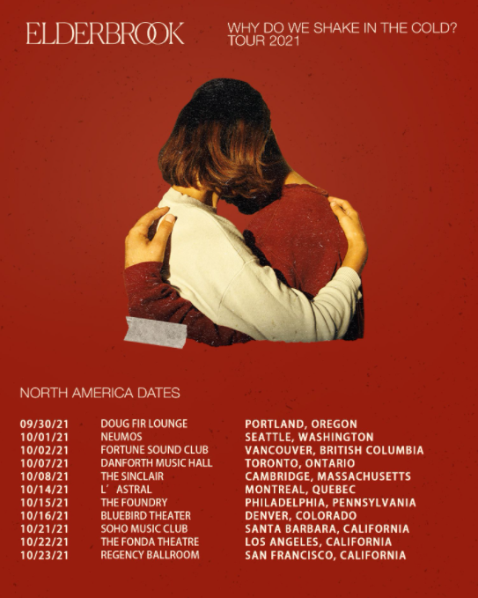
download hi-res admat here

Grammy-nominated UK singer-songwriter and producer Elderbrook has today announced plans for his upcoming ‘Why Do We Shake in the Cold’ North American headline tour – set to kick off Sept 30 in Portland, Oregon and include stops across the US and Canada, including a show at LA’s iconic The Fonda Theatre on Oct 22 (full tour itinerary below). Tickets for the tour will be available beginning this Friday here.

The highly-anticipated live shows will celebrate Elderbrook’s debut full-length album of the same name, released last September to critical acclaim including from NPR, Billboard, and more. ‘Why Do We Shake in the Cold’ has since gone on to amass over 200 million global streams and brought Elderbrook’s catalogue up over half a billion total streams.

Elderbrook’s most recent single “Body” was released last month via Big Beat Records. Produced by CamelPhat, the track marked the third collaboration between the two electronic acts, including their Grammy-nominated 2017 smash “Cola.” (Last year, Elderbrook also featured on the CamelPhat track “Dance With My Ghost.”) An effortless display of vocal-driven dance music from the UK multi-hyphenate, “Body” arrived alongside an official video juxtaposing 3D animation against spectacular cityscapes of Seoul, South Korea. Watch the video for “Body” here.

Last year, Elderbrook collaborated with Black Coffee & Diplo on Black Coffee’s single “Never Gonna Forget.” Earlier this month, Elderbrook performed a version of the track for his popular Hotel Room Sessions series. Watch that here. Last week, Diplo teased another forthcoming collaboration with Elderbrook & Andhim via his TikTok here.

A self-taught multi-instrumentalist, producer and singer/songwriter in his own right, Elderbrook has earned himself a revered reputation as a multi-faceted, forward-thinking talent who is comfortable exploring a range of genres. Over his career so far, he’s previously worked with the likes of Diplo, Rudimental, CamelPhat; gaining coveted Grammy and Ivor Novello nominations in the process.

UPCOMING NORTH AMERICAN TOUR DATES:
Sun, Sept 5 – Bonnaroo Music & Arts Festival 2021 – Manchester, TN
Thu, Sept 30 – Doug Fir Lounge – Portland, OR
Fri, Oct 1 – Neumos – Seattle, WA
Sat, Oct 2 – Fortune Sound Club – Vancouver, BC
Thu, Oct 7 – The Danforth Music Hall – Toronto, ON
Fri, Oct 8 – The Sinclair – Cambridge, MA
Thu, Oct 14 – L’Astral – Montreal, QC
Fri, Oct 15 – The Foundry – Philadelphia, PA
Sat, Oct 16 – Bluebird Theater – Denver, CO
Thu, Oct 21 – SOhO Restaurant & Music Club – Santa Barbara, CA
Fri, Oct 22 – The Fonda Theatre – Los Angeles, CA
Sat, Oct 23 – The Regency Ballroom – San Francisco, CA

###

For more information on Elderbrook, please visit:
Instagram | Twitter | Facebook | Spotify

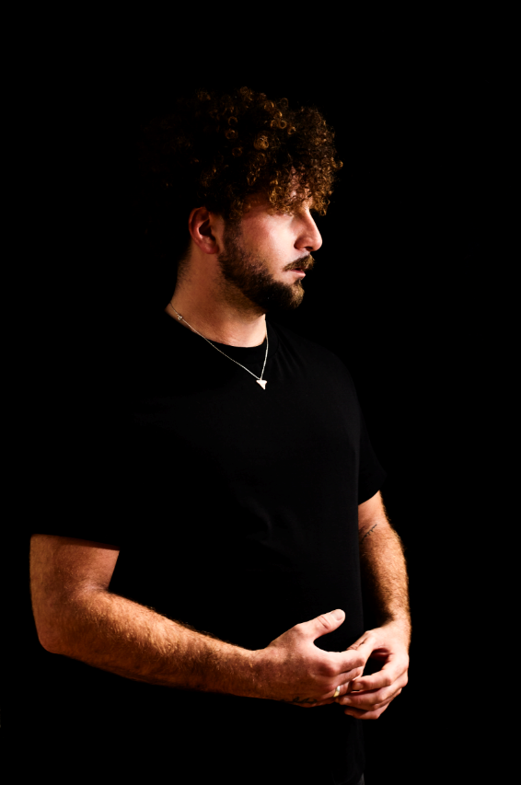
download hi-res press image

