**Elderbrook & Bob Moses join forces on new single**

**‘Inner Light’**

*Lead single from Elderbrook’s forthcoming EP will debut this Sunday at Lollapalooza*

*Fall 2021 North American headline tour features multiple sold-out shows*

[**Buy / Stream ‘Inner Light’ Here**](https://elderbrook.lnk.to/InnerLight)

[**Buy Tickets Here**](http://www.elderbrookofficial.com/index.html)

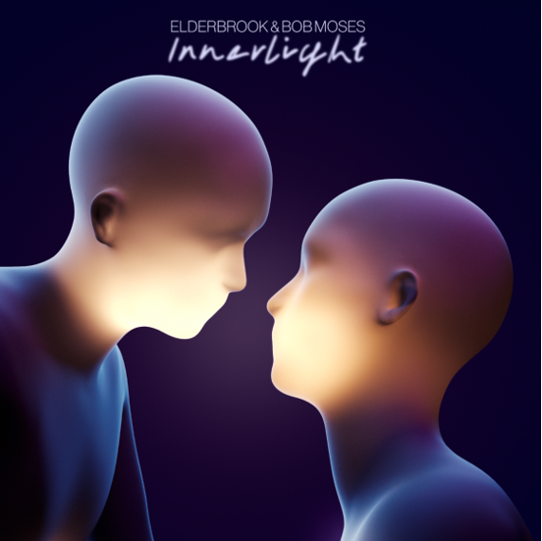

Global electronic music superstars **Elderbrook** and **Bob Moses** have linked up on their new single **‘Inner Light’** – listen [here](https://elderbrook.lnk.to/InnerLight).

Announcing itself with somber piano chords and delicate vocals that build to a euphoric crescendo, ‘Inner Light’ is a poignant, emotionally charged dose of electronica that blurs the lines between electronic and organic sounds. The track follows Elderbrook’s previous offering ‘Body’ and also marks the lead single from his forthcoming EP, which features collaborations with the likes of **Kolsch** and **Louis The Child**.

*“The song is about someone that’s too self-conscious to dance,”* Elderbrook explains. *“The person asking them realises that they are unsure but tells them ‘don’t worry about it, trust your instincts’ and follow your ‘inner-light.’”*

A live phenomenon, self-taught multi-instrumentalist, producer and singer-songwriter, Elderbrook arrived on the global stage in 2017, lending his vocals and co-writing the Grammy-nominated, platinum-selling smash ‘Cola’ with Camelphat. He then dropped his debut album *Why Do We Shake In The Cold?* last year, which has amassed over 100 million streams, and has collaborated with the likes of Rudimental, Martin Garrix, Black Coffee and Diplo.

Kicking off his North American Tour at Lollapalooza this weekend, Elderbrook will embark on a series of dates across the US and Canada – including The Novo in LA and the iconic Irving Plaza in New York. Multiple dates on the run have already sold out, with second nights added in Vancouver, Denver, and Santa Barbara.

Emerging in 2012 with a series of well-received EPs, electronic duo Bob Moses have built a reputation around their potent hybrid of house and lyrical pop music. They have earned numerous commercial and critical accolades in the years since, including a Grammy nomination for the single ‘Tearing Me Up’ and a nomination for ‘Live Act of the Year’ at the Electronic Music Awards. More recently they dropped their single ‘Griffith’ to coincide with a performance at the Griffith Observatory in LA.

‘Inner Light’ is a stunning collaboration between two masters of the electronic sphere and gives listeners a taste of what’s to come from Elderbrook and his much-anticipated EP and US Tour.

**Elderbrook North American Tour Dates - Tickets Available Now**

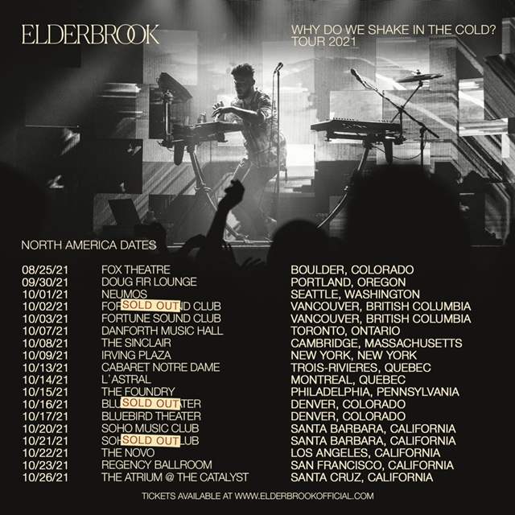

**# # #**

For more information on **Elderbrook**, please visit:

[Instagram](https://www.instagram.com/_elderbrook/) | [Twitter](https://twitter.com/_elderbrook?lang=en) | [Facebook](https://www.facebook.com/Elderbrookmusic/) | [Spotify](https://open.spotify.com/artist/2vf4pRsEY6LpL5tKmqWb64?si=BVe_HNJCSMGwCCUbhnpdaA)

