ELDERBROOK DELIVERS “CAPRICORN”

FOLLOWING HIS GRAMMY NOMINATED “COLA” COLLAB + “SLEEPWALKING”
PLUS NORTH AMERICAN HEADLINE TOUR KICKING OFF IN SEPTEMBER

LISTEN/SHARE: https://BigBeat.lnk.to/CapricornPR/youtube
BUY/SREAM: https://bigbeat.lnk.to/CAPRICORNPR/PR
(Big Beat Records)

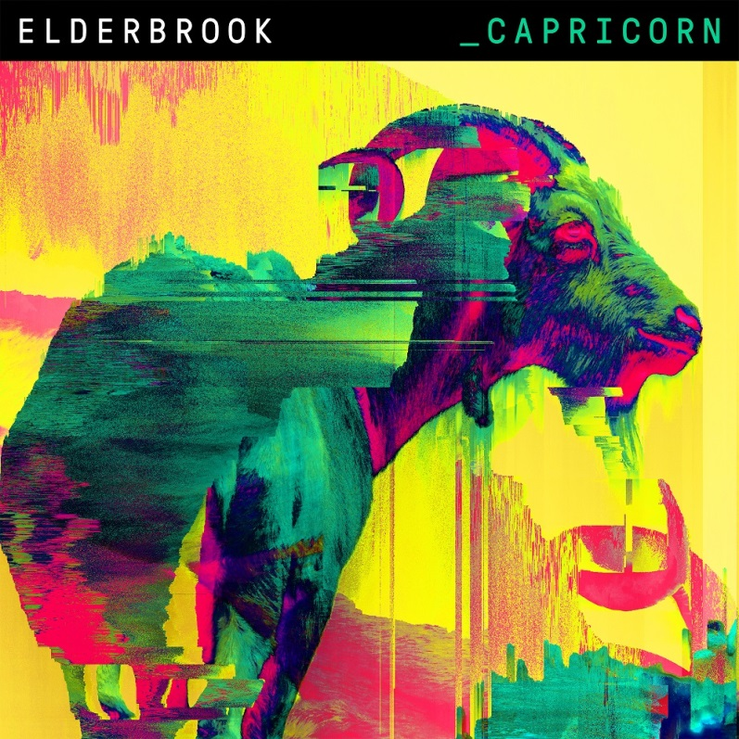

Grammy Award-nominated songwriter and producer Elderbrook made a flying start to a new stage in his career with his Big Beat Records debut ‘Sleepwalking’ which is now approaching 2 million streams. The track’s profile continued with a recent remix release from Hot Creations / Paradise / Hot Natured legend Jamie Jones.

Now Elderbrook is set for another big moment with the release of his new track ‘Capricorn’—LISTEN HERE!

“Capricorn” blends creative electronica with an immediately insistent pop vocal hook – a track that bursts with character and is heightened by Alexander Kotz - aka Elderbrook’s - intriguingly leftfield lyrics. A narrative about a couple’s relationship that’s strained by a women’s obsession with star signs, it takes a playful satirical stab at astrology.

As Elderbrook explains, “She’ll read the paper and say, ‘We’re in trouble today because I’m a Capricorn and you’re a whatever.’ This keeps on happening, so he decides he’s going to get a job so he can write all this stuff and quite sinisterly regain control. I think people can identify with the guy who’s just thinking it’s utter nonsense, but maybe others will identify with her instead.”

Last year, Elderbrook joined forces with production duo CamelPhat to release “a cool little club record” called ‘Cola’. Fate, however, had different plans when ‘Cola’ was catapulted from the underground and into charts all over the world. It emerged as a surprise nomination for the 2018 Grammy Award for Best Dance Recording, and its success has recently seen Elderbrook and CamelPhat earn an Ivor Novello nomination for Best Contemporary Song. He released his second EP ‘Talking’ last year as ‘Cola’ was breaking big.

Elderbrook has earned a track record for sold-out headline shows all over the globe, alongside tours with artists as varied as Rüfüs Du Sol, The Wombats and Bonobo. His solo gigs have included sold-out shows at The Roxy in L.A. and Baby’s All Right in NYC. Elderbrook will play his biggest American headline shows to date in September, and has just announced details of a major UK and European tour – see full itinerary below.

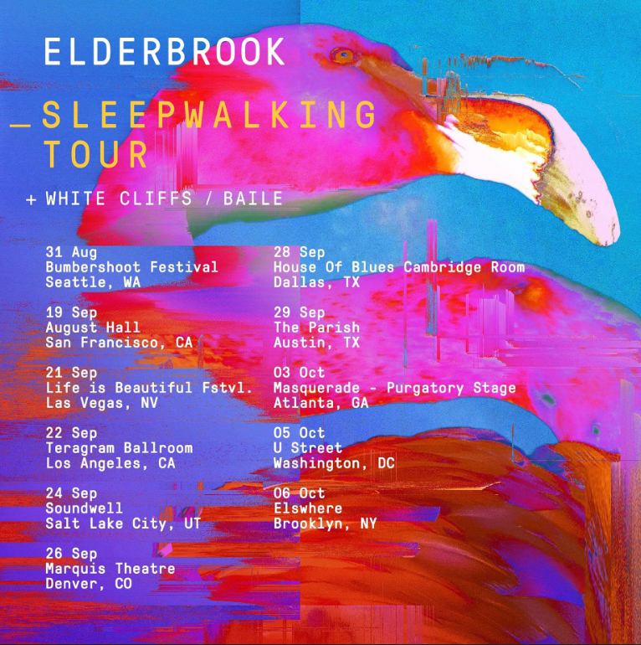

Elderbrook SLEEPWALKING TOUR + FESTIVAL DATES
August
24th – UK, Reading Festival
25th – UK, Leeds Festival
31st – USA, Seattle, Bumbershoot Festival

September
19th – USA, San Francisco, August Hall
21st – USA, Las Vegas, Life Is Beautiful Festival
22nd – USA, Los Angeles, Teragram Ballroom
24th – USA, Salt Lake City, Soundwell
26th – USA, Denver, Marquis Theatre
28th – USA, Dallas, House of Blues, Cambridge Room
29th – USA, Austin, The Parish

October
3rd – USA, Atlanta, Masquerade, Purgatory Stage
5th – USA, Washington, U Street
6th – USA, Brooklyn, Elsewhere

October – JUST ADDED
24th – UK, London, Heaven
25th – Ireland, Dublin, The Academy Green Room
27th – Germany, Hamburg, Hakkan
28th – Germany, Berlin, Maschinehaus
29th – Germany, Cologne, Veedel Club
Connect with Elderbrook:
https://www.facebook.com/Elderbrookmusic/
https://twitter.com/_elderbrook
https://www.instagram.com/_elderbrook/

For press assets: http://press.wearebigbeat.com/artists/elderbrook/

For more information on Elderbrook:

Jordan Danielle Frazes
Head of Publicity, Big Beat Records
Jordan.Frazes@atlanticrecords.com

Libby Kober
Tour Publicity, Big Beat Records
Libby.Kober@atlanticrecords.com

