Elderbrook returns with brand new single ‘Body’

The CamelPhat produced single is their third release together, following worldwide smash ‘Cola’ and CamelPhat track ‘Dance With My Ghost’

Buy / Stream ‘Body’ Here
Watch the Music Video Here

Out Now via Big Beat Records
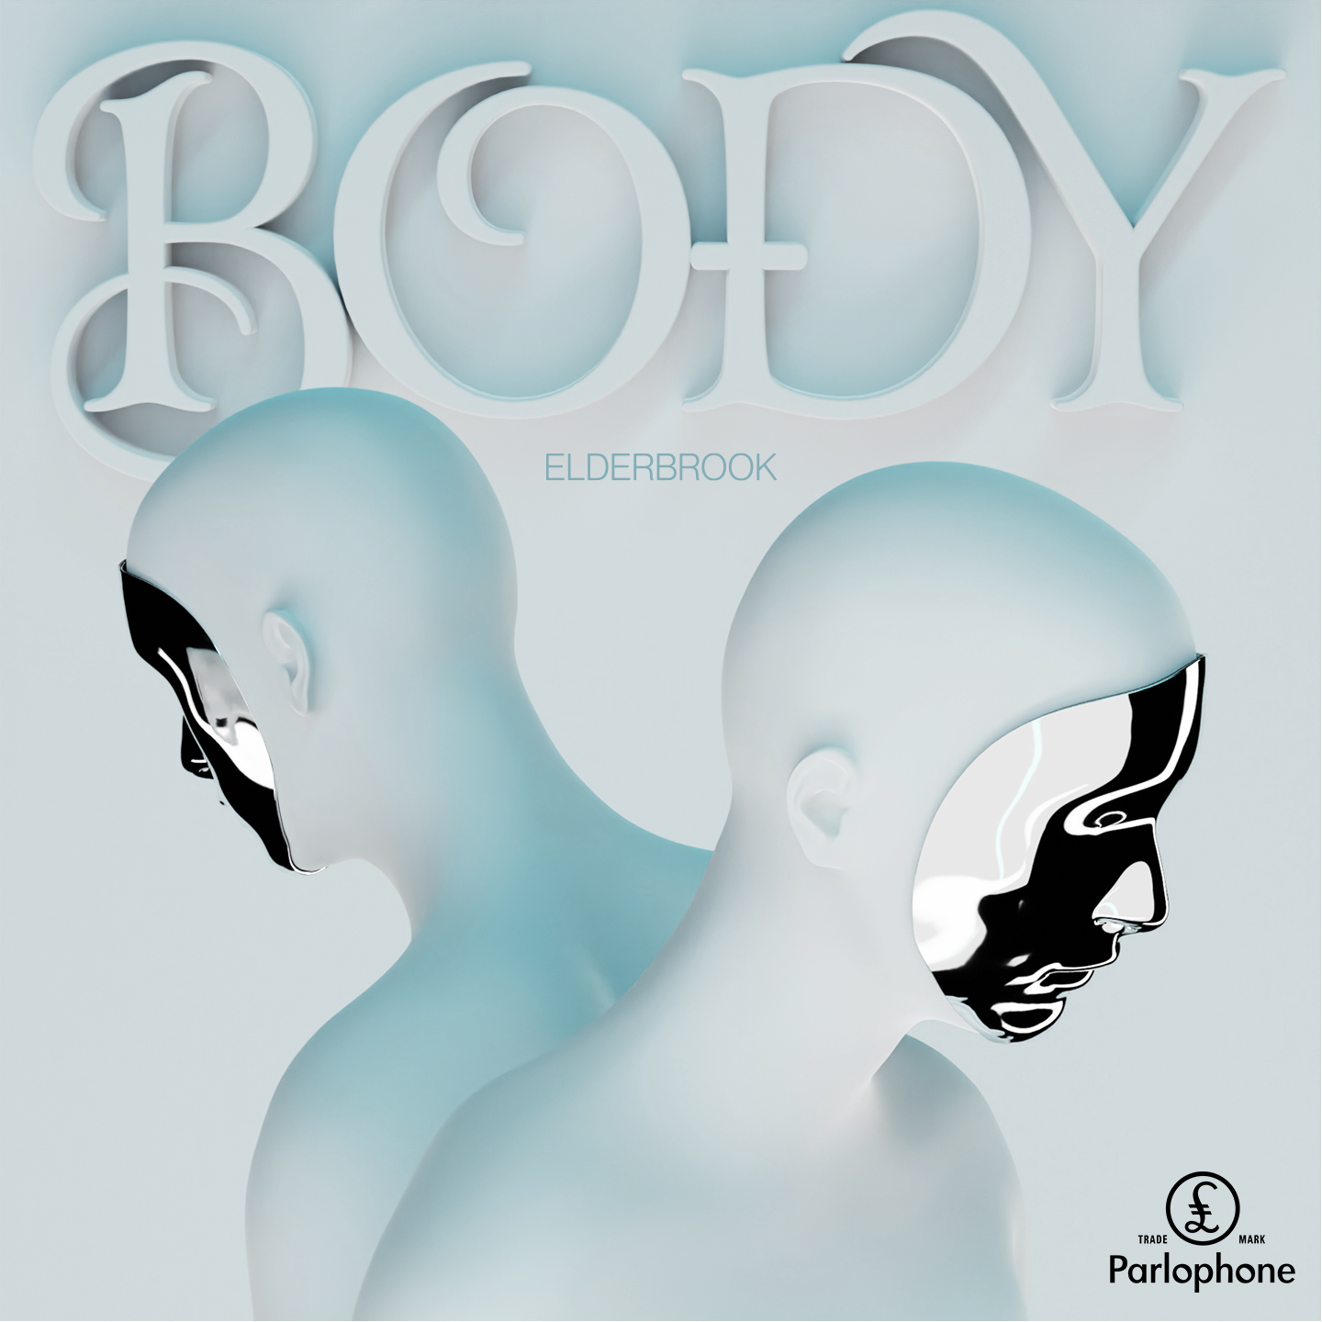

Grammy-nominated UK artist Elderbrook shares his highly-anticipated new single ‘Body’.

A sultry dance anthem in waiting, ‘Body’ flaunts hypnotic percussion and bubbling basslines underpinning Elderbrook’s ethereal vocals. Produced by CamelPhat, Elderbrook’s latest offering marks the second reunion of the two electronic acts since their Grammy-nominated 2017 smash ‘Cola’. (Last year, Elderbrook featured on the CamelPhat track ‘Dance With My Ghost.’)

Also released today, the music video for ‘Body’ intersperses cleverly-cut 3D animation amongst spectacular cityscapes of Seoul, Korea. ‘Body’ is Elderbrook’s first release of 2021, following his much-acclaimed debut album, Why Do We Shake In The Cold? which has accumulated over 200 million combined streams to date.

A self-taught multi-instrumentalist, producer and singer/songwriter in his own right, Elderbrook has earned himself a revered reputation as a multi-faceted, forward-thinking talent who is comfortable exploring a range of genres. Over his career so far, he’s previously worked with the likes of Diplo, Rudimental, CamelPhat; gaining coveted Grammy and Ivor Novello nominations in the process.

Destined for dancefloors and festivals alike, Elderbrook’s new single ‘Body’ is an effortless display of vocal-driven dance music from the UK multi-hyphenate.

###

For more information on Elderbrook, please visit:
Instagram | Twitter | Facebook | Spotify

download hi-res press image

