ELENOIR INVITES YOU TO THE ‘WRONG PARTY’

LISTEN HERE: https://elenoir.lnk.to/wrongparty
WATCH VIDEO HERE: https://youtu.be/2kXEdH6iW_8

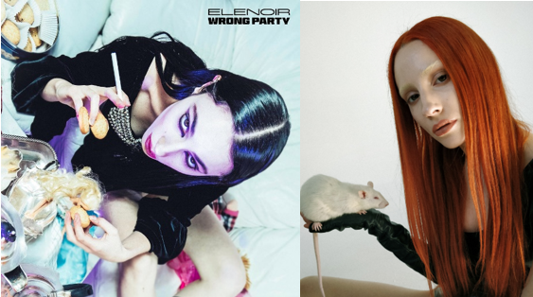

Fresh off her last tantalizing track ‘Queen Of Love’, a dark and bewitching collaboration with Xanti and Tim Bell, Elenoir is back, putting her spell on you with a cunning new single. Enter ‘Wrong Party’, where the gifted artist unleashes her imagination and talent to hypnotize and lead you into an alluring, twisted world which you will never want to leave. LISTEN HERE!

Born in 1994, Elenoir started playing piano and guitar as a little girl, building her own world based on music and written words tainted by a classical approach. Her nature, individual experiences and time spent together with the band led to an intimate and artistic approach in music and art, inspired by literature, psychedelic and dark genres, together with some surrealistic and oneiric flavours. She wants to introduce you to her reality while maintaining “a certain latitude”, a smart and elegant vision of the human being and Art itself. The Witch wishes you a nice trip.

Elenoir:
“Our is Mind is the Kingdom we have to rule the most, forgive its tricks.
The World is the most enchanting place we are gifted to live in, take your own
sweet chance to dissimulate, but don’t give up on yourself, ever.
Dance when it seems to be the worst moment.”

“Fair is Foul and Foul is Fair”
[W. Shakespeare, Macbeth - Act I, scene I]
CONNECT WITH ELENOIR:
INSTAGRAM | FACEBOOK | WEBSITE | TWITTER | PRESS SITE

Press contact: gabrielle.reese@atlanticrecords.com

