RISING PRODUCER DWILLY SHARES NEW FEEL-GOOD
EMO/HIP-HOP SINGLE, “DUCK DUCK GOOSE”

LISTEN HERE: https://BigBeat.lnk.to/DuckDuckGoosePR

OUT TODAY VIA BIG BEAT RECORDS!

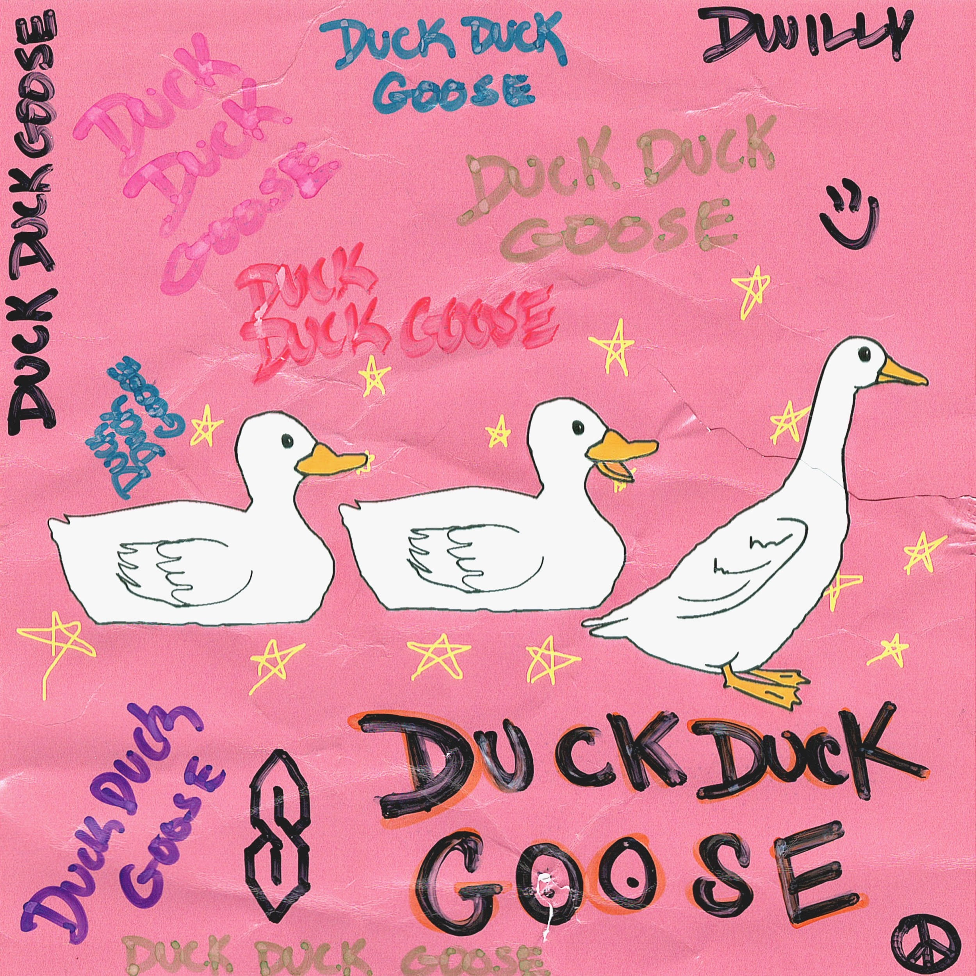

The fast-rising LA-based producer, songwriter and multi-instrumentalist dwilly is coming down off quite a year that saw him open for Zedd at his esteemed Red Rocks show and support GRiZ on his nationwide tour, but he isn’t done with 2019 quite yet. Today sees the release of “DUCK DUCK GOOSE,” his sophomore release for Big Beat Records and the last track he’ll be sharing ahead of the release of his forthcoming EP in December. “DUCK DUCK GOOSE” is a feel-good return to form for dwilly, who’s become known for fusing elements of trap, hip-hop, emo and electronic music into an undeniably fresh style that is all dwilly, and is showcased perfectly on this new single. And if that isn’t enough, the track also features vocals from a Los Angeles Public School Children's Choir (!!!) - LISTEN HERE!

It’s easy to see why Ones To Watch hailed dwilly as “music’s most brilliant threat” this year; he’s already released one EP called CRAYOLA, along with a stream of other singles, and has another EP coming in 2020! Aside from that, dwilly’s also produced hit records for A-list stars like Mike Posner, Ty Dolla $ign and Wiz Khalifa, along with being commissioned to crank out official remixes for "So Close" by NOTD & Felix Jaehn, "Move On" by Mike Posner, "Open My Mouth" by Kiiara, and more.

With the prolific rate in which dwilly is cranking out smash after smash, it’s fair to say that it won’t be long before you’re hearing more from this star producer in the making!

CONNECT WITH DWILLY:
Instagram | Facebook | Twitter | Spotify

DWILLY PRESS ASSETS: https://press.wearebigbeat.com/singles/dwilly

FOR MORE INFORMATION:
Paige Rosoff – Big Beat Records
Paige.Rosoff@atlanticrecords.com

