**HOUSE MUSIC MASTERMIND DILLON NATHANIEL RELEASES**

**LONG AWAITED *OBSESSIONS* EP TODAY**

**FEAT. RECENT SINGLES “OBSESSIONS” AND “MIND SENSATION” (W/ JACK BEATS)**

**OUT NOW VIA BIG BEAT RECORDS**

**LISTEN HERE:** [**https://BigBeat.lnk.to/obsessions-EPPR**](https://BigBeat.lnk.to/obsessions-EPPR)

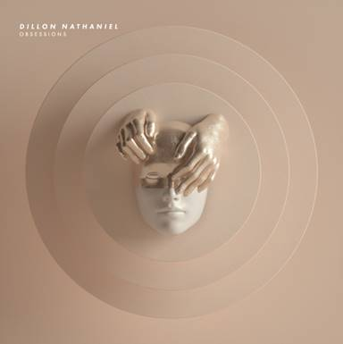

[**DL artwork HERE**](http://press.wearebigbeat.com/singles/dillon-nathaniel/)

Following his latest single “[Mind Sensation](https://www.youtube.com/watch?v=_Ym9TF6ybOk)” (w/ **Jack Beats**) and the EP’s title track “[Obsessions](https://www.youtube.com/watch?v=1tqKTKuNbn8),” today sees the release of house music prodigy **Dillon Nathaniel’s** ***Obsessions* EP** through **Big Beat Records**. Each track exemplifies this prodigious producer’s unparalleled, modern spin on classic house music. Featuring elastic bass lines, skittering drum machine, wobbling synths and plenty more, Dillon’s latest work is sure to further cement his place as an innovator in house music. [LISTEN HERE!](https://BigBeat.lnk.to/obsessions-EPPR)

On the EP Dillon says, “*The Obsessions EP is a project that came together over the past 3 years. Each song was made at a completely different time in my life and you can hear the progression in each record. All of the different experiences, relationships, and situations have shaped me in more ways than I could ever put to words. I have experienced a lot of positive growth these last three years and there are instances where I feel like a new person in so many different ways. But one thing is certain; making music that connects and resonates with others will always remain my ultimate obsession.*”

Dillon found his footing in music at a young age as a vocalist and guitar player. His father took him to his first EDC at the age of 16, with hopes of instilling a passion for dance music in him. It paid off, as Dillon decided to pursue a career in electronic music. Dealing with audio manipulation and production as a bass technician, Dillon’s transition into the electronic music industry was an easy one.

Nathaniel’s unconventional approach to house music is centered on sonic manipulation, and his low-end grooves and unique sound design have caught the ears of **Chris Lake, Mark Knight, Richy Ahmed, Solardo, Gorgon City, Malaa, Kyle Watson, Shiba San** and **Tchami.** A graduate of the revered **Icon Collective**, Nathaniel’s music has made it to the mainstream audiences of **BBC Radio 1, Rinse FM,** and **Sirius**. Last year was a big year for the producer with key festival performances at **CRSSD** in San Diego, **Seismic Dance Event** in Austin, and AMF’s **Friendship Maiden Voyage**. 2019 has shaped up to be Dillon’s best year yet with key performances at Coachella’s **Heineken House**, **EDC Las Vegas** (his self-renowned biggest accomplishment to date), and **Spring Awakening** in Chicago, among many headline shows across the country. There is no doubt that Dillon will continue to turn heads as he pushes forward in his effort to reshape the face of modern dance music.

OBSESSIONS EP TRACKLISTING:

1. Obsessions

2. Mind Sensation (w/ Jack Beats)

3. Straight From The Underground

4. Control

5. Be About It

6. Checking U

**FOLLOW DILLON NATHANIEL**

[**Instagram**](https://www.instagram.com/dillonnathaniel/?hl=en)| [**Twitter**](https://twitter.com/DillonNathaniel?ref_src=twsrc%255Egoogle%257Ctwcamp%255Eserp%257Ctwgr%255Eauthor)| [**Facebook**](https://www.facebook.com/dillonnathanielmusic/)| [**Soundcloud**](https://soundcloud.com/dillonnathaniel)| [**Spotify**](https://open.spotify.com/artist/0Ut5FcDeEgaM9PM3LvnH6j?si=9eJSWA89ROGgwnZxH2FxHg)| [**Apple Music**](https://music.apple.com/us/artist/dillon-nathaniel/998101330)

Press site: <http://press.wearebigbeat.com/singles/dillon-nathaniel/>

Press contact: Gabrielle.reese@atlanticrecords.com