DOG BLOOD RETURN WITH NEW EP, TURN OFF THE LIGHTS

FIRST PROJECT SINCE 2013's MIDDLE FINGER PT. 2

BUY/STREAM: https://dogblood.lnk.to/EPTOTLPR

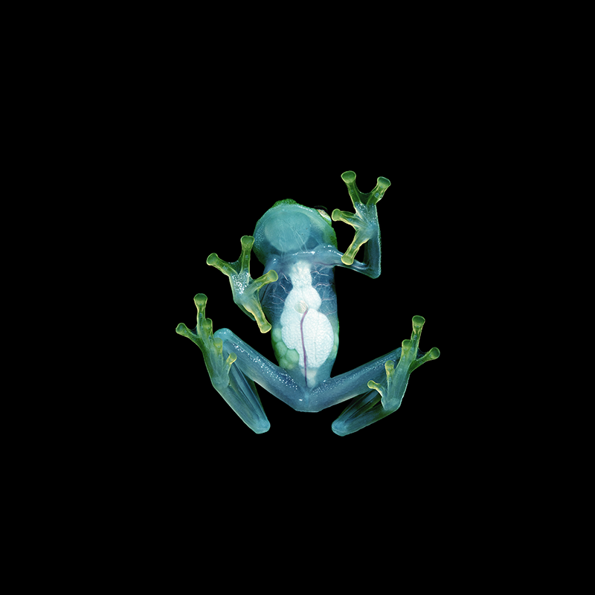

Skrillex and Boys Noize have returned as Dog Blood for their new EP, Turn Off The Lights, out now on OWSLA / Boysnoize Records. Listen HERE! The EP marks their first full project since 2013's Middle Finger Pt. 2 and brings the same high-energy experimentation that earned Dog Blood its cult following since their 2012 debut and acclaimed Coachella 2013 set. The duo has teased new music over the years but this April they confirmed a new EP as well as a string of shows including BUKU Music + Art Project, Sunset Music Festival, a headline set at Ultra Music Festival, and an upcoming performance at Electric Zoo on September 1st. The project was officially unveiled with the title track "Turn Off The Lights" which Complex called "the kind of banger that encompasses their shared love of, well, everything great in electronic music," and also includes three new tracks plus collaborations with OWSLA regulars josh pan & X&G and Otira.

LISTEN TO TURN OFF THE LIGHTS: https://dogblood.lnk.to/EPTOTLPR

TURN OFF THE LIGHTS TRACKLIST:
1. Dog Blood - BREAK LAW
2. Dog Blood - 4 MIND with josh pan & X&G
3. Dog Blood - KOKOE with Otira
4. Dog Blood - TURN OFF THE LIGHTS

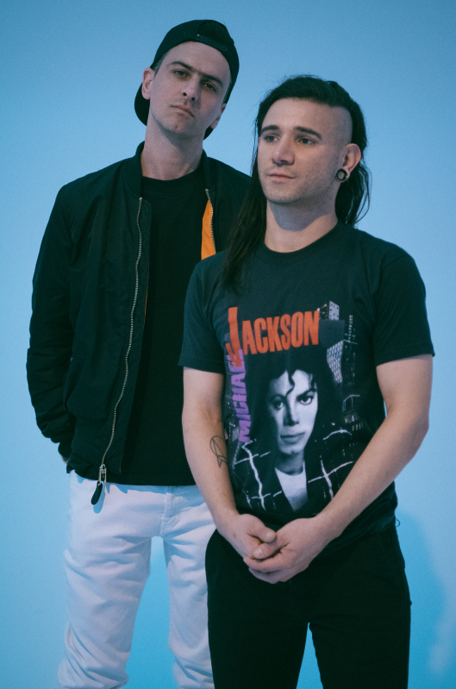
Photo credit: Marilyn Hue, DL Hi-Res
Follow Dog Blood:
Instagram / YouTube / Twitter / Facebook / Website / Spotify / Apple
For press assets: http://press.wearebigbeat.com/artists/dog-blood/

Press contacts:

Jordan Danielle Frazes - Jordan.Frazes@atlanticrecords.com

Brett Buren - brett@biz3.net

