GRAMMY AWARD WINNING UK TRIO
CLEAN BANDIT RELEASES NEW ALBUM TODAY
‘WHAT IS LOVE?’

ALBUM RIAA CERTIFIED GOLD IN THE US UPON RELEASE

FEATURING AN ALL-STAR CAST OF GUEST VOCALISTS INCLUDING
ELLIE GOULDING, MARINA, ANNE-MARIE, RITA ORA, STEFFLON DON, BIG BOI + MORE!
+ ALBUM RELEASE LIVESTREAM EVENT STREAMING ON THE BAND’S OFFICIAL YOUTUBE CHANNEL VIA KYOTO, JAPAN ON SAT 1ST DECEMBER
2.30AM PCT / 5.30AM EST / 10.30AM GMT / 11.30AM CET / 7.30PM JST / 9.30PM AEDT

BUY/STREAM: http://atlanti.cr/WhatIsLove
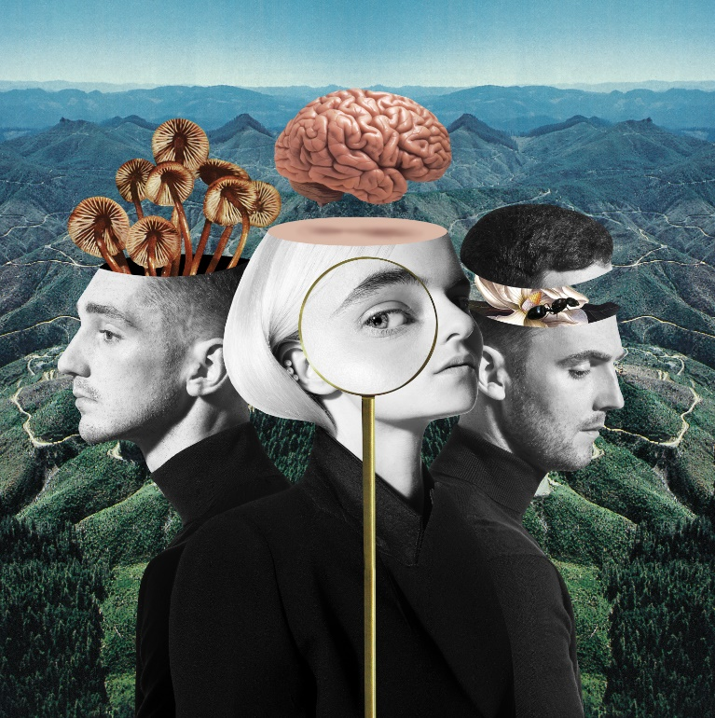

Global hitmakers Clean Bandit release their RIAA certified Gold album ‘What Is Love?’ today via Big Beat Records in the US. Listen HERE! A band that thrives on collaborative endeavours, the GRAMMY award winning British trio commanded another brilliantly extensive list of blockbuster vocalists: Zara Larsson, Marina, Luis Fonsi, Demi Lovato, Sean Paul, Anne-Marie, Ellie Goulding, KYLE, Big Boi, Tove Styrke, Stefflon Don, Craig David, Kirsten Joy, Rita Ora, Julia Michaels and ALMA. The deluxe edition will feature Yasmin Green, Charli XCX, Bhad Bhabie, DaVido, Love Ssega and Louisa Johnson.

To celebrate, Clean Bandit will hold an exclusive live set from Kyoto, Japan on Saturday, December 1st at 5:30am ET/2:30AM PT which fans from across the globe will be able to tune into via the band’s official YouTube channel to watch the global chart-toppers perform album tracks for the first time.

The new LP is underpinned by hit singles “Rockabye” ft. Anne-Marie and Sean Paul, “Symphony” feat. Zara Larsson, “I Miss You” ft. Julia Michaels, and “Solo” feat. Demi Lovato; which was recorded across the globe and has been produced by the trio’s long-standing producer, Mark Ralph (Years & Years), alongside Clean Bandit’s very own, 2 x Ivor Novello-winning, Jack Patterson, and Grace Chatto. ‘What Is Love?’ is the fruit of the past three years’ work and an exciting new chapter for Clean Bandit. The follow-up to the band’s two million-selling and UK Top 3 debut, ‘New Eyes’, released in 2014, ‘What Is Love?’ is a home to Clean Bandit’s inventive, eclectic multi-genre catalogue – a collection of gigantic upbeat megabops married with emotive lyricism.

The band’s cellist, Grace, commented – “The album looks at many different kinds and stages of love. We’ve been making it over three years, during which time we’ve all experiences love in our lives in different ways and, some of us, heartbreak too. Somehow this is all expressed in the music: brotherly love; family love; romantic love; crazy all-consuming love; the pain of love turning into something different or dishonest; and, of course, in ‘Rockabye’, unconditional motherly love. It explores the sacrifices we all go through for love and for each other, even when it is difficult. It’s been such an honour to write and record with all of the amazing singers and musicians involved in the record. We made the songs all over the world, mainly in North London and LA - some lines were even recorded in a bathroom in Uganda! We really hope that everyone will find tracks on this album to identify with and we can’t wait to share it with you.”

Breaking through to the mainstream in 2014 with their mammoth 12 million-selling and GRAMMY-award winning single “Rather Be”, the pioneering 6 x BRIT-nominated trio have paved the way in the global pop scene with their matchless blend of classical, electronica, pop, dancehall and R&B, proving themselves as a force to be reckoned with in the charts across the globe. One of the most successful and in-demand collectives of the century, Clean Bandit have sold over 40 million singles worldwide and accumulated over 10 billion streams and 3.5 billion YouTube views to date! Not to mention their cutting-edge self-directed official music videos that have further propelled the band as an unparalleled creative force. In their native UK, “Solo” feat. Demi Lovato not only marked Clean Bandit’s fourth UK No.1, but their ninth UK Top 5 and seventh consecutive UK Top 5 that saw them land the most consecutive Top 5 records, from any artist, since Girls Aloud in 2005 and the same amount of UK No.1’s as Justin Timberlake, One Direction and Lady Gaga. The trio’s 2016 UK Christmas No.1 “Rockabye” continues to hold the record as the longest-running UK No.1 in 24 years for a UK band, surpassing Wet Wet Wet’s “Love Is All Around”.

Clean Bandit’s forthcoming live set from Kyoto builds on their love affair with Japan, which started with the official video for their global breakout hit “Rather Be” being shot in Tokyo and continues through to the present day after an array of visits and performances in the country.

Clean Bandit is: Jack Patterson, Grace Chatto and Luke Patterson.

‘What Is Love?’ tracklisting
- Symphony (feat. Zara Larsson)
- Baby (feat. Marina & Luis Fonsi)
- Solo (feat. Demi Lovato)
- Rockabye (feat. Sean Paul & Anne-Marie)
- Mama (feat. Ellie Goulding)
- Should’ve Known Better (feat. Anne-Marie)
- Out at Night (feat. KYLE & Big Boi)
- Last Goodbye (feat. Tove Styrke & Stefflon Don)
- We Were Just Kids (feat. Craig David & Kirsten Joy)
- Nowhere (feat. Rita Ora & KYLE)
- I Miss You (feat. Julia Michaels)
- In Us I Believe (feat. ALMA)
Deluxe
- 24 Hours (feat. Yasmin Green)
- Playboy Style (feat. Charli XCX & Bhad Bhabie)
- Beautiful (feat. DaVido & Love Ssega)
- Tears (feat. Louisa Johnson)

Connect with Clean Bandit:
Twitter | Facebook | Instagram | YouTube
For more information, visit: http://cleanbandit.co.uk/
For press assets, visit: http://press.wearebigbeat.com/artists/cleanbandit/

Press Contact:
Jordan Danielle Frazes
Head of Publicity, Big Beat Records
Jordan.Frazes@atlanticrecords.com

