GRAMMY AWARD-WINNING CLEAN BANDIT UNVEIL THEIR NEW SINGLE “SOLO” FEAT. DEMI LOVATO!

35 MILLION SINGLES SOLD WORLDWIDE
3 BILLION STREAMS + 3.5 BILLION YOUTUBE VIEWS

“ROCKABYE” IS NOMINATED FOR ‘DANCE/ELECTRONIC SONG’
AT THE BILLBOARD MUSIC AWARDS AIRING THIS WEEKEND

WATCH/POST: https://www.youtube.com/watch?v=s_5-eID-U-g
BUY/STREAM: https://atlanti.cr/solo

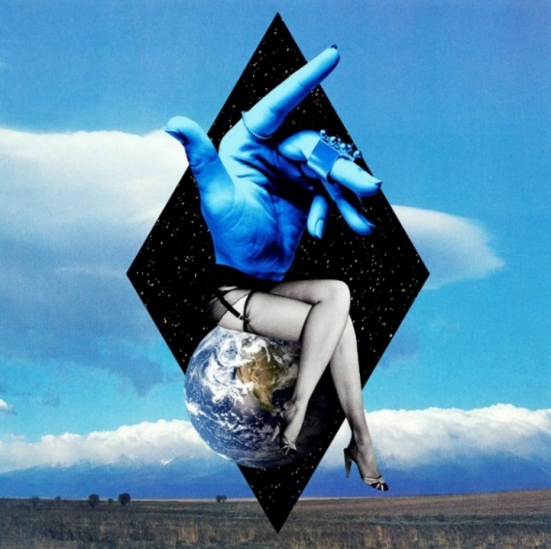

British hit-making trio Clean Bandit are delighted to unveil their new single “Solo” feat. Demi Lovato out today via Big Beat/Atlantic Records – LISTEN HERE!

“Solo” marks an assured return for Clean Bandit and is the follow-up to their platinum-certified, tear-jerking October 2017 smash “I Miss You”. Destined for further chart glory with the beat-driven, Latino-inspired “Solo”, the band have teamed-up with the award-winning and No.1 recording artist, Demi Lovato, for vocal duties, which has all the makings of a sure-fire summer hit. Written by the band’s very own Jack Patterson and Grace Chatto alongside Fred Gibson (Charli XCX, MØ) and Camille Purcell (Stormzy, Dua Lipa), the track follows an empowering narrative of self-love and appreciation. Mixing comes from the band’s long-time collaborator Mark Ralph (Years & Years).

Grace Chatto says, “Breaking apart from someone you love very much can be unbearably painful, but finding yourself again can be a beautiful thing if you do your solitude right. Self-care is like an art in itself and we tried to look at this in a fun way. The first time we met Demi was over FaceTime, believe it or not! She was recording in Alabama and we were recording in London and we recorded the song like this - over the ocean! When we finally met in person to shoot the music video, it was beautiful. She was so lovely and it was a joy to film her.”

Since breaking through to the mainstream in 2014 with their mammoth, 11 million-selling single “Rather Be” and two million-selling debut album ‘New Eyes’, the pioneering, GRAMMY-winning and 6 x BRIT-nominated trio have paved the way in the global pop scene with their multi-genre catalogue. Becoming one of the most successful singles collectives of the century with their matchless blend of classical, electronica, pop, dancehall and R&B, that only Grace Chatto, Jack Patterson and Luke Patterson could unite so compellingly, Clean Bandit have sold over 35 million singles, worldwide, and have accumulated over 3 billion streams and 3.5 billion YouTube views to date! Not to mention their cutting-edge self-directed official music videos, which have further propelled the band as an unparalleled creative force. To date, Clean Bandit have commanded a wealth of guest vocalists on their chart hits including Anne-Marie, Zara Larsson, Jess Glynne and Julia Michaels (to name a few). The band’s 2016 UK Christmas No.1 “Rockabye” featuring Anne-Marie and Sean Paul has received 65 x Platinum certifications across the globe since its release and even went onto become the UK’s longest-running UK No.1 in 22 years, surpassing Wet Wet Wet’s “Love Is All Around” – the track has since been nominated for a Billboard Music Award in the ‘Dance/Electronic Song’ category. Clean Bandit are currently working on their second studio album.

Demi Lovato is a GRAMMY-nominated and multi-platinum-selling singer, songwriter, actress, advocate, philanthropist, New York Times best-selling author and business women. In July 2017, she released the triple platinum-selling single “Sorry Not Sorry” - the first single off her sixth studio album and platinum-certified “Tell Me You Love Me”, which debuted at No.1 on iTunes in 37 countries. In 2015, she released her highly-anticipated fifth studio album, ‘Confident’, with the LP’s first single "Cool for the Summer" hitting the No.1 position on iTunes in 37 countries. Her previous album, 2013's ‘Demi’ hit No. 1 on iTunes in over 50 countries around the world with the lead single "Heart Attack" earning Platinum status just ten weeks after its release. "Heart Attack" was followed by the U.S. Top 5 radio smash "Neon Lights," and her U.S. Top 10 single "Really Don't Care”. In addition to her critically hailed album releases, Demi released a 78-minute documentary film, “Simply Complicated” which has amassed over 15 million views to date. She has been committed to raising awareness around LGBTQ issues and causes, and continues to be a global advocate for mental health.

Photo credit: Rita Zimmermann

Connect with Clean Bandit:
Twitter | Facebook | Instagram | YouTube
For more information, visit: http://cleanbandit.co.uk/
For press assets, visit: http://press.wearebigbeat.com/artists/cleanbandit/

Press Contact:
Jordan Danielle Frazes
Head of Publicity, Big Beat Records
Jordan.Frazes@atlanticrecords.com

