**CLEAN BANDIT UNVEILS NEW SELF-DIRECTED OFFICIAL MUSIC VIDEO FOR “*SOLO*” FEAT. DEMI LOVATO!**

**“SOLO” IS THE UK HIT-MAKING TRIO’S BIGGEST GLOBAL SINGLE LAUNCH TO DATE**

**WATCH/SHARE:** <https://atlanti.cr/solo-video>

**BUY/STREAM:** <https://atlanti.cr/solo>

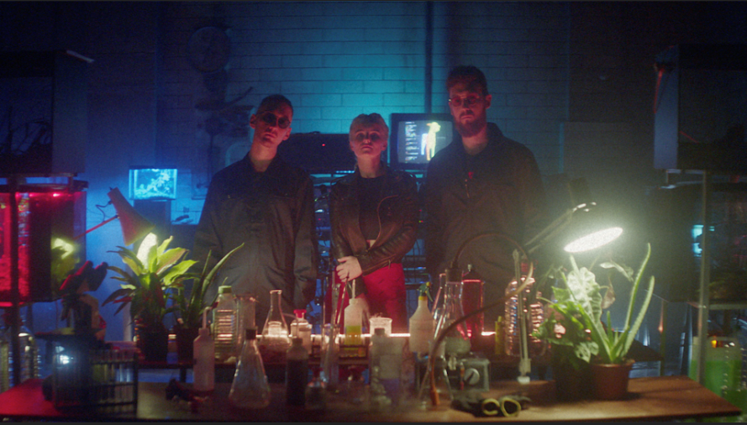

Chart-topping, **GRAMMY** award-winning, UK trio **Clean Bandit** unveil a brand new self-directed official music video for their single **“Solo” ft. Demi Lovato** released earlier this month, accumulating over **20 million** streams during its first week. Following the song’s empowering narrative of finding yourself after a break-up, the video which stars both Clean Bandit and Demi Lovato serves as another reminder of the band’s unparalleled, innovative visual output -- WATCH [HERE](https://atlanti.cr/solo-video)!

Grace Chatto of Clean Bandit says*, “Making little films is our passion, just as important to us as music (or more!). We made this one in LA, which was super cool! It was the first time we met Demi Lovato properly since we recorded the song, and filming her was really special. Can’t wait for you to see it!”*

###



*Photo credit: Rita Zimmermann*

Since breaking through to the mainstream in 2014 with their mammoth, 11 million-selling single **“Rather Be”** and two million-selling debut album **‘New Eyes’**, the pioneering, **GRAMMY**-winning and 6 x **BRIT**-nominated trio have paved the way in the global pop scene with their multi-genre catalogue. Becoming one of the most successful singles collectives of the century with their matchless blend of classical, electronica, pop, dancehall and R&B, that only **Grace Chatto, Jack Patterson** and **Luke Patterson** could unite so compellingly, **Clean Bandit** have sold over **35 million** singles, worldwide, and have accumulated **over 3 billion** streams and **3.5 billion** YouTube views to date! Not to mention their cutting-edge self-directed official music videos, which have further propelled the band as an unparalleled creative force. To date, **Clean Bandit** have commanded a wealth of guest vocalists on their chart hits including **Anne-Marie, Zara Larsson, Jess Glynne** and **Julia Michaels** (to name a few). The band’s 2016 UK Christmas No.1 **“Rockabye”** **featuring Anne-Marie** and **Sean Paul** has received **65 x Platinum** certifications across the globe since its release and even went onto become the UK’s longest-running UK No.1 in **22 years**, surpassing **Wet Wet Wet**’s “Love Is All Around” – the track has since been nominated for a **Billboard Music Award** in the ‘Dance/Electronic Song’ category. Clean Bandit is currently working on their second studio album.

**Connect with Clean Bandit:**

[Twitter](https://twitter.com/cleanbandit) | [Facebook](https://www.facebook.com/cleanbandit/) | [Instagram](https://www.instagram.com/cleanbandit/?hl=en) | [YouTube](https://www.youtube.com/channel/UCvhQPdeTHzIRneScV8MIocg)

For more information, visit: <http://cleanbandit.co.uk/>

For press assets, visit: <http://press.wearebigbeat.com/artists/cleanbandit/>

**Press Contact:**

Jordan Danielle Frazes

Head of Publicity, Big Beat Records

[Jordan.Frazes@atlanticrecords.com](mailto:Jordan.Frazes@atlanticrecords.com)