GRAMMY-AWARD WINNING UK ELECTRONIC TRIO
CLEAN BANDIT UNVEIL THEIR OFFICIAL VIDEO FOR ALBUM TRACK “MAMA” FEAT. ELLIE GOULDING
UK TOP 10 ALBUM ‘WHAT IS LOVE?’ OUT NOW

LISTEN/SHARE: https://youtu.be/Ao3XJ-UDdzI
BUY/STREAM: https://atlanti.cr/Mama
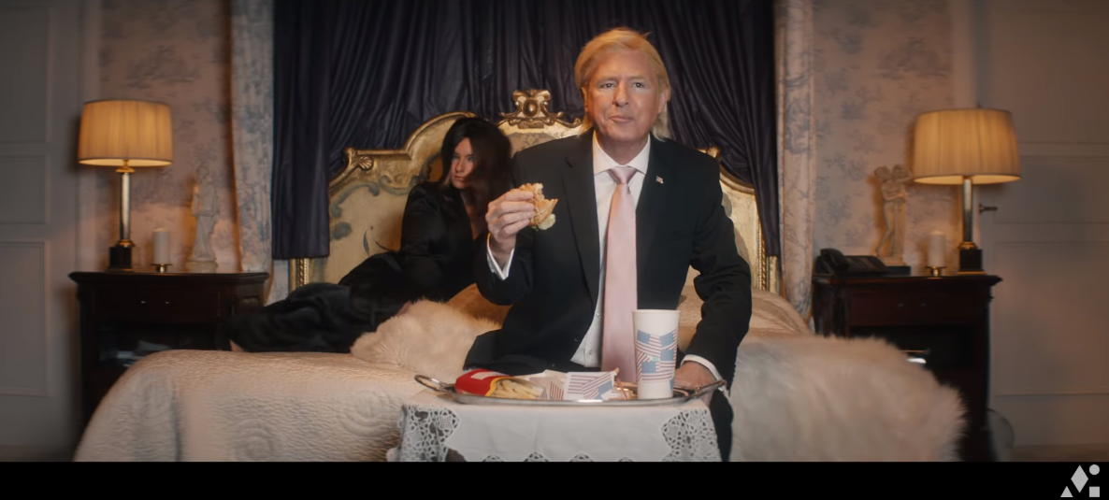

Global hitmakers Clean Bandit have unveiled their official video for “Mama” featuring Ellie Goulding, taken from their RIAA certified Gold second studio album, ‘What Is Love?’ out via Big Beat Records in the US. The 8 x BRIT nominated global chart-toppers have returned with another self-produced visual, which includes a cameo from British actor, Neil Morrissey! WATCH HERE!

Grace Chatto says – “We wrote this script about a boy whose power was taken away from him as a child and he grew up determined to take that power back. We directed it ourselves and we found it to be a really interesting experience.”

The track is taken from the band’s second studio album, ‘What Is Love?’. Featuring a cast of vocalists including Rita Ora, Demi Lovato, Anne-Marie and Stefflon Don. The LP, which was released last November, charted in the UK Top 10 and has now surpassed 3.2 million sales worldwide. The band’s swarm of hit singles - “Rockabye” feat. Anne-Marie and Sean Paul, “Symphony” feat. Zara Larsson, “I Miss You” feat. Julia Michaels, “Tears” feat. Louisa Johnson, “Solo” feat. Demi Lovato and “Baby” feat. Marina and Luis Fonsi – are all housed on the album.

Connect with Clean Bandit:
Twitter | Facebook | Instagram | YouTube
For more information, visit: http://cleanbandit.co.uk/
For press assets, visit: http://press.wearebigbeat.com/artists/cleanbandit/

Press Contact:
Jordan Danielle Frazes
Head of Publicity, Big Beat Records
Jordan.Frazes@atlanticrecords.com

