CLEAN BANDIT UNVEIL NEW SINGLE
“I MISS YOU” FT. JULIA MICHAELS

+ ANNOUNCE NORTH AMERICAN I MISS YOU SPRING 2018 TOUR

WATCH/POST “I MISS YOU”: HERE
BUY/STREAM “I MISS YOU”: HERE
BUY TICKETS TO I MISS YOU SPRING 2018 TOUR: HERE

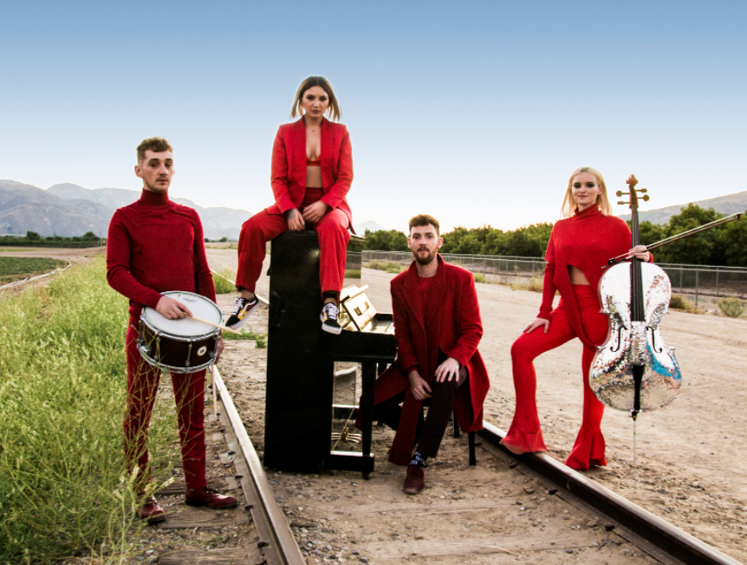

"['I Miss You'] comes packed with the bright symphonic elements synonymous with any Clean Bandit project, living up to the hype of an act still hot off their latest hits ‘Symphony,’ featuring Zara Larsson and ‘Rockabye’ with Sean Paul and Anne-Marie." -- Billboard

Chart-topping, GRAMMY award-winning, UK trio Clean Bandit, unveil a brilliant new single “I Miss You” feat. Julia Michaels alongside the band’s self-directed video – WATCH HERE - in celebration of their recently announced North American I Miss You Spring 2018 tour (full itinerary enclosed below).

“I Miss You” sees Clean Bandit return with a sentimental, tear-jerking smash and one of the band’s most inspired songs to date. Sonically, the band take it back a notch while retaining their matchless, experimental sound – something which has seen the trio become one of the most successful and biggest-selling singles acts of the century.

Produced by Jack Patterson and Grace Chatto alongside the band’s resident producer, Mark Ralph, vocal duties stem from the inimitable talent that is Julia Michaels. Over the last few years Michaels has made a name for herself as one of the most in demand songwriters, penning massive hits like Justin Bieber's "Sorry." This year she made her debut as a solo artist with the release of her multi-platinum selling debut single “Issues."

After meeting in Los Angeles this summer, the two parties joined forces for a writing session shortly after, leading to the birth of “I Miss You.” Inspired by Julia Michaels’ personal heartbreak, the new track is certain to resonate with fans across the globe for months to come. The accompanying official video – directed by the band themselves and shot across Los Angeles and the UK – weaves together striking landscape shots and powerful performance scenes, with Clean Bandit [formed of brothers Luke and Jack Patterson and Grace Chatto] providing yet another masterclass in world-class visuals.

Of the track, Chatto explains: "It's a simple song, about the unbelievable pain of breaking up with someone you love. It was an honor to work with Julia Michaels; "Issues" is my favorite song so far this year. She's super talented and really nice too. Making the video in the desert outside of Los Angeles was very special -- we got to know each other better in the blazing heat. We experimented with special effects and train tracks."

Clean Bandit’s new single follows an undeniable year for the UK collective. The trio – who have consistently pushed the boundaries of modern pop with their diverse blend of electronic, dancehall, classical, R&B and pop – released their 10 million-selling single “Rockabye” last year. Shooting to #1 in over 40 countries, the track became the longest-running #1 in the United Kingdom in 22 years. Clean Bandit followed the success of “Rockabye” with “Symphony” feat. Zara Larsson, which shot to #1 in 20 countries. The band’s 2014 breakthrough single “Rather Be” ft. Jess Glynne (spawned from their debut album New Eyes) has now surpassed 10 million global sales.

This spring, Clean Bandit will embark on their North American headline tour – kicking off at Vancouver’s Commodore Ballroom on March 26th and wrapping at The Beacham in Orlando, Florida on April 28th. The tour will be powered by NYLON as well as The Ally Coalition – a group of individuals throughout the music, fashion, and entertainment communities seeking to end discrimination against LGBTQ people. Volunteers from TAC will be present at Clean Bandit’s concerts throughout North America to help get fans involved in the fight against discrimination.

Clean Bandit Spring 2018 North American Headline Tour:
Tickets: http://cleanbandit.co.uk/natour/
Mar 26 - Vancouver, BC - The Commodore Ballroom
Mar 27 - Seattle, WA - Showbox Market
Mar 28 - Portland, OR - Crystal Ballroom
Mar 30 - Berkley, CA - UC Theatre
Mar 31 - Santa Ana, CA - The Observatory
Apr 2 - Los Angeles, CA - The NoVo
Apr 3 - Phoenix, AZ - Marquee
Apr 5 - Dallas, TX - Granada Theatre
Apr 6 - Austin, TX - Scout Inn
Apr 7 - Houston, TX - White Oak Music Hall
Apr 9 - St. Louis, MO - Ready Room
Apr 10 - Indianapolis, IN - Deluxe
Apr 11 - Chicago, IL - The Vic
Apr 13 - Pittsburgh, PA - Mr. Smalls
Apr 14 - New Haven, CT - College Street
Apr 17 - Brooklyn, NY - Brooklyn Steel
Apr 19 - Washington, DC - 9:30 Club
Apr 20 - Philadelphia, PA - Trocadero
Apr 21 - Norfolk, VA - The NorVa
Apr 23 - Charlotte, NC - The Fillmore
Apr 24 - Atlanta, GA - The Loft
Apr 26 - Tampa, FL - State Theatre
Apr 27 - Miami, FL - Revolution
Apr 28 - Orlando, FL - The Beacham

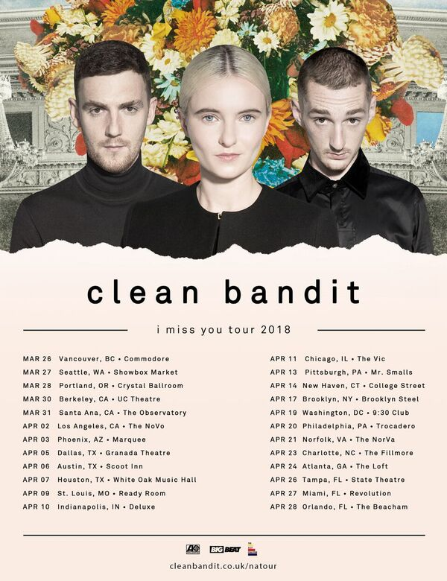

About The Ally Coalition:
The Ally Coalition works with members of the music, fashion and entertainment worlds to raise awareness and funds in support of LGBTQ equality. TAC believes that it is the responsibility of allies to support LGBTQ causes and fight against discrimination through education, awareness and advocacy. Visit http://theallycoalition.org/ to learn more.

Connect with Clean Bandit:
Twitter | Facebook | Instagram | YouTube
For tour information, visit: http://cleanbandit.co.uk/natour/
For press assets, visit: http://press.wearebigbeat.com/artists/cleanbandit/

Press Contacts:
Jordan Danielle Frazes (Clean Bandit): Jordan.Frazes@atlanticrecords.com
Amy Laudicano (Clean Bandit tour press): Amy.Laudicano@atlanticrecords.com

