**MULTI-PLATINUM ARTIST/SINGER DRAM ADDS NEW VERSE ON CLEAN BANDIT’S SMASH SINGLE “I MISS YOU” FT. JULIA MICHAELS!**

**+ CLEAN BANDIT RELAUNCH NORTH AMERICAN *I MISS YOU* SPRING 2018 TOUR**

**WATCH/POST “I MISS YOU” DRAM REMIX:** [**https://www.youtube.com/watch?v=uplXF-3B6Ro**](https://www.youtube.com/watch?v=uplXF-3B6Ro)

**BUY/STREAM “I MISS YOU” DRAM REMIX:** [**https://BigBeat.lnk.to/IMYDPR**](https://BigBeat.lnk.to/IMYDPR)

**BUY TICKETS TO *I MISS YOU* SPRING 2018 TOUR:** [**HERE**](http://cleanbandit.co.uk/natour/)

*“DRAM joins in the mournful vibe on the new remix. He calls out to a significant other… over the electronic group's smooth synths.”* ***–*** [***The FADER***](http://www.thefader.com/2018/01/24/clean-bandit-julia-michaels-dram-miss-you)

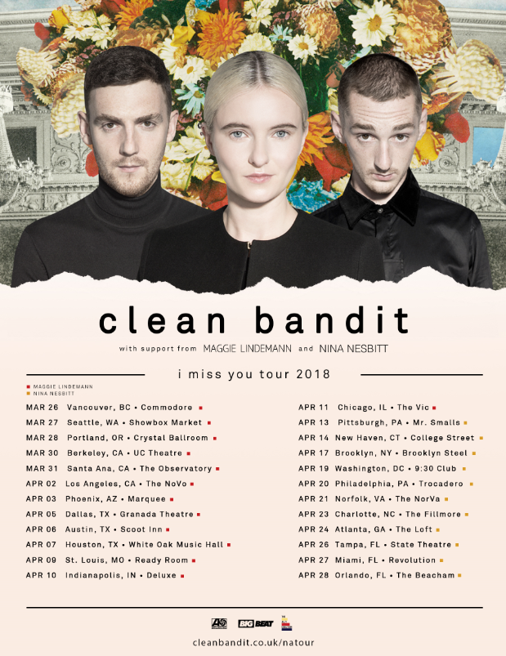

Chart-topping, **GRAMMY** award-winning, UK trio **Clean Bandit** enlists 3x GRAMMY nominated artist, singer and producer **DRAM** for a new remix of their smash single **“I Miss You”**ft. 2x GRAMMY nominee **Julia Michaels** arriving today on Big Beat Records – [LISTEN & POST THIS LINK](https://www.youtube.com/watch?v=uplXF-3B6Ro) – in celebration of the relaunch of the trio’s North American “I Miss You” Spring 2018 tour (*full itinerary enclosed below*).

[“I](https://atlanti.cr/imissyou-video) Miss You” sees **Clean Bandit** [formed of brothers **Luke** and **Jack Patterson** and **Grace Chatto**] return with a sentimental, tear-jerking smash; one of the band’s most inspired songs to date. Produced by **Jack Patterson** and **Grace Chatto** alongside the band’s resident producer, **Mark Ralph**, vocal duties stem from the inimitable talent that is **Julia Michaels**.

The remix comes fresh off the heels of Clean Bandit’s two **BRIT Award** nominations for “British Single” and “British Artist Video” for their hit “Symphony” ft. **Zara Larsson**. The group took the stage at the nomination event, for a stunning performance of “I Miss You” and “Symphony” (watch [here](https://www.youtube.com/watch?v=NIOdcO-2L_g)).

This spring, **Clean Bandit** will embark on their **North American headline** tour – kicking off at Vancouver’s **Commodore Ballroom** on March 26th and wrapping at The Beacham in Orlando, Florida on April 28th. The tour will be powered by **NYLON** as well as **The Ally Coalition** – a group of individuals throughout the music, fashion, and entertainment communities seeking to end discrimination against LGBTQ people. Volunteers from TAC will be present at Clean Bandit’s concerts throughout North America to help get fans involved in the fight against discrimination.

**Clean Bandit** have consistently pushed the boundaries of modern pop with their diverse blend of electronic, dancehall, classical, R&B and pop – released their 10 million-selling single “Rockabye” last year. Shooting to #1 in over 40 countries, the track became the longest-running #1 in the United Kingdom in 22 years. Clean Bandit followed the success of “Rockabye” with “Symphony” feat. **Zara Larsson**, which shot to #1 in 20 countries. The band’s 2014 breakthrough single “Rather Be” ft. **Jess Glynne** (spawned from their debut album *New Eyes*) has now surpassed 10 million global sales.

**Clean Bandit Spring 2018 North American Headline Tour:**

Tickets: <http://cleanbandit.co.uk/natour/>

Flyer: <http://press.wearebigbeat.com/wp-content/uploads/2018/01/CLEANBANDIT_US2018_1.jpg>

Mar 26 - Vancouver, BC - The Commodore Ballroom

Mar 27 - Seattle, WA - Showbox Market

Mar 28 - Portland, OR - Crystal Ballroom

Mar 30 - Berkley, CA - UC Theatre

Mar 31 - Santa Ana, CA - The Observatory

Apr 2 - Los Angeles, CA - The Novo

Apr 3 - Phoenix, AZ - Marquee

Apr 5 - Dallas, TX - Granada Theatre

Apr 6 - Austin, TX - Scout Inn

Apr 7 - Houston, TX - White Oak Music Hall

Apr 9 - St. Louis, MO - Ready Room

Apr 10 - Indianapolis, IN - Deluxe

Apr 11 - Chicago, IL - The Vic

Apr 13 - Pittsburgh, PA - Mr. Smalls

Apr 14 - New Haven, CT - College Street Music Hall

Apr 17 - Brooklyn, NY - Brooklyn Steel

Apr 19 - Washington, DC - 9:30 Club

Apr 20 - Philadelphia, PA – Trocadero Theatre

Apr 21 - Norfolk, VA - The NorVa

Apr 23 - Charlotte, NC - The Fillmore

Apr 24 - Atlanta, GA - The Loft

Apr 26 - Tampa, FL - State Theatre

Apr 27 - Miami, FL - Revolution

Apr 28 - Orlando, FL - The Beacham

**About The Ally Coalition:**

The Ally Coalition works with members of the music, fashion and entertainment worlds to raise awareness and funds in support of LGBTQ equality.  TAC believes that it is the responsibility of allies to support LGBTQ causes and fight against discrimination through education, awareness and advocacy. Visit <http://theallycoalition.org/> to learn more.

**Connect with Clean Bandit:**

[Twitter](https://twitter.com/cleanbandit) | [Facebook](https://www.facebook.com/cleanbandit/) | [Instagram](https://www.instagram.com/cleanbandit/?hl=en) | [YouTube](https://www.youtube.com/channel/UCvhQPdeTHzIRneScV8MIocg)

For tour information, visit: <http://cleanbandit.co.uk/natour/>

For press assets, visit: <http://press.wearebigbeat.com/artists/cleanbandit/>

[](http://press.wearebigbeat.com/wp-content/uploads/2017/10/Clean-Bandit-and-Julia-Michaels-2.jpg)

**Press Contacts:**

Jordan Danielle Frazes (Clean Bandit): [Jordan.Frazes@atlanticrecords.com](mailto:Jordan.Frazes@atlanticrecords.com)

Amy Laudicano (Clean Bandit tour press): [Amy.Laudicano@atlanticrecords.com](mailto:Amy.Laudicano@atlanticrecords.com)

Marisa Bianco (Julia Michaels): [Marisa.Bianco@umusic.com](mailto:Marisa.Bianco@umusic.com)

Jason Davis (DRAM): [Jason.Davis@atlanticrecords.com](mailto:Jason.Davis@atlanticrecords.com)