STEPPING OUT FROM BEHIND THE CURTAIN, CASPER COLE RELEASES DEBUT TRACK ‘I WANT IT ALL’ FEATURING ELDERBROOK
OUT TODAY ON FFRR/BIG BEAT RECORDS
LISTEN HERE: https://BigBeat.lnk.to/IWIAEPR
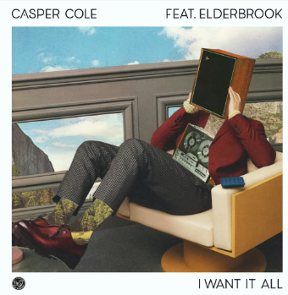
DL art here
After a few years of behind the scenes studio collaborations, Casper Cole steps out for his debut release ‘I Want It All’ featuring Elderbrook on FFRR/Big Beat Records. Listen HERE!
Singer/songwriter, multi-instrumentalist, and producer Elderbrook – Grammy-nominated for the smash 2017 hit “Cola” with CamelPhat – lends his vocals to the track. With his most recent single “Something About You” (w/ Rudimental) reaching #1 at US Dance Radio and C-Listed at BBC Radio 1, the much in-demand Elderbrook now turns his vocal talents towards the hotly tipped new name Casper Cole, his melancholic vocals oscillating over Casper Cole's infectious bassline.
‘I Want It All’ demonstrates Casper’s ability to construct an array of electronic textures from a thumping kick drum on top of an angelic melodic bassline and a layer of dreamy vocals, a product of his own orchestral meets progressive house sound.
As an artist, there is little known about Casper Cole - however his exquisite sound speaks for itself. With a backing from Elderbrook as well as the support of FFRR and Big Beat Records, ‘I Want It All’ is sure to light up dancefloors everywhere and Casper Cole sure to become a name to remember as he sets off on his artist journey.
Press site: http://press.wearebigbeat.com/singles/casper-cole/
“I Want It All” feat. Elderbrook Press contact (Gabby Reese) gabrielle.reese@atlanticrecords.com
Elderbrook press contact (Libby Kober) libby.kober@atlanticrecords.com

