**CASH CASH DROP *NSFW* NEW MUSIC VIDEO FOR SINGLE “SURRENDER”!**

Watch / Post: <http://youtu.be/7Vi578l61V4>

***Surrender (w/ r*emixes) out now via Big Beat Records:**

<http://smarturl.it/surrenderremixes>

& <http://smarturl.it/Spotify_Surrender>

“*[Surrender] is a well-oiled rendition of what high-energy chart toppers of yesteryear have been trying to achieve. (Think infectious rather than catchy.) Even better, the video itself is 3 minutes and 30 seconds of vibrant NSFW imagery, starting when the band pulls up to a sunlit mansion housing a group of nearly-naked twenty-somethings with the most sensual hangovers of all time.*”—[**NYLON**](http://www.nylon.com/articles/video-premiere-cash-cash-surrender)

*“The mansion is filled with beautiful, scantily clad squatters doing what all beautiful, scantily clad squatters in woodsy mansions probably do.”—***BUZZFEED**

*“Surrender” bodes well for the collection: original, infectious, vibrant.” —***Entertainment Weekly**

*“The track is one that catches the ear immediately… light, bubbly, interesting and just screams "radio hit" right off the bat.”—***Earmilk**

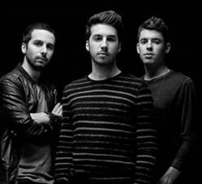

**Big Beat Records**’ break-out trio **Cash Cash** is kicking the New Year off in style, sharing their incredibly sexy (and *slightly* NSFW!) video for their recent hit “**Surrender**” ([iTunes](http://smarturl.it/CC_Surrender%20)). Directed by Roy Raz, the seductive video was beautifully shot, and features several chic youths taking over a pristine mansion, surrendering their mind, body and souls in all manners… stick & poke tattoos, spin the bottle, and much, *much* more come into play with reckless abandon. Watch the debauchery unfold for yourself: ([LINK](http://youtu.be/CsXH_gHn9uE))!

There’s also an **interactive** version created in collaboration with **Interlude** (the new standard in interactive video creation and distribution) on [HERE](http://www.buzzfeed.com/reggieugwu/premiere-cash-cash-surrender#.amldzzo91a), where you can surrender *yourself*within the revelry via their revolutionary video authoring technology, allowing **Cash Cash**fans to switch seamlessly through alternative paths through the mansion.

“**Surrender**” is currently sitting at **#1** on **Dance Radio**, and hits Top 40 radio this week.In addition to its early radio success, “Surrender” is also nearing **6 million** plays on **Spotify**, and has eclipsed **3 million** combined plays on **YouTube** and over **2.5 million** combined plays on **SoundCloud**.

Cash Cash released the Remix EP for “Surrender” late last year, which features remixes, including an infectious remix from **Tritonal**, along with reworks from **Pierce Fulton**, **Dzeko & Torres**, **Stadiumx** and more. You can share it through [soundcloud](https://soundcloud.com/cashcash/sets/surrender-remixes), or buy it through [Beatport](http://smarturl.it/BSurrender_Remixes).

**UPCOMING CASH CASH TOUR DATES:**

2/6 – Danbury, CT @ Tuxedo Junction2/12 – Trinidad @ O2 Park  
2/15 – Edmonton, AB @ Shaw Conference Center  
2/28 – Atlantic City, NJ @ Mixx  
3/6 – Vail, CO @ Decimo3/9 – Las Vegas, NV @ Marquee  
3/10 – Panama City Beach, FL @ Club La Vela  
3/13 – Atlanta, GA @ Opera  
3/14 – Orlando, FL @ Venue 578  
3/15 – Paradise Island, Bahamas @ Aura Nightclub  
3/16 – Cancun, Mexico @ Palazzo  
3/19 – Santa Ana, CA @ Sutra  
3/21 – Las Vegas, NV @ Marquee Dayclub  
3/21 – San Diego, CA @ Bassmnt

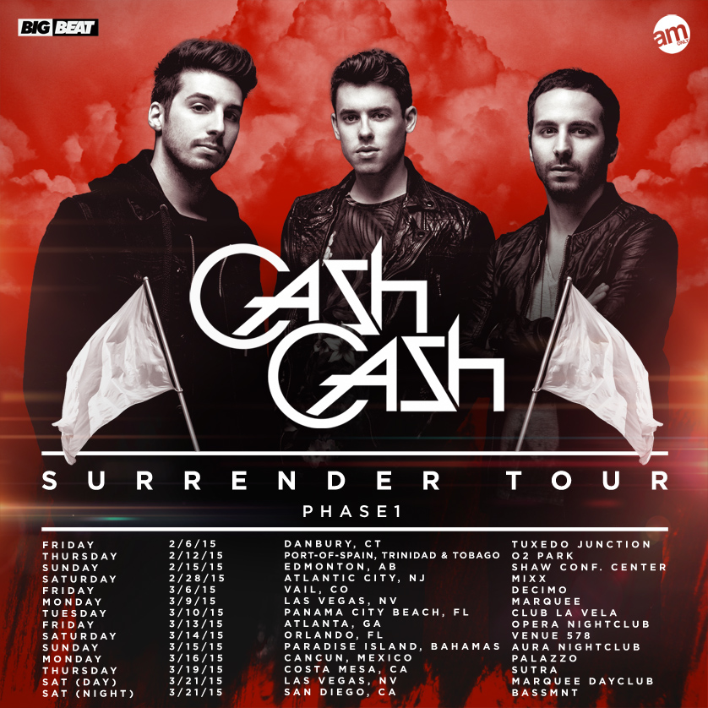

Connect:

<http://cashcashmusic.com>

<https://twitter.com/cashcash>

<https://soundcloud.com/cashcash>

<https://www.facebook.com/cashcash>

Press tools:

<http://press.wearebigbeat.com/artists/cashcash/>

Contact:

National publicist: [Jordan.Frazes@atlanticrecords.com](mailto:Jordan.Frazes@atlanticrecords.com)

Tour publicist: [Jill.Segal@atlanticrecords.com](mailto:Jill.Segal@atlanticrecords.com)

cid:image003.jpg@01D008DE.9AA9DE10