**Cash Cash Release “Surrender Remixes” via Big Beat Records, w/ mixes from Pierce Fulton, Dzeko & Torres, Stadiumx & more!**

**Purchase: “Surrender Remixes” Exclusively via** [**Beatport**](http://smarturl.it/BSurrender_Remixes)

**Post:** [**https://soundcloud.com/cashcash/sets/surrender-remixes**](https://soundcloud.com/cashcash/sets/surrender-remixes)

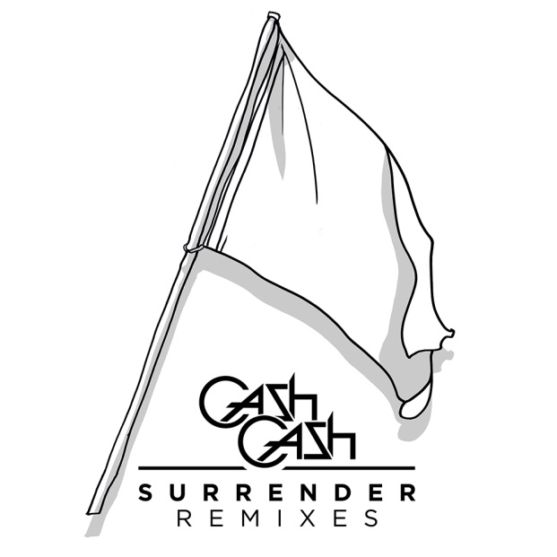

[Cash Cash](http://press.wearebigbeat.com/artists/cashcash/) released a new remix bundle for their hit single “Surrender,” which is out now on **Big Beat Records** exclusively via [Beatport](http://smarturl.it/BSurrender_Remixes) and will be available on all other digital retailers on December 9th featuring official remixes from Pierce Fulton, Dzeko & Torres, Stadiumx, Laibert and David Solano.

The EP kicks off with **Pierce Fulton**’s big room remix, and is followed by **Dzeko & Torres**’ fiery high-octane remix and **Stadiumx**’s more ethereal take on the smash hit. Rounding out the EP is **Laibert**’s funky garage-inspired take, and **David Solano**’s remix that steadily builds up with a drop that explodes, which is destined for dancefloors worldwide.

The internationally-acclaimed production trio have had quite a year, bringing their infectious live DJ sets to festival stages and clubs across the globe. Cash Cash released their first **RIAA-certified GOLD** hit single “**Take Me Home feat. Bebe Rexha**” from the *Overtime* EP (Big Beat Records) along with another smash-hit “**Lightning**” featuring Goo Goo Dolls frontman **John Rzeznik**.

Lauded by **Nicky Romero**, **Tiestö**, **Hardwell** and **Zedd** this year, Cash Cash made waves for their production work and co-writing on **Krewella**’s monstrous single “**Live For The Night**.” Additionally, the unstoppable trio churned out official remixes for **Katy Perry** (“Birthday”), **Icona Pop** (“All Night”), **Bruno Mars** (“Treasure”) and more, many of which topped Hype Machine’s popular chart.

Cash Cash is currently in the midst of wrapping up a world tour, with dates lined up in Australia, the Philippines, Atlantic City and Montreal before the end of the year. The dynamic trio is also currently working on their debut full-length, so keep an eye out for BIG things from Cash Cash in 2015!

**UPCOMING CASH CASH TOUR DATES:**

11/29 – Perth, Australia @ Stereosonic

11/30 – Sydney, Australia @ Stereosonic

12/3 – Manila, Philippines @ Raven

12/6 – Melbourne, Australia @ Stereosonic

12/6 – Adelaide, Australia @ Stereosonic

12/7 – Brisbane, Australia @ Stereosonic

12/27 – Atlantic City, NJ @ Mixx

12/28 – Montreal, QC @ New City Gas

1/ 9 – Las Vegas, NV @ Marquee

1/10 – Honolulu, HI @ The Republic

Connect:

<http://cashcashmusic.com>

https://twitter.com/cashcash

https://soundcloud.com/cashcash

<https://www.facebook.com/cashcash>

Press tools:

<http://press.wearebigbeat.com/artists/cashcash/>

Contact:

National publicist: [Jordan.Frazes@atlanticrecords.com](mailto:Jordan.Frazes@atlanticrecords.com)

Tour publicist: [Jill.Segal@atlanticrecords.com](mailto:Jill.Segal@atlanticrecords.com)

cid:image003.jpg@01CFE31C.D2686480