**CASH CASH DROP HIGHLY ANTICIPATED 18 TRACK ALBUM**

**“SAY IT LIKE YOU FEEL IT”**

FEATURING COLLABORATIONS WITH **DASHBOARD CONFESSIONAL**, **WIZ KHALIFA**, **CONOR MAYNARD**, **PHOEBE RYAN**, **WRABEL**, AND MORE]

**LISTEN HERE:** [https://CashCash.lnk.to/SayItLikeYouFeelItPR](https://nam04.safelinks.protection.outlook.com/?url=https%3A%2F%2Fcashcash.lnk.to%2FSayItLikeYouFeelItPR&data=04%7C01%7CGabrielle.Reese%40atlanticrecords.com%7C86a89ac913b4461c9d5508d9148ab5c5%7C8367939002ec4ba1ad3d69da3fdd637e%7C0%7C0%7C637563408255758009%7CUnknown%7CTWFpbGZsb3d8eyJWIjoiMC4wLjAwMDAiLCJQIjoiV2luMzIiLCJBTiI6Ik1haWwiLCJXVCI6Mn0%3D%7C1000&sdata=%2Bu%2BP%2BwL7mrWC4cMHMNI4q%2FUQToAPUKvbwTNr8hrKbpw%3D&reserved=0)

**WATCH THE “42” VISUALIZER HERE:** <https://youtu.be/1nw3FO_dG38>

**OUT TODAY VIA BIG BEAT RECORDS**

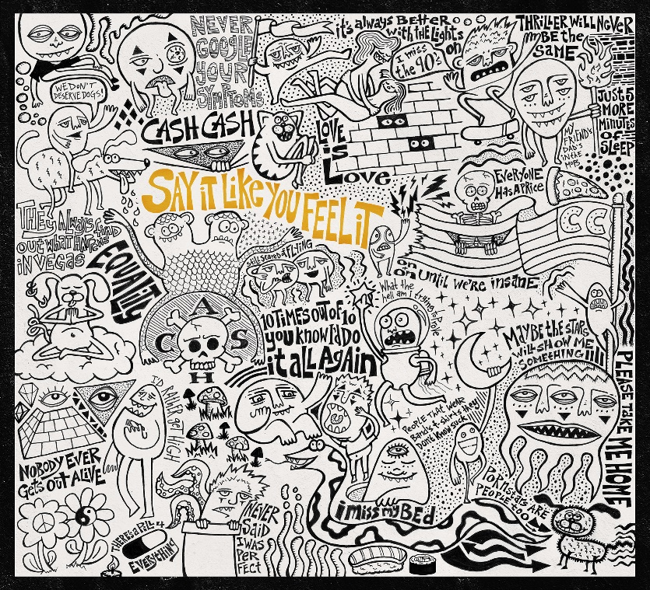

**(ARTWORK HAND DRAWN BY SAM FRISCH OF CASH CASH)**

[**DOWNLOAD HERE**](https://press.wearebigbeat.com/wp-content/uploads/2021/04/say-it-art-.jpg)

World-renowned, **multi-platinum** electronic music trio **Cash Cash** are back today and with big news we’ve all been waiting for – the drop of their highly anticipated album ***Say it Like You Feel It***, which is available everywhere today. Cash Cash initially teased out the album with “Too Late” [feat. Lukas Graham & Wiz Khalifa], and the recent release of “Ride Or Die” [feat. Phoebe Ryan]. Today we hear the album in its entirety – and it’s everything we’ve been waiting for and more. Listen[**HERE**](https://cashcash.lnk.to/SayItLikeYouFeelItPR)and watch the “42” visualizer [**HERE.**](https://youtu.be/1nw3FO_dG38)

Cash Cash bottle the memories, lessons, and experiences of an entire era in their 2021 full-length offering, Say It Like You Feel It. They fashion an electronic pop pastiche out of analog synth transmissions, live instrumentation, blockbuster hooks, and a rotating cast of dynamic and diverse guest vocalists. As such, they relay the ebbs and flows of their journey through these 18 tracks.

*“The title speaks to the overarching theme,” states JP. “Say what you feel. Don’t hold your emotions back. You have to be able to express yourself, what you believe, and what you think. If you’re going to say something, let it all out. If you’re going to do something, be sure to do it all the way.”*

*“All of these songs were made as shared experiences a lot of people can relate to,” says Samuel. “It’s been so long we can’t wait to share these songs with everyone. Don’t worry about what’s going on in the world for an hour. Sit back and listen.”*

The album kicks off with “42.” Underscored by breezy acoustic guitar, this upbeat bop recalls “memories of being in Las Vegas and drinking a bottle of 42 every night,” smiles Samuel. Then, there’s “Talk About It” [feat. HARLOE]. It builds from a lightly plucked intro into a dancefloor-ready hook punctuated by HARLOE’s explosive delivery. Whether it be the glossy and glistening fingersnap-driven “Reforget” [feat. Violet Days] or the emotionally charged “Practice” [feat. Tayler Buono], *Say It Like You Feel It* canvases an entire sonic spectrum.

*“We try to be an escape from reality for people,” says JP. “You can listen to the music and enjoy the songs. If there’s an emotion we can convey to help you get through something, that’s the goal. Music is all about healing. For as much as our music may help fans, it’s the same for us. Playing shows helped me get through the hardest times in my life.”*

Since 2008, Cash Cash have asserted themselves as a bastion of electronic music innovation, crossing over on their own terms, generating billions of streams, selling out shows on multiple continents, and launching a high-profile Las Vegas residency. Not to mention, the multiplatinum genre-breaking New Jersey trio—brothers Jean Paul and Alex Makhlouf accompanied by lifelong friend Samuel Frisch—have collaborated with everyone from **Busta Rhymes** and **Nelly** to **Goo Goo Dolls** and **Christina Perri**. Along the way, 2016’s *Blood, Sweat & 3 Years* yielded an international smash with the **platinum-certified** “Take Me Home” [feat. **Bebe Rexha**]. Igniting the next chapter, “Matches” [feat. ROZES] vaulted to **#1 on Dance Radio**, while “All My Love” [feat. Conor Maynard] eclipsed **117 million-plus Spotify streams**. In between packed gigs, “Finest Hour” [feat. Abir] posted **up 92 million Spotify streams and garnered a gold certification from the RIAA**. “Call You” [feat. Nasri of MAGIC!] saw them return to **#1 at Dance Radio as *Billboard* pegged them among the 2019 *“Dance 100 List*.*”* P!NK** recruited them for the *“bucket list”* collaboration “Can We Pretend,” which bubbled up to the **Top 10 at AC Radio**. Meanwhile, they joined forces with **Dashboard Confessional** for “BELONG.” Kicking off 2020, “Mean It” [feat. Wrabel] attracted the praise of *PAPER Magazine* who called it *“Instantly relatable and infectiously danceable*.*”*

**“SAY IT LIKE YOU FEEL IT” TRACKLIST:**

1.42

2.Too Late (ft. Wiz Khalifa & Lukas Graham)

3.Ride Or Die (ft. Phoebe Ryan)

4.Finest Hour (ft. Abir)

5.Practice (ft. Tayler Buono)

6.Paris In New York (ft. Brandon Colbein)

7.Talk About It (ft. Harloe)

8.Belong (w/ Dashboard Confessional)

9.Black

10.Reforget (ft. Violet Days)

11.Call You (ft. Nasri of Magic!)

12.The Feels (ft. Alex Newell)

13.Mean It (ft. Wrabel)

14.All My Love (ft. Conor Maynard)

15.Matches (ft. Rozes)

16.Gasoline (ft. Laura White)

17.Love You Now (ft. Georgia Ku)

18.Jewel (ft. Nikki Vianna)

**CONNECT WITH CASH CASH:**

[Instagram](https://www.instagram.com/cashcash/) | [Facebook](https://www.facebook.com/cashcash) | [Twitter](https://twitter.com/cashcash) | [Spotify](https://open.spotify.com/artist/1LOB7jTeEV14pHai6EXSzF) | [TikTok](https://www.tiktok.com/@cashcash?lang=en)

**Press Assets:** <https://press.wearebigbeat.com/artists/cashcash/>

**Press inquiries:**

Paige.Rosoff@atlanticrecords.com

Big Beat Records | Atlantic Records