**CASH CASH DROP NEW SINGLE “RIDE OR DIE” FT. PHOEBE RYAN**

**+ ANNOUNCE NEW ALBUM “SAY IT LIKE YOU FEEL IT” OUT MAY 14**

[ALBUM TO FEATURE COLLABORATIONS WITH **DASHBOARD CONFESSIONAL**, **WIZ KHALIFA**, **WRABEL**, AND MORE]

**LISTEN HERE:** [https://cashcash.lnk.to/RideOrDiePR](https://nam04.safelinks.protection.outlook.com/?url=https%3A%2F%2Fcashcash.lnk.to%2FRideOrDiePR&data=04%7C01%7CPaige.Rosoff%40atlanticrecords.com%7Cdb88a09808c44e9906f508d904e32ca9%7C8367939002ec4ba1ad3d69da3fdd637e%7C0%7C0%7C637546196019530287%7CUnknown%7CTWFpbGZsb3d8eyJWIjoiMC4wLjAwMDAiLCJQIjoiV2luMzIiLCJBTiI6Ik1haWwiLCJXVCI6Mn0%3D%7C1000&sdata=bRKk1MuH9uEX1Hwa%2FbyMRJWd%2B%2BpeoMZGKy0oWmbGgq8%3D&reserved=0)

**OUT TODAY VIA BIG BEAT RECORDS**

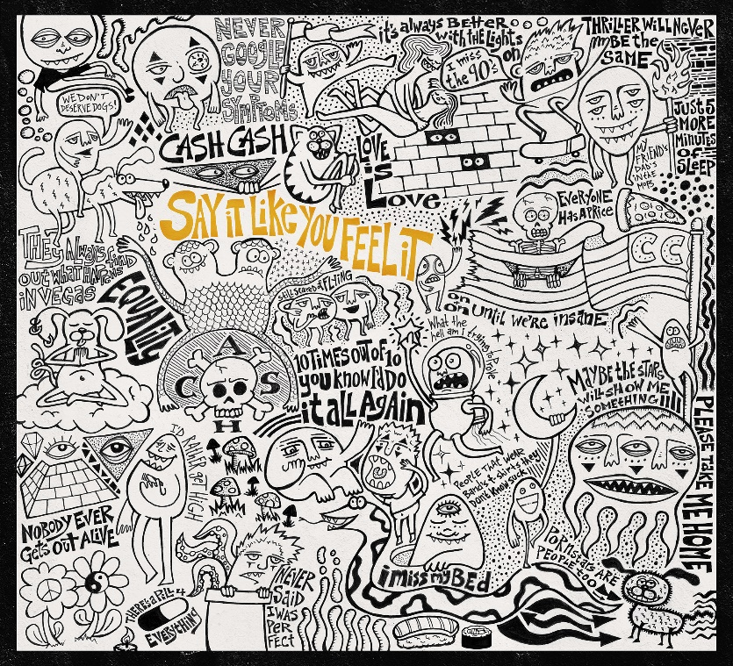

**DOWNLOAD ARTWORK** [**HERE**](https://press.wearebigbeat.com/wp-content/uploads/2021/04/say-it-art-.jpg)

World-renowned, **multi-platinum** electronic music trio **Cash Cash** are back today and with big news we’ve all been anticipating – a new single “Ride or Die” ft. **Phoebe Ryan**, and the announcement of their highly anticipated album **“Say it Like You Feel it”.** Listen to “Ride or Die” [HERE](https://cashcash.lnk.to/RideOrDiePR) and pre-save the album [HERE](https://CashCash.lnk.to/ILYFIPresavePR).

Cash Cash initially teased out the album with “Too Late” [feat. Lukas Graham & Wiz Khalifa], and on its heels, the 2021 single “Ride Or Die” [feat. Phoebe Ryan] illuminates the enduring power of their signature sound. Shimmering keys twinkle through a thumping bass line and head-nodding beat before culminating on a sweeping and soaring refrain from Phoebe as she asks, *“Are you with me ride or die?”* “The song is about the one person in your life—whether it’s a friend, girlfriend, parent or family member—you really lean on,” explains JP. “The message is, *‘It’s never too late to put yourself out there and make that friendship or relationship’*.”

*“I’m so happy this song is finally out in the world!”* says Phoebe Ryan. *“It’s been a while since I’ve done a dance record so I’m particularly excited about this one. I’ve been a fan of Cash Cash for a long time, not only because we’re all from Jersey, but because they consistently put out great music. If this isn’t the song of summer I’ll kiss your dad.”*

The album kicks off with “42.” Underscored by breezy acoustic guitar, this upbeat bop recalls *“memories of being in Las Vegas and drinking a bottle of 42 every night*,*”* smiles Samuel. Then, there’s “Talk About It” [feat. HARLOE]. It builds from a lightly plucked intro into a dancefloor-ready hook punctuated by HARLOE’s explosive delivery. Whether it be the glossy and glistening fingersnap-driven “Reforget” [feat. Violet Days] or the emotionally charged “Practice” [feat. Tayler Buono], *Say It Like You Feel It* canvases an entire sonic spectrum. “The title speaks to the overarching theme,” states JP. “Say what you feel. Don’t hold your emotions back. You have to be able to express yourself, what you believe, and what you think. If you’re going to say something, let it all out. If you’re going to do something, be sure to do it all the way.” Cash Cash do just that every time they make a record or play a gig.

“We try to be an escape from reality for people,” JP leaves off. “You can listen to the music and enjoy the songs. If there’s an emotion we can convey to help you get through something, that’s the goal. Music is all about healing. For as much as our music may help fans, it’s the same for us. Playing shows helped me get through the hardest times in my life.” “All of these songs were made as shared experiences a lot of people can relate to,” concludes Samuel. “It’s been so long we can’t wait to share these songs with everyone. Don’t worry about what’s going on in the world for an hour. Sit back and listen.”

Since 2008, Cash Cash have asserted themselves as a bastion of electronic music innovation, crossing over on their own terms, generating billions of streams, selling out shows on multiple continents, and launching a high-profile Las Vegas residency. Not to mention, the multiplatinum genre-breaking New Jersey trio—brothers Jean Paul and Alex Makhlouf accompanied by lifelong friend Samuel Frisch—have collaborated with everyone from **Busta Rhymes** and **Nelly** to **Goo Goo Dolls** and **Christina Perri**. Along the way, 2016’s *Blood, Sweat & 3 Years* yielded an international smash with the **platinum-certified** “Take Me Home” [feat. **Bebe Rexha**]. Igniting the next chapter, “Matches” [feat. ROZES] vaulted to **#1 on Dance Radio**, while “All My Love” [feat. Conor Maynard] eclipsed **117 million-plus Spotify streams**. In between packed gigs, “Finest Hour” [feat. Abir] posted **up 92 million Spotify streams and garnered a gold certification from the RIAA**. “Call You” [feat. Nasri of MAGIC!] saw them return to **#1 at Dance Radio as *Billboard* pegged them among the 2019 *“Dance 100 List*.*”* P!NK** recruited them for the *“bucket list”* collaboration “Can We Pretend,” which bubbled up to the **Top 10 at AC Radio**. Meanwhile, they joined forces with **Dashboard Confessional** for “BELONG.” Kicking off 2020, “Mean It” [feat. Wrabel] attracted the praise of *PAPER Magazine* who called it *“Instantly relatable and infectiously danceable*.*”* Now, Cash Cash bottle the memories, lessons, and experiences of an entire era in their 2021 full-length offering, *Say It Like You Feel It* [Big Beat/Atlantic Records] ignited by the single “Ride or Die” [feat. Phoebe Ryan].

Pop singer/songwriter Phoebe Holiday Ryan combines the effervescence of [Carly Rae Jepsen](https://open.spotify.com/artist/6sFIWsNpZYqfjUpaCgueju) and coolness of [Tove Lo](https://open.spotify.com/artist/4NHQUGzhtTLFvgF5SZesLK) with a sharp attention to pop hooks like contemporaries [Daya](https://open.spotify.com/artist/6Dd3NScHWwnW6obMFbl1BH) and [Chvrches](https://open.spotify.com/artist/3CjlHNtplJyTf9npxaPl5w). Born in Dallas, Texas, Ryan was raised in oceanside Rumson, New Jersey, where she was in a [Grateful Dead](https://open.spotify.com/artist/4TMHGUX5WI7OOm53PqSDAT) cover band in high school. However, her own music is a sharp detour from the likes of [Garcia](https://open.spotify.com/artist/3QDaXfnxfQqqJQK5lSdjLN) and company. Honing her craft at [Clive Davis](https://open.spotify.com/artist/5alKeK7PQGqEJ2oBz5n7sU)' Institute of Recorded Music at New York University, she graduated in 2013 and moved to Los Angeles to pursue a joint songwriting and solo career. Her earliest work included songwriting for a diverse mix of artists like **Melanie Martinez, Tritonal, Skizzy Mars, Bea Miller**, and **All Time Low**. In 2016, she signed with Columbia Records, wrote for **Britney Spears’s album Glory** (“Man on the Moon”), and released a feature with **The Chainsmokers** (“All We Know”) that quickly went platinum. Other collaborators include **Quinn XCII** (“Middle Finger”), **Tove Lo** (“Heart Attack”), **The Knocks** (“Purple Eyes”), **blackbear** (“Forgetting All About You”), **Jaymes Young** (“We Won’t”), and **Kaskade** (“Almost Back”). In July 2020, she released her first full length album titled “**How it Used to Feel.”**

**“SAY IT LIKE YOU FEEL IT” TRACKLIST:**

1. 42
2. Too Late ft. Wiz Khalifa & Lukas Graham
3. Ride or Die ft. Phoebe Ryan
4. Finest Hour ft. Abir
5. Talk About It ft. Harloe
6. Practice ft. Tayler Buono
7. Meant It ft. Wrabel
8. Belong - Cash Cash & Dashboard Confessional
9. Paris to New York ft. Brandon Colbein
10. Reforget ft. Violet Days
11. Call You ft. Nasri of MAGIC!
12. Black
13. Love You Now ft. Georgia Ku
14. All My Love ft. Conor Maynard
15. The Feels ft. Alex Newell
16. Matches - Cash Cash & Rozes
17. Gasoline ft. Laura White
18. Jewel ft. Nikki Vianna

**CONNECT WITH CASH CASH:**

[Instagram](https://www.instagram.com/cashcash/) | [Facebook](https://www.facebook.com/cashcash) | [Twitter](https://twitter.com/cashcash) | [Spotify](https://open.spotify.com/artist/1LOB7jTeEV14pHai6EXSzF?si=KL1IrumlSZWgikOBTct3ng)

**CONNECT WITH PHOEBE RYAN:**

[Instagram](https://www.instagram.com/phoeberyan/) |[Facebook](https://www.facebook.com/PhoebeRyanMusic/) |[Twitter](https://twitter.com/PhoebeRyan?ref_src=twsrc%5Egoogle%7Ctwcamp%5Eserp%7Ctwgr%5Eauthor) |[Spotify](https://open.spotify.com/artist/4N874uPqBka1QiCvnCVOtr)

**Press Assets:** <https://press.wearebigbeat.com/artists/cashcash/>

**Press inquiries:**

Paige.Rosoff@atlanticrecords.com

Big Beat Records | Atlantic Records