Cash Cash & ROZES
“Matches” Remixes Out Now!
+ Catch Cash Cash live this Summer!

“Matches”
LISTEN/POST: https://bbr.ec/mtsrmxyt
STREAM/BUY: https://BigBeat.lnk.to/mrmxsPR

REMIXES FROM:
Instant Karma
Max Styler
Holl & Rush
ye.
Sam F
Rich Edwards

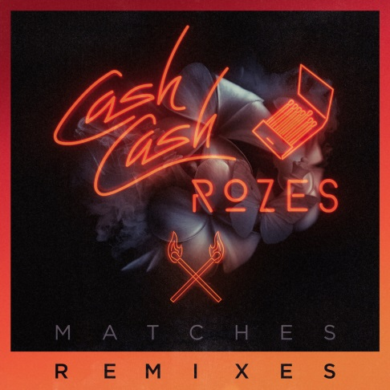

"...a pulsating, aching jam..." – Billboard

Last month globally-celebrated electronic DJ/producer/multi-instrumentalists Cash Cash teamed up with Philadelphia songwriter and powerhouse vocalist ROZES for their new joint single “Matches,” currently #5 at Dance Radio, out via Big Beat Records. They return today with an impressive “Matches” Remix EP – LISTEN HERE – featuring an epic spread of emerging producers including Max Styler, ye., Holl & Rush, Instant Karma, Rich Edwards & SamF. Hot off commencing new residencies at the prestigious HAKKASAN, Jewel, and Omnia nightclubs, Cash Cash shares a Las Vegas stage alongside Tiesto, Calvin Harris, Steve Aoki, Zedd and Kaskade. The trio also just wrapped their tour in support of their debut album, Blood, Sweat & 3 Years. The live fun continues with a heavy lineup of show dates beginning this May and continuing through September, so don’t miss out if they’re heading to a town near you!

Cash Cash, is a trio originally hailing from New Jersey, which consists of brothers Jean Paul Makhlouf and Alex Makhlouf, and life-long friend Samuel Frisch. Together, the three record, mix and master all of their music. The trio has released four full-length albums, an array of EPs and singles, and have found success producing and co-writing official remixes for major artists such as Katy Perry, Bruno Mars, Britney Spears, Kelly Clarkson, Krewella, David Guetta, Hardwell and many others.
Max Styler; 21 year old producer out of California has been making waves online with his original music & remixes while performing alongside international DJs, ye.; Syracuse, NY based artist has produced 4 #1 tracks on Hype Machine in the last 6 months alone, with hits like “Hlsy Flip”, Holl & Rush; production duo hailing from Rotterdam have devoted their partnership to creating unique electro and bigroom house sounds with a distinctive groove., Instant Karma; female production duo from LA and London have been remixing for some of today’s hottest club records, Rich Edwards; producer out of Stockholm, Sweden known for his progressive house beats, and Sam F; Bay Area producer, on the rise in the last year - playing the main stage at many festivals, touring the US and garnering the support from A list DJs.

##

Cash Cash show dates:
May 5 – Louisville, KY @ Fourth Street Live!
May 12 – New York, NY @ Space NYC
May 19 – Gulf Shores, Alabama @ Hangout Festival
June 2 – Las Vegas, NV @ Hakkasan Las Vegas
June 9 – Las Vegas, NV @ Hakkasan Las Vegas
June 16 – Las Vegas, NV @ Liquid
June 24 – Las Vegas, NV @ Hakkasan Las Vegas
July 1 – Costa Mesa CA @ Time Night Club
July 8 – Las Vegas, NV @ Jewel Nightclub
July 11 - Las Vegas, NV @ Omnia
July 14 – Las Vegas, NV @ Hakkasan Las Vegas
July 20 – Las Vegas, NV @ Hakkasan Las Vegas
July 21 – Kansas City, MO @ Mosaic
July 28 – Kelowna, BC @ Center of Gravity Festival
July 30 – Las Vegas, NV @ Wet Republic
August 12 – Jakarta @ We The Fest
August 26 – Monterrey, MX @ Hellow Fest
September 2 – Philadelphia, PA @ Made In America Festival
September 3 – Seattle, WA @ Bumbershoot

Connect with Cash Cash:
http://cashcashmusic.com
https://twitter.com/cashcash
https://soundcloud.com/cashcash
https://www.facebook.com/cashcash

For more information on CASH CASH please contact:

Jordan Danielle Frazes
Head of Publicity, Big Beat Records
Jordan.Frazes@atlanticrecords.com

Catherine Corkery
Publicity, Big Beat Records
Catherine.Corkery@atlanticrecords.com

