CASH CASH EMERGE FROM STUDIO HIBERNATION WITH NEW SINGLE
“MEAN IT” (FEAT. WRABEL), THEIR FIRST NEW MUSIC IN OVER A YEAR

LISTEN HERE: https://BigBeat.lnk.to/MeanItPR

OUT TODAY VIA BIG BEAT RECORDS!
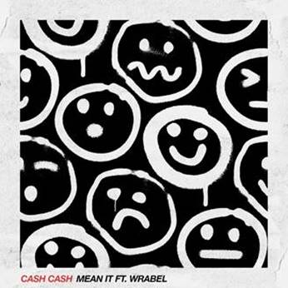

Cash Cash hasn’t released any new music in over a year, but that doesn’t mean the acclaimed DJ/production team hasn’t stayed busy - the trio’s been selling out shows worldwide. They’re now emerging from the studio with a new single called “Mean It” that’s out today through Big Beat Records, featuring Wrabel on vocals, with whom they co-wrote the track. The heartfelt song features Wrabel’s soaring falsetto over Cash Cash’s infectious, anthemic and hook-laden production - LISTEN HERE!

Over the past year, Cash Cash’s previous single “Finest Hour” (feat. Abir) has been RIAA-certified Gold, and their 2019 collaboration with P!NK called “Can We Pretend” hit Top 10 at AC radio. Their last original single “Call You” hit #1 on US Dance Radio, and they were also featured on Billboard’s Dance 100 List for 2019.

The trio will continue festival dancefloor domination in 2020, with appearances already confirmed at Lollapalooza and Firefly, with more coming your way soon. They also sold out their entire co-headline tour with R3HAB in Fall 2019, including prestigious venues like NYC’s Avant Gardner & Hollywood’s Palladium.

According to Billboard, “Wrabel is primed for a major breakthrough and you ought to be on board when he finally does.” His original single “11 Blocks” has 70M+ streams, and he has written & been featured on songs for artists including Kesha (“Raising Hell”), P!NK, Kygo, Marshmello, Galantis, Ben Platt, and more. He also opened for P!NK during her last European stadium tour and was named One To Watch by People Mag in Fall 2019 along with being Billboard Pride’s Artist of the Month in June 2019.

Cash Cash is no stranger to successful vocal collaborations. In addition to their smash single “Take Me Home” ft. Bebe Rexha which celebrates an RIAA platinum certification, their song “All My Love” ft. Conor Mayard has amassed over 80 million global streams, “Matches” featuring ROZES achieved #1 on Dance Radio, and one of their latest releases “Belong” is on Dashboard Confessional’s latest album. Their 2016 Blood, Sweat & 3 Years debut album has racked up over 500M streams since its release as well.

With a New Year on the horizon and Cash Cash emerging from the studio, you can likely expect to hear much more from the chart-topping trio this year - stay tuned!

UPCOMING CASH CASH SHOW DATES:
01/25/2020 – Hollywood, FL – DAER Dayclub South Florida
01/25/2020 – Houston, TX – Stereo Live Houston
01/31/2020 – San Diego, CA – Omnia SD
02/07/2020 – Sunnyvale, CA – Pure Lounge
02/11/2020 – Las Vegas, NV – Omnia **residency date
02/14/2020 – Boston, MA – The Grand
02/15/2020 – Atlantic City, NJ – Premier Nightclub @ The Borgata **residency date
02/21/2020 – New York, NY – Marquee
02/27/2020 – Las Vegas, NV – Hakkasan **residency date
02/29/2020 – Mexico City, DF – EDC Mexico *festival
03/21/2020 – San Jose Del Cabo, BCS – Omnia Cabo

CONNECT WITH CASH CASH:
Instagram| Twitter | Facebook | Spotify

PRESS ASSETS: http://press.wearebigbeat.com/artists/cashcash/

FOR MORE INFORMATION:
Paige Rosoff – Big Beat / Atlantic Records
Paige.Rosoff@atlanticrecords.com

