CASH CASH RELEASE “LIGHTNING” EP
FEATURING NEW SMASH “LIGHTNING” FT. JOHN RZEZNIK!

ON SALE TODAY (3/24) VIA BIG BEAT RECORDS:
https://itunes.apple.com/us/album/lightning-ep/id841171870
http://www.beatport.com/release/lightning-ep/1269039

LISTEN: https://soundcloud.com/cashcash/sets/lightning-ep/s-j6ty6

BAND FEATURED ON USA TODAY’s “ON THE VERGE”!

New York based producers and DJ trio Cash Cash (comprised of JP Makhlouf, Alex Makhlouf and Sam Frisch) drop a new four-track EP on Big Beat Records named after their destined festival anthem, “Lightning” which features iconic vocals from Goo Goo Dolls’ front-man, John Rzeznik and has been described as “an infectious radio smash destined for inspiring festival-sized sing-a-longs throughout the summer” by Dancing Astronaut.

The new EP voyages across Cash Cash’s repertoire; including a “party rockin’ monster” remix from Candyland & DotEXE for “Overtime” exclusive to iTunes, a new version of their pop radio success story single, “Take Me Home” from Patrick Hagenaar along with two new takes on “Satellite” from the likes of Quilinez as well as an additional Beatport exclusive from Häxeri.

Heading from South by Southwest straight to Miami Music Week / Winter Music Conference Cash Cash will play a span of DJ sets across South Beach “… that you seasoned Miami veterans need to check out” (Complex’s Earmilk) including one among label-mates and peers at the Big Beat & Friends Miami Rooftop Pool Party at the Dream Hotel on Wednesday March 26th, with tickets on sale now: http://bigbeatmiami.wantickets.com/ >> see below for the full itinerary!

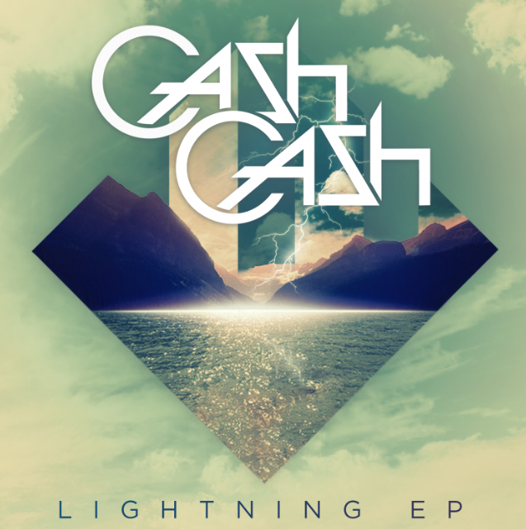

CASH CASH “LIGHTNING” EP:
1) Lightning (feat. John Rzeznik)
2) Satellite (Qulinez Remix)
3) Satellite (Häxeri Remix)** / Overtime (Candyland & DotEXE Remix)*
4) Take Me Home (feat. Bebe Rexha) (Patrick Hagenaar Colour Code Remix)
*iTunes exclusive
**Beatport exclusive

CASH CASH on TOUR
Mar 22 – MIXX @ Borgata – Atlantic City, NJ
Mar 25 - Bob Sinclair Pool Party @ The Delano - Miami, FL
Mar 26 – Big Beat & Friends Miami Rooftop Pool Party @ The Dream Hotel – Miami, FL (TIX)
Mar 26 - Paul Oakenfold Perfecto Party @ Space - Miami, FL
Mar 27 - ATB Pool Party @ Clevelander, Miami, FL
Mar-28 – WALL MMW @ WALL, Miami, FL
Mar 29 - No Sugar Added Festival @ Nikki Beach, Miami, FL
Mar 30 – Dirty South & Friends @ Delano Beach Club, Miami, FL
Mar 30 – Adventure Club & Friends @ Cameo, Miami, FL
Apr 01 – Budweiser Made in America Madison Party @ Madison, WI
Apr 04 - LAVO - New York, NY
Apr 08 – Budweiser Made in America Madison Party - Washington, DC
Apr 09 – Fahrenheit Ultra Lounge - Lansing, MI
Apr 10 - Union - Iowa City, IA
Apr 11 - Whim - Pittsburg, PA
Apr 15 – Club Luna - Nassau, Bahamas
Apr 17 – Budweiser Made In America Charlotte Party - Charlotte, NC
Apr 19 – New City Gas – Montreal, CA
Apr 22 – Budweiser Made In America – Athens, GA
Apr 25 – Life in Color Festival – West Lafayette, IN
Apr 26 – Life in Color Festival – Columbia, MO
May 20 – Marquee Theater – Tempe, AZ
May 22 - The Park - Sacramento, CA
May 23 - Exchange - Los Angeles, CA
May 24-25 – EDC Festival - New York, NY
May 26 - Marquee Day Club - Las Vegas, NV
May 27 – Shrine – Mashantucket, CT
Jun 06 – Royale – Boston, MA
Jun 07 – X Games – Austin, TX
Jun 19-22 – Firefly Festival – Dover, DE
Jun 26 - Electric Forrest @ Double JJ Ranch - Rothbury, MI
Jul 18 – Bassmnt - San Diego, CA

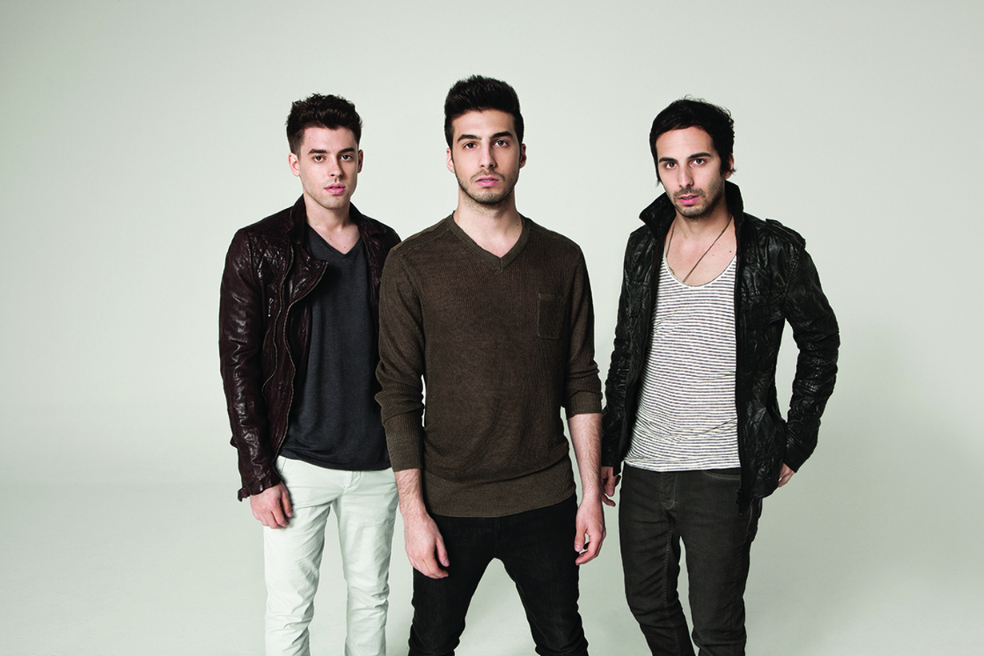

APPROVED ASSETS:

STREAM “OVERTIME” EP: https://soundcloud.com/cashcash/sets/overtime-ep

“TAKE ME HOME” OFFICIAL VIDEO: http://youtu.be/wvzfOyW0ZMo

“TAKE ME HOME” ACOUSTIC VIDEO: http://youtu.be/nWZ5_F45r4s

CONNECT:
www.cashcashmusic.com
https://twitter.com/cashcash
https://soundcloud.com/cashcash
https://www.facebook.com/cashcash
http://press.wearebigbeat.com/cashcash

NATIONAL PUBLICIST: Jordan.Frazes@atlanticrecords.com
TOUR PUBLICIST: Jason.Davis@atlanticrecords.com

