ACCLAIMED DJ/PRODUCER TRIO
CASH CASH
DELIVER VALENTINE’S DAY
“JEWEL”
FEATURING NIKKI VIANNA!

LISTEN/SHARE “JEWEL”: https://youtu.be/MdMPQViOwCo
STREAM/BUY “JEWEL”: https://BigBeat.lnk.to/JewelPR
(Big Beat Records)

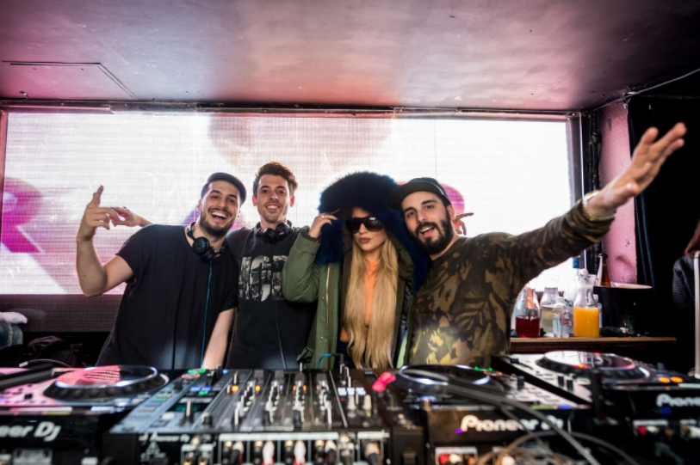
credit: Matthew Enbar

Electronic production trio Cash Cash return today with “Jewel” an energetic, uplifting new dance single featuring singer/songwriter, Nikki Vianna arriving today via Big Beat Records. Nikki Vianna’s heartfelt, powerful vocals soar over a bright fluttering beat, building up to a characteristically dancefloor-friendly Cash Cash drop – LISTEN HERE.

In describing their experience making the record, Cash Cash explains:

“When we made ‘Jewel’ our goal was to not overthink the song and just let the emotion of the instrumental bring the song to life. We started with the track and knew the chords and instrumental melody alone had a special feeling. We knew we wanted to keep that vibe going with the vocals and Nikki Vianna gave us exactly what we were all hearing in our heads. We’re known for mixing up many genres, vibes, & tempos in our music but there’s something very ‘Cash Cash’ about the songwriting in ‘Jewel.’ The core of this song hits you in the same place most of our favorite songs we’ve made do. It has a very powerful moving hook that should be the soundtrack to your Valentine’s Day.”

Cash Cash is no stranger to successful vocal collaborations. In addition to their smash single “Take Me Home” ft. Bebe Rexha which celebrates an RIAA platinum certification, their song “All My Love” ft. Conor Mayard has amassed over 75 million global streams, “Matches” featuring ROZES achieved #1 on Dance Radio, and their latest release “Belong” will be included on Dashboard Confessional’s new album.

2016’s Blood, Sweat & 3 Years applauds nearly 500M streams, and their Las Vegas residency at MGM Grand nightclub HAKKASAN and Atlantic City’s Premier keeps brothers Jean Paul and Alex Makhlouf, and Samuel Frisch busy. Cash Cash continue to prove themselves as a live force to be reckoned with at major festivals including performances at Electric Zoo, TomorrowWorld, Made In America, Billboard Hot 100 Festival & ULTRA Music Festival.

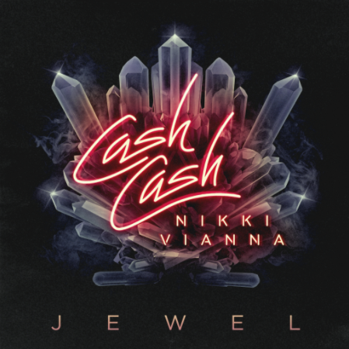

Cash Cash Upcoming Show Dates:

February 23 – MACC Castle Theater @ Maui, HI
February 24 – The Republik @ Honolulu, HI
March 9 – Hakkasan @ Las Vegas, NV
March 12 – Fort Charlotte @ Nassau, Bahamas
March 14 – Mandala Beach @ Cancun, Mexico
March 24 – Wet Republic @ Las Vegas, NV
March 30 – Omnia @ San José del Cabo, Mexico
April 7 – Omnia @ Las Vegas, NV
April 12 – Hakkasan @ Las Vegas, NV
April 13, 20 – Coachella Valley Music & Arts Festival @ Indio, CA

###

MORE ON CASH CASH:

Globally celebrated production trio Cash Cash behind hits “Take Me Home” ft. Bebe Rexha, “Millionaire” ft. Nelly & “Matches” ft. ROZES –record, mix, and master electronic music that effortlessly satisfies pop and dance elements. Brothers Jean Paul and Alex Makhlouf, and life-long friend Samuel Frisch, originally hail from New Jersey. Now signed to Big Beat Records, the multi-instrumentalists have released a debut dance album, an array of EPs and singles, and have found success producing and co-writing official remixes for major artists such as Katy Perry, Bruno Mars, Britney Spears, Kelly Clarkson, Krewella, David Guetta, Hardwell and many others. Cash Cash has amassed over one million career track sales, nearly 500 million career track streams, and a RIAA certified platinum hit in “Take Me Home” featuring Bebe Rexha. The hit was part of the Overtime EP, which also featured Kerli on the track "Here and Now." The following year, Cash Cash nabbed head Goo Goo Doll Johnny Rzeznik for the single "Lightning." "Surrender" arrived the year later with American singer Julia Michaels on vocals. These songs would later feature on their album -- Blood, Sweat & 3 Years -- which landed at #1 on the iTunes Dance Chart opening week. The 2016 release featured additional contributions from artists such as Busta Rhymes, Fitz & the Tantrums, Nelly, Christina Perri, and more. The following year, Cash Cash issued the stand-alone single "Matches," with singer ROZES. The groups last single “All My Love” featured UK-singer/songwriter Connor Maynard. Cash Cash has DJ Residency’s at Las Vegas’: Hakkasan & Marquee, as well as Atlantic City Borgata: MurMur – on top of a major festival Performances at Electric Zoo, TomorrowWorld, Made In America, Billboard Hot 100 Festival & ULTRA Music Festival.

Instagram| Twitter | Soundcloud | Facebook | Spotify

Press tools available for download (http://press.wearebigbeat.com/artists/cashcash/)
or contact: Jordan Danielle Frazes - Jordan.Frazes@atlanticrecords.com
& Catherine Corkery - Catherine.Corkery@atlanticrecords.com

MORE ON NIKKI VIANNA:

Nikki Vianna is a 25 year-old pop singer/songwriter hailing from New York, NY. An alumna of LaGuardia High School for Performing Arts, Vianna is an avid performer who can command the attention of any room. Having early collaborations with Flo Rida, Toby Gad (Beyoncé, Fergie) and more already under her belt, Vianna has been in the studio with famed songwriter/producers Poo Bear (Justin Bieber, Sam Smith), The Stereotypes (Bruno Mars, Chris Brown) & Dave Tozer (John Legend) co-writing material for her forthcoming major label solo debut on Atlantic Records in 2018. Having amassed an online following of over 3.5 million on Instagram alone, she has also appeared as a brand ambassador for numerous influencer campaigns.

Press inquiries: Ted Sullivan - Ted.Sullivan@atlanticrecords.com

