CASH CASH TEAM UP WITH ANDY GRAMMER
FOR “I FOUND YOU” COLLABORATION

LISTEN HERE: https://BigBeat.lnk.to/IFoundYouPR

OUT TODAY VIA BIG BEAT RECORDS!
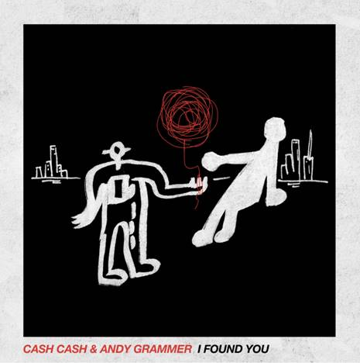

The world-renowned electronic music trio Cash Cash has been churning out chart-topping EDM hits for over a decade, and today they’re sharing their latest track called “I Found You” that they cut with multiplatinum pop singer-songwriter Andy Grammer. An original version of “I Found You” was released on Grammer’s 2019 album Naive. The new rendition is an anthemic track that takes the original into uncharted territory, combining the trio’s up-tempo electronic production with a pop edge that’ll have people on the dance floor from the first note - LISTEN HERE!

Currently signed to Big Beat/Atlantic Records, Cash Cash consists of brothers Jean Paul Makhlouf and Alex Makhlouf, as well as life-long friend Samuel Frisch. Together, the three DJ, producer and multi-instrumentalists record, mix and master all their music themselves. Over the past few years they have seen massive success with their slew of single releases. Their song “Finest Hour” (feat. Abir) has been RIAA-certified Gold, and their 2019 collaboration with P!NK called “Can We Pretend” hit Top 10 at AC radio. Their single “Call You” (feat. Nasri of MAGIC!) hit #1 on US Dance Radio, and they were also featured on Billboard’s Dance 100 List for 2019. Their smash single “Take Me Home” (ft. Bebe Rexha) celebrated an RIAA platinum certification; their song “All My Love” ft. Conor Maynard has amassed over 100 million streams on Spotify alone; “Matches” featuring ROZES achieved #1 on Dance Radio, and one of their releases “Belong” was featured on Dashboard Confessional’s album “Crooked Shadows.” In addition, Cash Cash started 2020 off strong with their release of “Mean It” (feat. Wrabel) which premiered on PAPER magazine.
Since his 2011 self-titled debut, Grammer has consistently delivered stratosphere-size smashes buoyed by impressive range, deft musicality, and endless charisma. By 2019, he scored seven chart-topping hits—each certified gold or better by the RIAA. The artist’s breakout “Fine By Me” and its follow-up “Keep Your Head Up” are both certified platinum. His 2014 sophomore offering, Magazines or Novels, went gold and yielded the gold “Good To Be Alive (Hallelujah).” During this chapter, the single “Honey, I’m Good” reached quadruple-platinum status globally, emerging as “one of the best-selling songs of 2015.” He maintained this streak on 2017’s The Good Parts. The standout “Fresh Eyes” tallied over 350 million streams, achieving a platinum plaque. Not to mention, he consistently sold out headline gigs everywhere. Building upon that foundation, his 2019 fourth full-length, Naive [S-Curve Records/BMG], amplifies both the message and the musicianship. Vibrant instrumentation upholds a feeling of unabashed positivity for Grammer throughout. This uplifting spirit defines the first single “Don’t Give Up On Me.” Featured in the big screen drama Five Feet Apart, the song clocked 18 million Spotify streams in three weeks between the original and R3HAB remix. From the bright “Wish You Pain” to the epic Lady Blacksmith Mambazo-assisted “She’d Say,” these moments commute and inspire happiness in its purest form on Naive and beyond.

As festival season approaches, you can hedge your bets that Cash Cash will be reliable stalwarts to catch at the biggest and best among them; the trio is set to continue their dancefloor domination with several festival announcements coming soon. In the meantime, “I Found You” is the perfect song to hit play on while you prep your Summer travel!

CATCH CASH CASH LIVE:
Thu 2/27 – Hakkasan – Las Vegas, NV
Fri 2/28 – Time Nightclub – Costa Mesa, CA
2/28-2/30 – EDC Mexico – Mexico City
Tue 3/3 – Brick Street Bar – Oxford, OH
Fri 3/6 – Metropolitan Entertainment Centre – Winnipeg, MB
Sat 3/7 – Coors Event Centre – Saskatoon, SK
Wed 3/11 – Dancing Sasquatch – Banff, AB
Thu 3/12 – DISTRIKT – Victoria, BC
Fri 3/13 – Sapphire Nightclub – Kelowna, BC
Sun 3/15 – Longhorn Saloon – Whistler, BC
Fri 3/20 (EARLY) – Wet Republic – Las Vegas, NV
Fri 3/20 (LATE) – Temple SF – San Francisco, CA
Sat 3/21 – Omnia Cabo – San Jose del Cabo, BCS
Sun 3/29 – Wet Republic – Las Vegas, NV
Sat 4/4 – LIV – Miami Beach, FL
Fri 4/10 – Hakkasan – Las Vegas, NV
Sat 5/30 – Union Hall – Edmonton, AB
6/18-6/21 – Firefly – Dover, DE
8/1-8/2 – Veld Music Festival – Toronto, ON

CONNECT WITH CASH CASH:
Instagram | Facebook | Twitter | Spotify

PRESS ASSETS: https://press.wearebigbeat.com/artists/cashcash/

CONNECT WITH ANDY GRAMMER:
Website | Apple Music | Spotify | Facebook | Twitter | Instagram

FOR MORE INFORMATION:
Paige Rosoff – Big Beat Records
Paige.Rosoff@atlanticrecords.com

ANDY GRAMMER PRESS CONTACTS:
Carleen Donovan
carleen@donovanpublicrelations.com
Amanda Brophy
amanda@donovanpublicrelations.com

