Cash Cash Deliver New Single “Devil” (feat. Busta Rhymes, B.o.B. & Neon Hitch) - out today via Big Beat Records!

STREAM/POST: https://soundcloud.com/cashcash/cash-cash-devil-feat-busta-rhymes-bob-neon-hitch/
PURCHASE: http://smarturl.it/CCDevil

“…an incredible mix of modern hip-hop style with some in your face EDM techniques that are sure to have you turnt.”—Complex

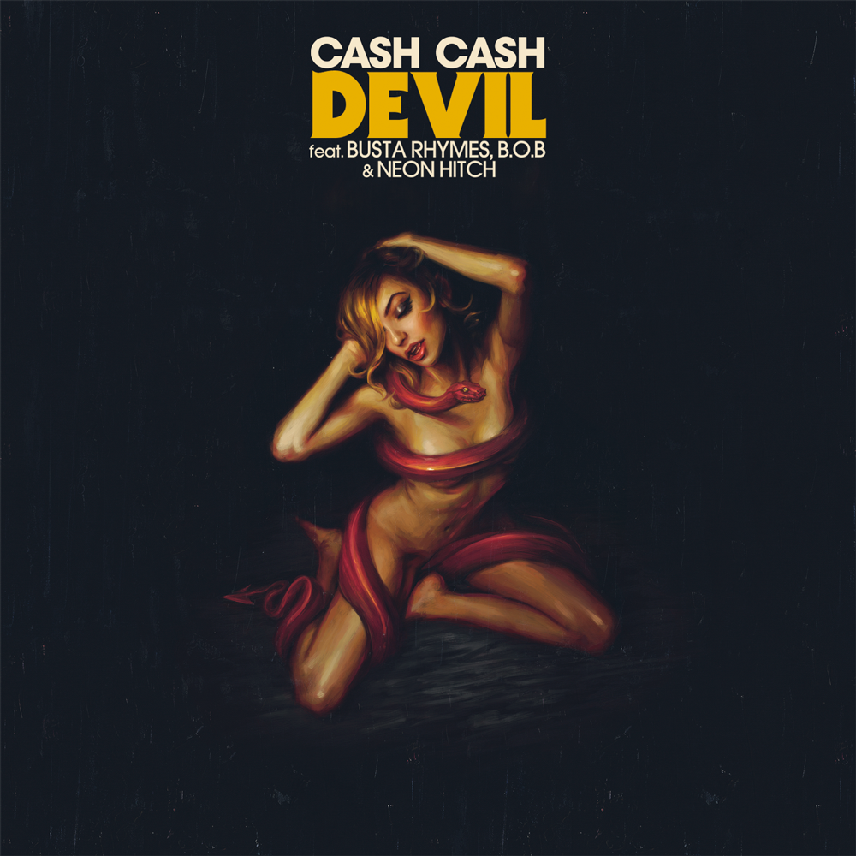

Internationally-acclaimed electronic act Cash Cash drop a new single “Devil” featuring superstar contributions from legendary Busta Rhymes, incomparable verses from B.o.B. and an irresistible hook from Neon Hitch, all tied together via the trio’s signature catchy pop production. Single arrives today (http://smarturl.it/CCDevil) via Big Beat Records and is available for streaming on Complex & https://soundcloud.com/cashcash/cash-cash-devil-feat-busta-rhymes-bob-neon-hitch/.

Hailed for their infectious dance-pop original tracks, vibrant remix productions as well as their energetic live DJ sets on festival main stages and clubs spanning across the globe - Cash Cash has garnered global recognition and support from renowned DJs and peers, including Tiesto, Hardwell, Zedd, Nicky Romero, captivating dance music insiders and friends along the way. Their hit song “Take Me Home” featuring Bebe Rexha has gathered over 50 million Spotify streams, over 20 million YouTube views, and Gold certification in the United States; while latest single “Surrender” has peaked at #36 on the Top 40 chart, the trio’s Catch Cash Cash on the road across North America this fall, co-headlining The Untouchable Tour with friends Tritonal, kicking off mid-September!

Cash Cash Tour Dates (w/ Tritonal)
Tickets: http://www.untouchabletour.co/
September 17 - New Orleans, LA - Republic New Orleans
September 18 - Dallas, TX - The Bomb Factory
September 19 - Austin, TX - Emo’s
September 20 - San Antonio, TX - Club Rio
September 24 - Scottsdale, AZ - Livewire
September 25 - Los Angeles, CA - Club Nokia
September 28 – Las Vegas, NV – The Cosmopolitan / Marquee Nightclub*
September 30 – Santa Barbara, CA - Soho
October 1 - Santa Cruz, CA - The Catalyst
October 2 - San Luis Obispo, CA - Avila Beach Golf Resort
October 3 - San Francisco, CA - Warfield Theatre
October 6 - Reno, NV - Knitting Factory Concert House
October 8 - Eugene, OR - Hi-Fi Music Hall
October 9 - Seattle, WA - Showbox Sodo
October 10 - Portland, OR - Roseland Theater
October 11 - Vancouver, BC - Commodore Ballroom
October 13 - Victoria, BC - Sugar
October 16 - Calgary, AB - Flames Central
October 17 - Edmonton, AB - YEG Dance Club
October 21 - Missoula, MT - The Wilma Theater
October 22 - Boise, ID - Revolution Event Center
October 24 - Denver, CO - Bluebird Theater
October 27 - Columbia, MO - The Blue Note
October 28 - Urbana, IL - The Canopy Club
October 29 - Nashville, TN - Exit / In
October 30 – Washington, DC – Echostage
October 31 – Chicago, IL – Freaky Deaky
November 1 - Pittsburgh, PA - Diesel Club Lounge
November 3 - Bloomington, IN - The Dunnkirk
November 4 - Ann Arbor, MI - Necto
November 5 - Buffalo, NY - The Town Ballroom
November 6 - Toronto, ON - Uniun Nightclub
November 7 – New York, NY – Terminal 5
November 11 - Syracuse, NY - The Westcott Theater
November 12 – New Haven, CT – Toad’s Place
November 13 - Boston, MA - House Of Blues
November 14 – Philadelphia, PA – Soundgarden Hall
November 19 - Miami Beach, FL - LIV
November 20 - Orlando, FL - Venue 578
November 21 - Tampa, FL - Amphitheater Event Facility

*Cash Cash only

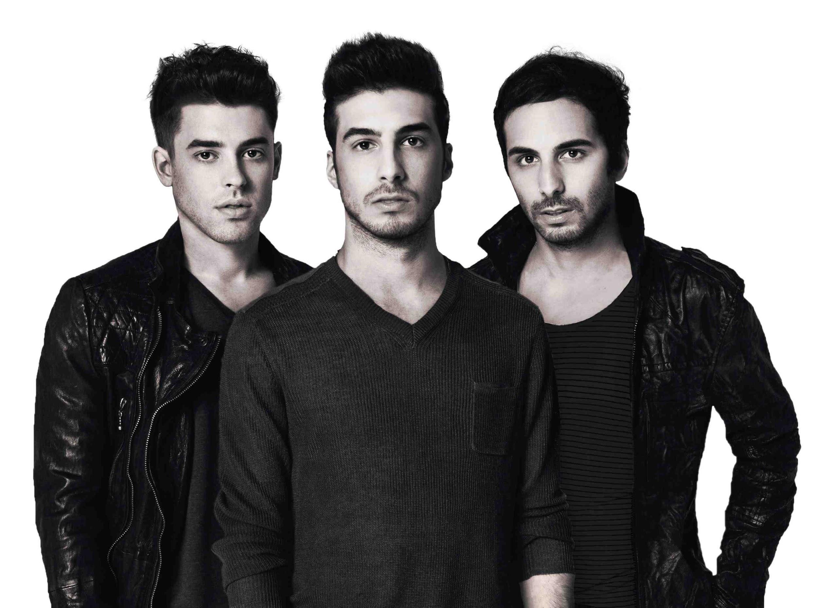

Connect // CASH CASH
http://cashcashmusic.com
https://twitter.com/cashcash
https://soundcloud.com/cashcash
https://www.facebook.com/cashcash
http://press.wearebigbeat.com/artists/cashcash/

Contact // CASH CASH
Jordan Frazes, Publicity Director: Jordan.Frazes@atlanticrecords.com
Ted Sullivan, Tour Publicist: Ted.Sullivan@atlanticrecords.com

