CASH CASH RECRUITS NASRI FROM MAGIC! FOR NEW SINGLE “CALL YOU”
OUT TODAY VIA BIG BEAT RECORDS

LISTEN/SHARE: https://youtu.be/Lj-l_g8EUV0
STREAM/BUY: https://BigBeat.lnk.to/CYPR

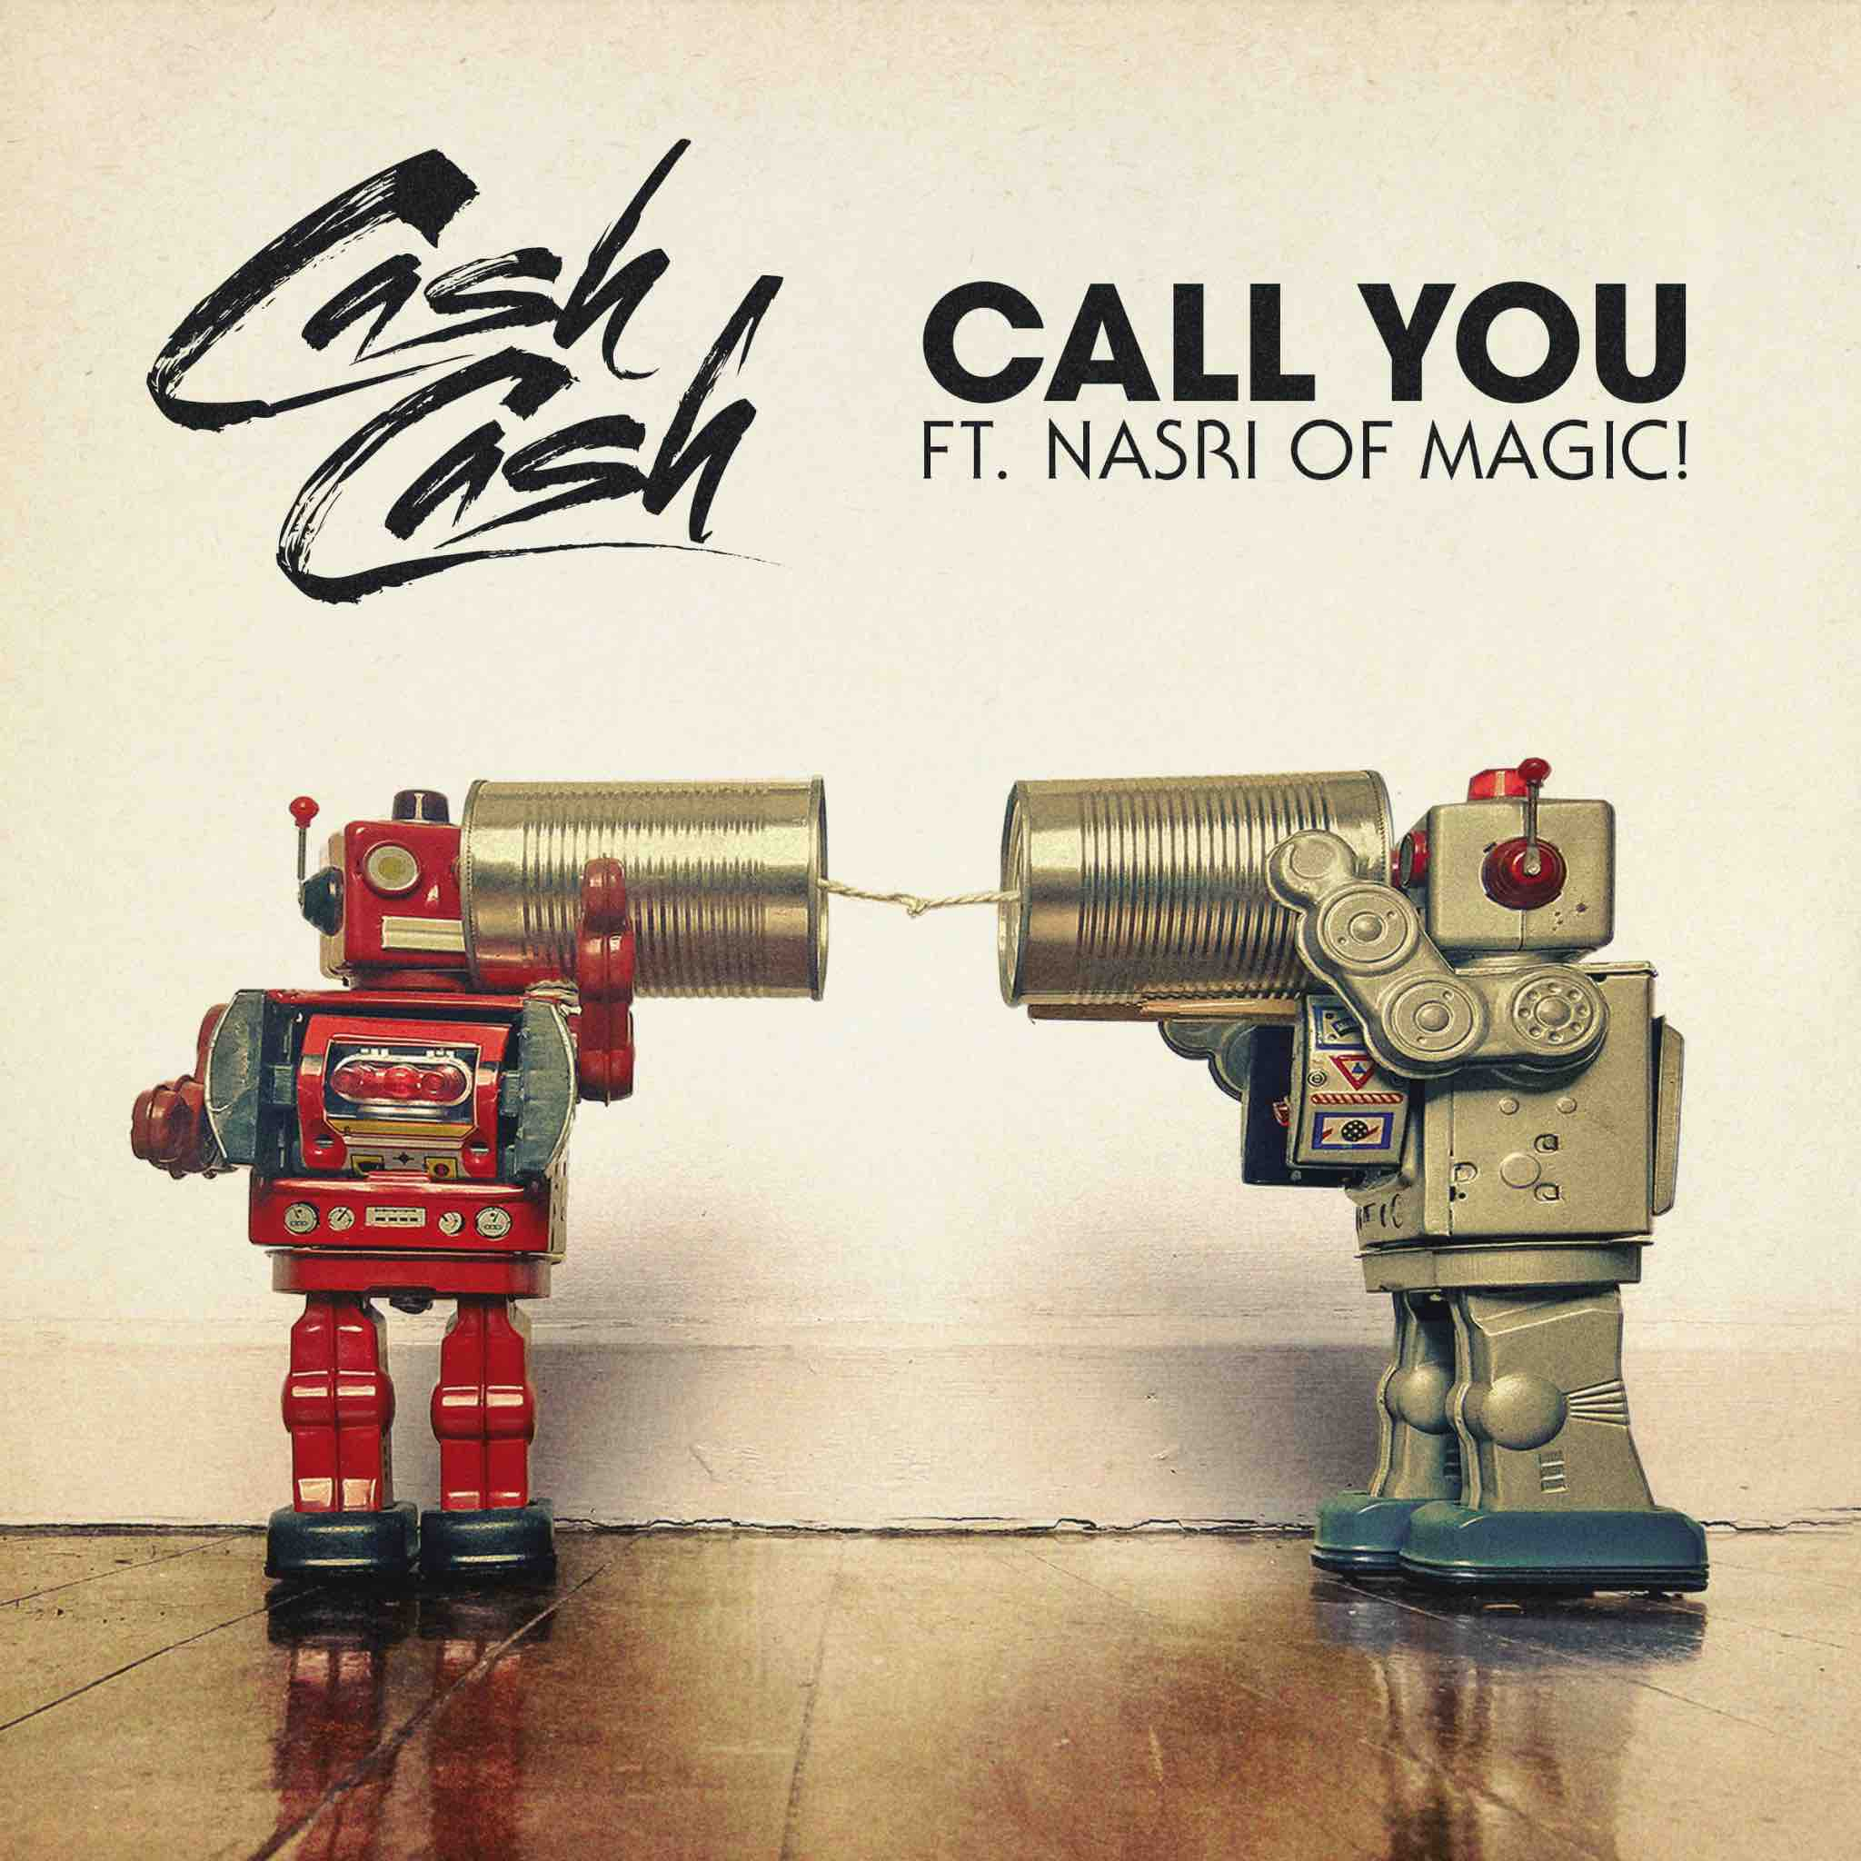
DOWNLOAD IMAGE HERE

The internationally-acclaimed American electronic trio Cash Cash is back with their final new single this side of 2018 called “Call You”, out today through their longtime label home of Big Beat Records. Listen to the track HERE. Cash Cash recruited Nasri to lend his powerful vocals to the single; Nasri is the lead vocalist and songwriter for the GRAMMY Award-winning Canadian reggae fusion band MAGIC!, famously known for their hit song “Rude.” The track starts out as a stark, contemplative cut before Cash Cash drop in their signature magic production touch, elevating the song to previously unheard heights.

Cash Cash is behind so many of your favorite hits spanning the past several years, including “Take Me Home” ft. Bebe Rexha, “Millionaire” ft. Nelly, “Matches” ft. ROZES and “All My Love” ft. Conor Maynard, and most recently “Finest Hour” ft. ABIR, which debuted on the US Top 40 Radio Chart and was #1 on Dance Radio 6 weeks in a row.

This new track evokes their signature emotion while, as Cash Cash put it, adding a whole new musical twist:

“We’ve all lost someone before but it’s strengthening to hold onto the idea of always being able to call upon them when you need them the most. “Call You” has that familiar Cash Cash emotion with a whole new twist musically. Our goal was to make the drop an extension of the vocal unifying them as one. They almost evolve in and out of each other throughout the song. Working with Nasri of Magic! really brought things to another level. The emotional nuances in his voice are bone chilling and truly make you feel the song’s underlying grief and beauty.”
Comprised of brothers Jean Paul and Alex Makhlouf, and lifelong friend Samuel Frisch, the trio record, mix and master electronic music that satisfies pop and dance elements. Signed to Big Beat Records, the multi-instrumentalists have released a debut dance album Blood, Sweat & 3 Years, an array of EPs and singles, and have also produced official chart-topping remixes for superstars such as Katy Perry, Bruno Mars, Britney Spears, Kelly Clarkson, Krewella, David Guetta & Hardwell.

More on Cash Cash:
Cash Cash has amassed over 1 million track sales, 1.5 billion track streams, and a RIAA-certified platinum hit “Take Me Home,” part of their Overtime EP. Cash Cash nabbed Goo Goo Dolls front man Johnny Rzeznik for their single "Lightning" and collaborated with Julia Michaels for “Surrender,” both featured on their album Blood, Sweat & 3 Years, which landed #1 on iTunes Dance Chart opening week. The 2016 release also featured Busta Rhymes, Fitz & the Tantrums, Nelly, Christina Perri & more. Cash Cash has since issued stand-alone singles, "Matches" with ROZES and “All My Love” ft. Connor Maynard, “Belong” which is included on Dashboard Confessional’s new album. On top of high-profile festival performances at Electric Zoo, TomorrowWorld, Made In America, Billboard Hot 100 Festival, ULTRA & Coachella and holding a residency at Las Vegas’ Hakkasan, they are also selling out shows, including their most recent headline performance at Brooklyn Steel in New York. Cash Cash’s transcendent live show is one you need to see to believe.

More on Nasri:
Nasri Tony Atweh known mononymously as Nasri, is a Grammy Award winning Canadian singer, songwriter, and record producer currently residing in Los Angeles, California. He is well known for writing many chart-topping songs including “As Long As You Love Me” By Justin Bieber and “Feel This Moment” By Pitbull. Both songs made the top 10 on the Billboard Hot 100 chart in the United States.
Nasri has also written and produced for the likes of Justin Bieber, Shakira, Pitbull, Chris Brown, Halsey, Sabrina Claudio and more. In 2012, he earned a Grammy Award for Best R&B Album for his production work on Chris Brown's F.A.M.E.. In 2017 he received Latin Grammys for Best Pop Vocal Album and Best Latin Pop Album for his work on Shakira's El Dorado. Additionally, Nasri is highly recognized as the lead vocalist and songwriter for the reggae fusion band, MAGIC!. MAGIC!'s single "Rude" became a major international hit in 2014, hitting #1 on the Billboard Hot 100 chart.

PRESS ASSETS:
http://press.wearebigbeat.com/artists/cashcash/

CONNECT WITH CASH CASH:
Instagram| Twitter | Soundcloud | Facebook | Spotify

FOR MORE INFORMATION:
Paige Rosoff - Big Beat Records
Paige.Rosoff@atlanticrecords.com

Jordan Danielle Frazes - Big Beat Records
Jordan.Frazes@atlanticrecords.com

