Cash Cash debuts ‘Blood, Sweat & 3 Years’ LP at #1 on iTunes Dance chart! + celebrates with music video for “Millionaire” featuring Nelly out today!

WATCH & POST “Millionaire”: http://smarturl.it/FeelLikeAMillionaire
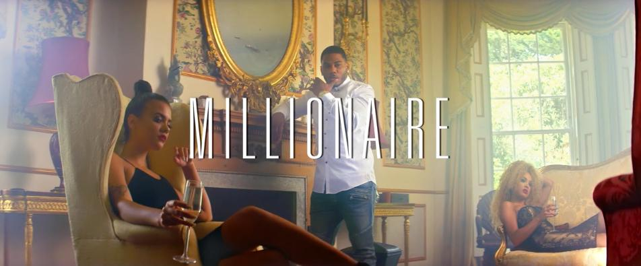

Buy/Stream Blood, Sweat & 3 Years:
iTunes: http://smarturl.it/BloodSweat3Years
Spotify: http://smarturl.it/BloodSweat3Years_s
Amazon: http://smarturl.it/BloodSweat3Years_a
Google Play: http://smarturl.it/BloodSweat3Years_g
Apple Music: http://smarturl.it/BloodSweat3Years_am
Beatport: http://smarturl.it/BloodSweat3Years_B

After years of steadily releasing chart-topping hit singles, today sees the long-awaited worldwide release of Cash Cash’s phenomenal debut album “Blood, Sweat & 3 Years” through Big Beat Records—currently sitting at the top of the iTunes Dance Chart at #1! To celebrate the momentous occasion, the electronic trio is sharing the decadent video for album track “Millionaire” (feat. Nelly), which will make you want to jump on the next private plane to France and party with Cash Cash and Nelly in style!

“Blood, Sweat & 3 Years” has been a long time in the making, but the result is well worth the wait. The album boasts vocal features from superstars all over the spectrum, including Fitz and The Tantrums, Nelly, Christina Perri, Busta Rhymes, B.o.B, Neon Hitch, Jacquie Lee, Trinidad James, Dev, John Rzeznik (of The Goo Goo Dolls), Bebe Rexha, and Night Terrors of 1927 to name a few.

Cash Cash will keep their party going on the road in celebration of “Blood, Sweat & 3 Years” all Summer long, with dates currently planned through September. Along with festival appearances at Electric Zoo and Global Dance Festival, the trio continue their infamous “Make That Cash Cash” residency at Marquee in Las Vegas, regularly infused with celebrity rappers including Busta Rhymes, French Montana, Lil Dicky and Wiz Khalifa, with bi-monthly dates planned through July.

Cash Cash also recently launched their Cash Cash Radio Show on the SiriusXM BPM channel, which airs on the 4th Friday of every month at 11pm EST/8pm PST (shows are archived here in case you missed any!).

Cash Cash Tour Dates:
6/24/16 - Paradiso (Quincy, WA)
6/25/16 - Marquee Nightclub (Las Vegas, NV)
7/02/16 - Yost (Costa Mesa, CA)
7/09/16 - Global Dance Festival (Morrison, CO)
7/15/16 - Marquee Nightclub (Las Vegas, NV)
7/16/16 - Omnia SD (San Diego, CA)
7/30/16 - Marquee Dayclub (Las Vegas, NV)
8/5/16 - Marquee Nightclub (Las Vegas, NV)
8/19/16 - Marquee Nightclub (Las Vegas, NV)
8/21/16 - Center of Gravity (Wasaga Beach, ON)
9/03/16 - Sun City Music Festival (El Paso, TX)
9/04/16 - Electric Zoo (New York, NY)
10/01/16 - Marquee Nightclub (Las Vegas, NV)
10/10/16 - Marquee Nightclub (Las Vegas, NV)
10/28/16 - Marquee Nightclub (Las Vegas, NV)

Cash Cash, “Blood, Sweat & 3 Years” (out June 24th via Big Beat Records):
1. How To Love (ft. Sofia Reyes)
2. Broken Drum (ft. Fitz of Fitz & The Tantrums)
3. Millionaire (ft. Nelly) [Cash Cash & Digital Farm Animals]
4. Hero (ft. Christina Perri)
5. Devil (ft. Busta Rhymes, B.o.B & Neon Hitch)
6. Aftershock (ft. Jacquie Lee)
7. The Gun (ft. Trinidad James, Dev & Chrish)
8. Turn (ft. Little Daylight)
9. Escarole
10. Lightning (ft. John Rzeznik)
11. Arrows In The Dark (ft. Anjulie)
12. We Will Live (ft. Night Terrors of 1927)
13. Bada Boom
14. Take Me Home (ft. Bebe Rexha)
15. Sweat (ft. Jenna Andrews)
16. Surrender

Connect:
http://cashcashmusic.com
https://twitter.com/cashcash
https://soundcloud.com/cashcash
https://www.facebook.com/cashcash

Press tools:
http://press.wearebigbeat.com/artists/cashcash/

Press contact:
Jordan Danielle Frazes, Head of Publicity, Big Beat Records: Jordan.Frazes@atlanticrecords.com
Ted Sullivan, Tour Publicist: Ted.Sullivan@atlanticrecords.com

