CAMELPHAT & ELDERBROOK TURN TO ZHU FOR SPECIAL REWORK OF GRAMMY NOMINATED “COLA”!

LISTEN/POST REMIX: https://BigBeat.lnk.to/CZPR/youtube
BUY/STREAM: https://BigBeat.lnk.to/CZPR

WATCH/POST OFFICIAL “COLA” MUSIC VIDEO:
https://www.youtube.com/watch?v=LcNXG-6SqWA
(Big Beat Records)

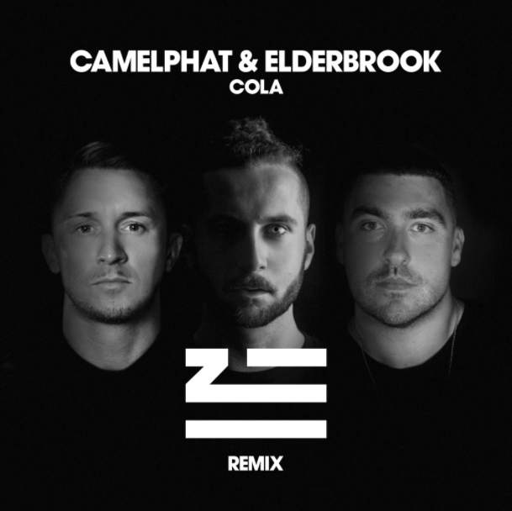

Elderbrook & CamelPhat’s GRAMMY nominated underground club monster, “Cola,” has now received another official rework from fellow Grammy nominee ZHU, out today via Big Beat/Defected Records. LISTEN HERE.

Undoubtedly the biggest and most addictive dance music record of 2017, the now Grammy-nominated “Cola” from British DJ/production duo CamelPhat and singer/co-writer Elderbrook has been a defining musical moment of the year and currently sits at #2 at US Dance Radio.

Growing exponentially since its release, the track has captivated tastemakers, DJs and clubbers alike – topping charts (including #1 on Billboard Dance Club Songs), transcending the genre, and blowing up worldwide to become a true modern anthem.

Following chart-topping mixes from Franky Rizardo, Mousse T., Robin Schulz and heavy national radio rotation across Europe, fellow Grammy nominee ZHU steps up to spin his otherworldly take on the famous record. His remix of “Cola” stretches out the familiar vocal refrain and flips the breakdown on its head, bringing an eccentric edge that takes the track to heady new places.

ZHU first started turning heads in 2014 with ‘THE NIGHTDAY EP,’ featuring the smash single “Faded,” which picked up a Grammy nomination and went on to amass over 500 million global streams. His futuristic multi-layered sound is characterized by expansive shuddering beats and ethereal lingering vocals.

“COLA” HIGHLIGHTS:

55M+ streams to date, growing at 650k per week globally
Spinning at all dance radio panels, including iHeart Evolution, SIRIUS Chill & Electric Area, KNHC/Seattle, Music Choice Dance, plus mixshows in New York, San Francisco, San Diego, and more
#3 on Shazam Global Dance | #11 and rising on Shazam Global Top 200
Debuted as Danny Howard’s “Hottest Record in the World”
Included in BBC 1 Radio’s “Hottest Tracks In The World”
“Track of the Season” at Ibiza DJ Awards
Highest selling track on Beatport for all of 2017
#1 on Beatport for over a month | #1 on House chart for 3 months straight
Featured in Rolling Stone’s “10 New Artists You Need To Know”

“‘Cola’ is one of this year's stealthiest and most vital dance records… once an ‘ooh-ooh’ melodic motif drifts in from above it sticks like pop.”

“Camelphat & Elderbook's 'Cola' is an infectious and emotive anthem.”
-- DJ Mag

“This one's fire... ‘Cola’ is moody, groovy, infectious and entrancing.”
-- Earmilk

ELDERBROOK ON TOUR
Feb 6th @ Floyd – Miami, FL
Feb 7th @ Newspeak – Montreal, Canada
Feb 8th @ Chop Shop – Chicago, IL
Feb 9th @ Knitting Factory – Brooklyn, NY
Feb 10th @ Drake Hotel Underground – Toronto, Canada
Feb 14th @ SOhO Music Club – Santa Barbara, CA
Feb 15th @ Popscene – San Francisco, CA
Feb 16th @ Roxy – Los Angeles, CA
Feb 17th @ Bang Bang – San Diego, CA
Feb 21st @ Bar Standard – Denver, CO
Feb 22nd @ 45 East – Portland, OR
Feb 24th @ The Bunkhouse Saloon – Las Vegas, NV

##

FOR “COLA” PRESS INQUIRIES:

Jordan Danielle Frazes
Head of Publicity, Big Beat Records
Jordan.Frazes@atlanticrecords.com

FOR ELDERBROOK TOUR INQUIRIES:

Libby Kober
Tour Publicity, Big Beat Records
Libby.Kober@atlanticrecords.com

