GRAMMY NOMINATED DUO CAMELPHAT RETURNS WITH ALI LOVE ON NEW TRACK ‘DOPAMINE MACHINE’!

LISTEN/SHARE: https://youtu.be/RAMD0JPPCRo
BUY/STREAM: https://bigbeat.lnk.to/DMPR

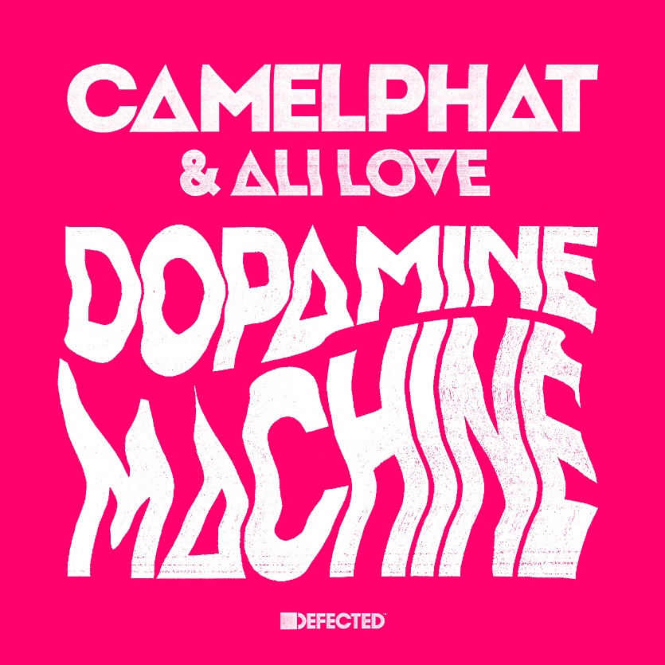

CamelPhat continue their unprecedented run of successes with yet another killer club track on Big Beat/Defected, this time alongside Ali Love. Listen to ‘Dopamine Machine’ HERE!

‘Dopamine Machine’ follows up on 2017’s ‘Cola’, the GRAMMY and Ivor Novello-nominated track that hit over one million sales internationally and established CamelPhat as the UK’s hottest house music export. Written by Ali Love, a songwriter and vocalist who has been featured on a ‘who’s who’ of dance music’s greatest from Chemical Brothers to Justice and of course Hot Natured; CamelPhat have produced a knockout record that’s destined to take the clubs and festivals by storm this summer and beyond. ‘Dopamine Machine’, with its intoxicating vocal hook and floor-rocking beat that’s not to be messed with, takes CamelPhat to further new heights proving the pair’s heady and direct house sound is here to stay.

Connect with CamelPhat:
https://twitter.com/CamelPhat
https://www.facebook.com/CamelPhat/
https://www.instagram.com/camelphatmusic/

For press assets: http://press.wearebigbeat.com/singles/dopamine-machine…melphat-ali-love/

For press inquiries:
Jordan Danielle Frazes
Head of Publicity, Big Beat Records
Jordan.Frazes@atlanticrecords.com

