BREATHE CAROLINA ANNOUNCE NEW STUDIO ALBUM ‘DEAD’ AND
REVEAL LEAD SINGLE ‘TOO GOOD’

RELEASED ON BIG BEAT/SPINNIN’ RECORDS

WATCH THE MUSIC VIDEO HERE: https://youtu.be/Mo-pOF5_enw
LISTEN HERE: https://BigBeat.lnk.to/TGPR

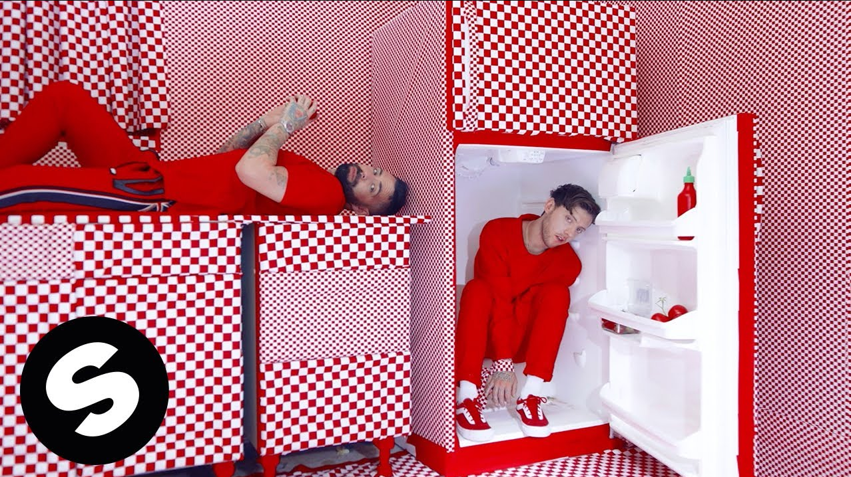

The multi-talented musicians David Schmitt and Tommy Cooperman, better known as Breathe Carolina, have long had an impactful presence within electronic music circles. With a string of studio successes already under their belt, the duo has emerged from a prolonged studio agenda with their new album DEAD. Due for official release in the Fall, fans can get an early peak of what’s to come with the album’s first single ‘Too Good’. Watch the official music video HERE!

The pop-dance nature of ‘Too Good’ sways with lush melodies and a saccharine groove that is an infectious dose of house music for the masses. David’s velveteen voice complements the single’s colorful texture, as the track’s delivery is another exquisite piece of production gold by a duo that seem to have found a rhythm with this new album that truly indicates their creative prowess.

The decision to jump into a committed album schedule came about from the completion of the album’s first ‘Too Good’. “It ignited a spark in us”, Tommy says, “the energy we both felt with this record was undeniable and there was this palpable enthusiasm in the studio. We very quickly came to the decision that we needed to make an entire album that had the feeling and mood of this first song.” David adds, “it felt like a breath of fresh air and a vibe we haven’t heard come from anyone.”

As with all things Breathe Carolina related the guys are constantly looking to push the envelope with their musical endeavors. Fusing their past with a modern approach, DEAD is a body of work that will see Breathe Carolina, as Tommy puts it, “go back to our roots while also taking a giant leap forward into the future." With David stating, “It touches on emotions from our past and connects that with the sounds of our present.”

Bringing a degree of punk rock verve to the dance floor is a trait that has been ingrained in Breathe Carolina’s DNA since the beginning. With David providing vocals on the entire album, the duo wanted to revisit their early years growing up on the emo sound of the late 2000’s early 2010’s and bring with that a big modern-day feel coalescing their love of house music, on top of the production values that they’ve become synonymous for with their live sound.

“We’re so excited for this album because with this project we really dove in and created something that’s fun, emotional, sad, dark and happy all at the same time. It also led me to rediscovering my passion for singing again and through that process explore new ways of using my voice which, for me personally, put such a deeper connection on the music than anything we’ve done before”, explains David when shedding some light on the album’s development.

Denver born, LA based, the duo has entrenched themselves amongst the headline artist pack in recent years thanks to stream of popular hits ‘Rhythm Is A Dancer’, ‘Happier’, ‘The Fever, ‘Sweet Dreams’ and ‘Blackout - which to date has amassed over 30 million Spotify streams. With their popularity on the rise, so too has their touring schedule. With recent tours taking them to Asia and Europe, on top of a never-ending run of North American shows, it’s clear their impact from the studio is equally felt in their live show. In previous years, favourite festival stages such as Tomorrowland, EDC, Paradiso, and many more have seen Breathe Carolina bring their all.

In typical Breathe Carolina fashion ‘Too Good’ is a single that demands one more play, so what are you waiting for...

Upcoming Breathe Carolina tour dates:
To be announced shortly…

DEAD The Album Is An Original Recording by Breathe Carolina
Out via Big Beat Records/Spinnin’ Records
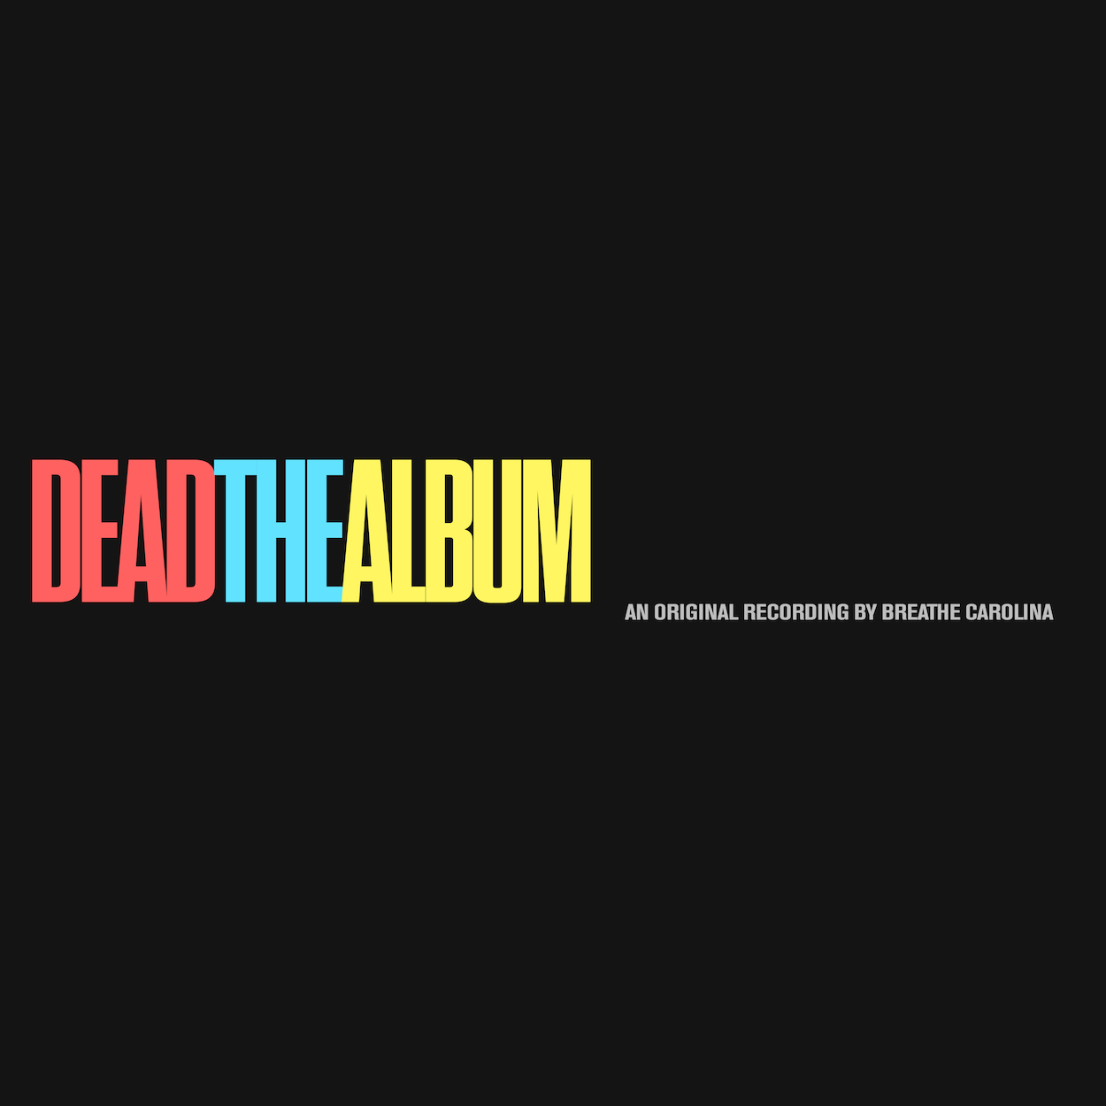

DL photo here- Courtesy Big Beat Records

CONNECT WITH BREATHE CAROLINA:
WEBSITE | FACEBOOK | TWITTER | INSTAGRAM | PRESS SITE

Press contact: gabrielle.reese@atlanticrecords.com

