**BREATHE CAROLINA ANNOUNCE THIRD SINGLE FROM THEIR FORTHCOMING LP WITH THE GENRE-DEFYING ‘DRIVE’!**

VIA SPINNIN’ RECORDS/BIG BEAT RECORDS

WATCH THE MUSIC VIDEO HERE: <https://youtu.be/PK8TkYldvoo>

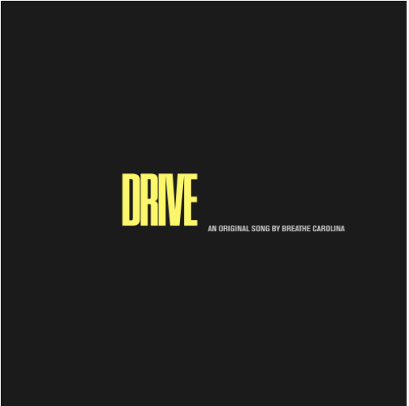

[DL art here](https://press.wearebigbeat.com/wp-content/uploads/2019/11/DRIVE-ART.jpg)

After teasing their new album ‘DEADTHEALBUM’ to fans waiting with bated breath, California-based duo **Breathe Carolina** have already released two cuts from the forthcoming package including high-energy, pop-dance cut ‘[TOO GOOD’](https://www.youtube.com/watch?v=Mo-pOF5_enw) and the attitude-roaring ‘[Like This’](https://www.youtube.com/watch?v=mers4igx2Tw), and now they blaze back to form wasting no time on ‘[DRIVE](https://youtu.be/PK8TkYldvoo)’.

Taking a stylistic, polished approach on house-inflected, radio-ready pop, the duo provides all the ingredients to create a cocktail that fizzes with originality and will crack the Richter scale with its weight on dancefloors, while also shining out of the speakers at home. David’s high-pitched vocal soars with a vulnerability that is delivered smooth and finessed, whilst the low-end bass beats bring a gnarly addition that bears its teeth; a union of styles that the pairing have perfected.

A a hugely successful ADE also saw the boys take their high-energy show to heralded venues across the city including Jimmy Woo and Q-Factory and they’re now approaching a run of Fall/ Winter headline dates in support of the long-awaited LP that will zig-zag across continents with stops throughout Asia, the USA and beyond, before ‘DEADTHEALBUM’ is unleashed November 15th, .



[DL photo here](https://nam04.safelinks.protection.outlook.com/?url=https%3A%2F%2Fpress.wearebigbeat.com%2Fwp-content%2Fuploads%2F2019%2F09%2FBreathe_Carolina-1-courtesy-Big-Beat-Records-.jpg&data=02%7C01%7CGabrielle.Reese%40atlanticrecords.com%7Ce499f35bdd5b46168b6f08d7385f6563%7C8367939002ec4ba1ad3d69da3fdd637e%7C0%7C0%7C637039855259464779&sdata=ClYFCp%2B8Lrc19WqBwFBYImrDdhx645Bx3mORYuiklgk%3D&reserved=0)- Courtesy Big Beat Records

CONNECT WITH BREATHE CAROLINA:

[WEBSITE](https://nam04.safelinks.protection.outlook.com/?url=http%3A%2F%2Fwww.breathecarolinamusic.com&data=02%7C01%7CGabrielle.Reese%40atlanticrecords.com%7Ce499f35bdd5b46168b6f08d7385f6563%7C8367939002ec4ba1ad3d69da3fdd637e%7C0%7C0%7C637039855259464779&sdata=DzWtE95CicBaj9dxcNvs2991M8%2Fv1HvMCQC8T3yPkZg%3D&reserved=0) | [FACEBOOK](https://nam04.safelinks.protection.outlook.com/?url=http%3A%2F%2Fwww.facebook.com%2Fbreathecarolina&data=02%7C01%7CGabrielle.Reese%40atlanticrecords.com%7Ce499f35bdd5b46168b6f08d7385f6563%7C8367939002ec4ba1ad3d69da3fdd637e%7C0%7C0%7C637039855259474773&sdata=yZXosiyOEenlHFr%2Bdfdy%2BypEQbCQi%2FVZsVkpAiRMkEM%3D&reserved=0) | [TWITTER](https://nam04.safelinks.protection.outlook.com/?url=http%3A%2F%2Fwww.twitter.com%2Fbreathecarolina&data=02%7C01%7CGabrielle.Reese%40atlanticrecords.com%7Ce499f35bdd5b46168b6f08d7385f6563%7C8367939002ec4ba1ad3d69da3fdd637e%7C0%7C0%7C637039855259474773&sdata=5UFeZ4Y0vw9kejr3fPzEuIbTXS2Z6bRTC7yt%2FRLxiWM%3D&reserved=0) | [INSTAGRAM](https://nam04.safelinks.protection.outlook.com/?url=http%3A%2F%2Fwww.instagram.com%2Fbreathecarolina&data=02%7C01%7CGabrielle.Reese%40atlanticrecords.com%7Ce499f35bdd5b46168b6f08d7385f6563%7C8367939002ec4ba1ad3d69da3fdd637e%7C0%7C0%7C637039855259484765&sdata=D079Is7NBQfpffATX8wv0MFJcuZk9WAoaN%2F2rTmdMnc%3D&reserved=0) | [PRESS SITE](https://nam04.safelinks.protection.outlook.com/?url=http%3A%2F%2Fpress.wearebigbeat.com%2F%3Fpost_type%3Dsingle%26p%3D14416%26preview%3Dtrue&data=02%7C01%7CGabrielle.Reese%40atlanticrecords.com%7Ce499f35bdd5b46168b6f08d7385f6563%7C8367939002ec4ba1ad3d69da3fdd637e%7C0%7C0%7C637039855259484765&sdata=juarIf7CyPwiQRigba4E8BsazQ%2FJWEl88QOkH9GxvBc%3D&reserved=0)

Press contact: [gabrielle.reese@atlanticrecords.com](mailto:gabrielle.reese@atlanticrecords.com)