DENMARK PRODUCTION/DJ DUO BOYE & SIGVARDT RELEASE NEW TRACK, “WHAT DO WE DO”

OUT TODAY VIA BIG BEAT RECORDS

THE DANISH DUO SURROUNDS EMOTIONAL VOCALS WITH A DOSE OF VIBRANT PRODUCTION

LISTEN/SHARE: https://youtu.be/kdgoKgV-qHI
BUY/STREAM: https://bigbeat.lnk.to/WDPR

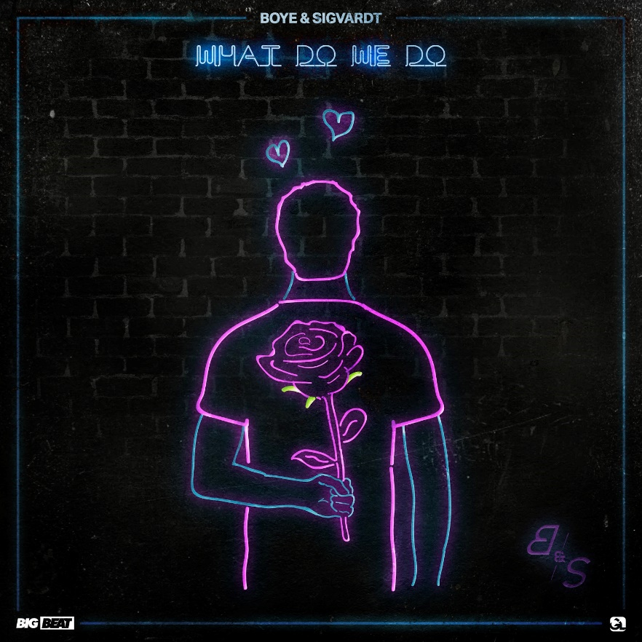

“What Do We Do,” out today via Big Beat Records in the US, is the cool and vibrant new single from young Danish dance duo, Boye & Sigvardt.

“What Do We Do,” begins with soft production and smooth, deep vocals that tell the story of a love affair coming to an end. After the somber intro draws to a close, Boye & Sigvardt’s signature playfulness comes in to lift the track out of sadness, and into a club-infused vibe filled with cheekiness and fun.

Boye & Sigvardt, who are currently aged 18 and 19, have an influence that continues to rise ever since the viral release of their 2016 smash, “Give Me.” In April 2018, the went on to release “FADE” via Big Beat Records. The industry has certainly taken notice of them, and the pair has received support from many of the world’s top electronic DJ and producers including Don Diablo, Lost Frequencies, Thomas Gold, Cedric Gervais, Sam Feldt and more.

The duo’s sound has also enjoyed viral status across radio and streaming platforms at home in Denmark and in countries like Switzerland and Hungary. Boye & Sigvardt are in rotation on dance music radio across the world, where they have been supported by Kiss FM (Germany, Belgium and Ukraine), Capital Radio (UK), Sirius FM (US) and more.

Boye & Sigvardt have already performed all over their native Scandinavia at events such as Danish Deejay Awards in 2017 and Distortion in 2018. In 2018, the pair has proven that their talent is becoming one to watch in the dance music world, and will be playing at two of Denmark’s most respected music events: SMUKfest festival UHØRT, the second largest music festival in Denmark, and Club Awards, an award show that features “the best of the Danish clubbing scene.”

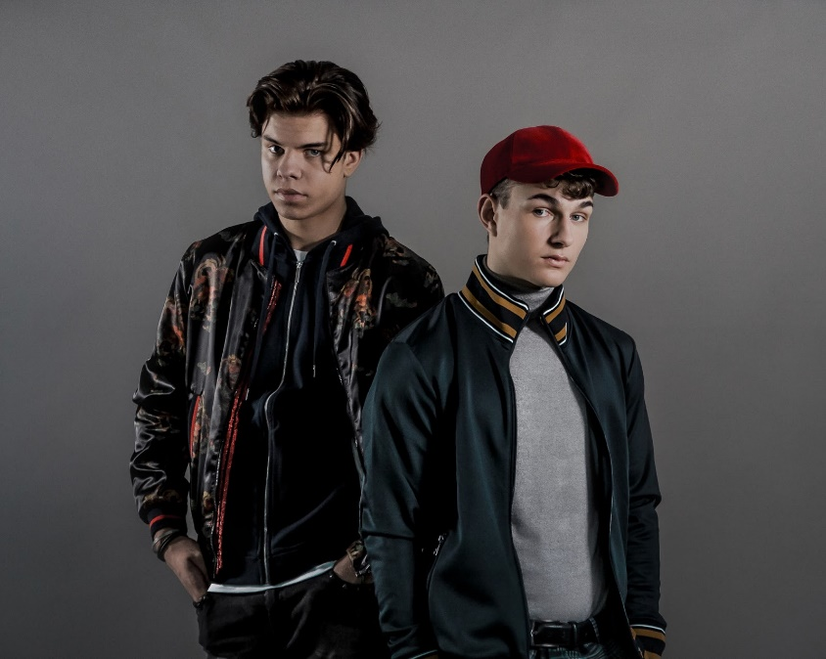
DOWNLOAD HI-RES

***
Connect with Boye & Sigvardt:
SOUNDCLOUD I FACEBOOK I TWITTER | INSTAGRAM I PRESS ASSETS

For more information:
For “Boye & Sigvardt” press inquiries:
Lindsay Herr: Publicity, The Wanderlvst
Lindsay@thewanderlvst.com

For Big Beat Records inquiries:
Jordan Frazes: Head of Publicity, Big Beat Records
Jordan.Frazes@atlanticrecords.com

