BOSTON BUN RELEASES NEW SUMMER ANTHEM
‘SPREAD LOVE (PADDINGTON)’ FT. DVNO

Listen/share: https://youtu.be/0k6_YVTpPdo
Buy/stream: https://bigbeat.lnk.to/SLP
(Big Beat Records)

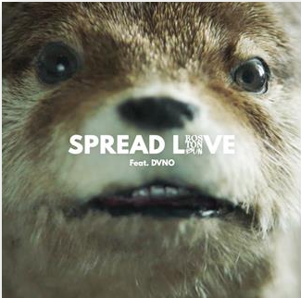
French born, now London-based DJ/producer Boston Bun has unveiled massive new summer anthem, ‘Spread Love (Paddington)’ featuring former Justice collaborator, DVNO. Listen HERE!
Firmly treading his own path after first coming up through the underground as one of the next-gen of Ed Banger producers back in 2013/14, Boston Bun has struck gold again with ‘Spread Love (Paddington)’ – a maverick, infectious deep house jam featuring DVNO that feels primed for the summer, complete with a memorable official video soon to drop. Watch the “Behind The Scenes” video HERE! With a booming dub version already on heavy rotation in the clubs, the official single release lands as Boston Bun’s debut on Atlantic Records.
The track follows 2017 breakthrough record, ‘Missing You’, which has since gone on to amass over 6 million combined streams online, as well as being championed by radio tastemakers like BBC R1’s Annie Mac, Danny Howard and Beats 1’s Zane Lowe and world-leading club DJs like Diplo, David Guetta and DJ Snake.
Already shaping up to be one of the tracks of the incoming summer, ‘Spread Love (Paddington)’ forms Boston Bun’s most exciting work yet, and reaffirms his status as one of Europe’s most promising and exciting dance producers.
###
CONNECT WITH BOSTON BUN: Facebook / Twitter / Instagram / Soundcloud / Press
For press Assets: http://press.wearebigbeat.com/singles/boston-bun-spread-love-paddington-ft-dvno/
For press inquiries:
Lindsay Herr
Lindsay@thewanderlvst.com

Jordan Danielle Frazes
Sr. Director of Publicity, Atlantic Records
Jordan.Frazes@atlanticrecords.com

