BOSTON BUN RELEASES MUSIC VIDEO FOR SUMMER ANTHEM, ‘SPREAD LOVE (PADDINGTON)’ FT. DVNO
OUT NOW VIA BIG BEAT RECORDS
WATCH/SHARE: https://youtu.be/5rF0AeF3FY4
BUY/STREAM: https://lnk.to/SpreadLove

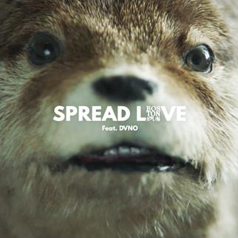
French born, now London-based DJ/producer Boston Bun unveiled massive new summer anthem, ‘Spread Love (Paddington)’ featuring DVNO earlier this month and now the hilarious official music video has been released. Watch HERE!
Firmly treading his own path after first coming up through the underground as one of the next-gen of Ed Banger producers back in 2013/14, Boston Bun has struck gold again with ‘Spread Love (Paddington)’ – a maverick, infectious deep house jam primed for the summer, complete with a memorable official video.
Since launching earlier this month, ‘Spread Love (Paddington)’ has already amassed over 4 million streams internationally and been championed by key radio tastemakers like BBC R1’s Annie Mac, Pete Tong, MistaJam and Scott Mills in the UK. The track follows Boston Bun’s 2017 breakthrough record, ‘Missing You’, which has since gone on to rack up over 6 million combined streams of its own.
The cult official video to ‘Spread Love (Paddington)’ also offers great insight into Boston Bun’s creative world and wider ethos behind the track. Centered on the relationship between a guy down on his luck and an all-singing, all-dancing otter he picks up at a local pet shop, it details a comical journey through the highs and lows of modern life.
Already shaping up to be one of the tracks of the incoming summer, ‘Spread Love (Paddington)’ is Boston Bun’s most exciting work yet, and reaffirms his status as one of Europe’s most promising and exciting dance producers.
(Photo credit: Julien Soulier. Click for hi-res)
CONNECT WITH BOSTON BUN
Facebook / Twitter / Instagram / Soundcloud / Press Assets
For more information or press inquiries:
Lindsay Herr
Director, The Wanderlvst
Lindsay@thewanderlvst.com

Jordan Danielle Frazes
Head of Publicity, Big Beat Records
Jordan.Frazes@atlanticrecords.com

