Big Beat Presents Big Beat Ignition: Paris

WATCH/POST: https://www.youtube.com/playlist?list=PLjW4k-pi0SvnIHnkEQ7Brk7iCIhvz9Qy-
https://soundcloud.com/wearebigbeat/sets/big-beat-ignition-paris
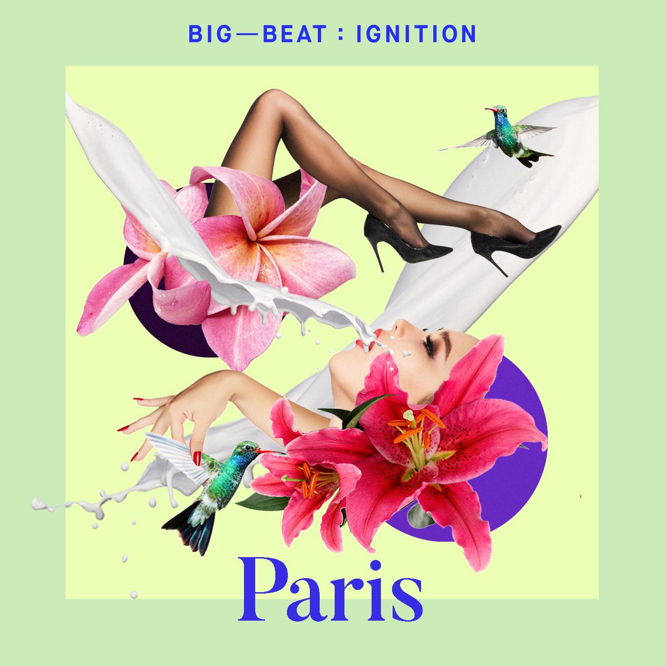
PURCHASE: https://BigBeat.lnk.to/parisPR

Last year, they spent some time looking at what was happening in Amsterdam, but to kick off the new year, they are heading to Paris, and while the focus on the city has just started, it seems like they are finding some really great gems! - Magnetic Magazine

US based Big Beat Records take us to Paris this time around with their latest Ignition video compilation, as they sonically recreate the musical landscape of these trendy cities. - Data Transmission

Big Beat Records returns with the second edition of their Big Beat Ignition compilation, a new series highlighting a selection of regionally relevant electronic and dance music from around the world. Unequivocally the most globally embraced genre, dance and electronic music bring together cultures and people to create amazing shared experiences and lifelong memories. From late night bedroom listening to legendary club nights to the festival stages that draw crowds larger than some entire cities, Big Beat Ignition will showcase this world while celebrating and highlighting some of our favorite music creators, from the up-and-coming to the established.
This month they are putting the spotlight on Paris, France. Taking things into a unique direction the label put together a 10 track visual compilation that follows the storyline of a group of spirited youths as they take on Paris from day to night. Produced and directed by Stephanie Varela, Derec Dunn and Katia Spivakova, the trio commissioned the visuals from New York. Naturally, the goal for Ignition: Paris was to shoot on the premises. They share, “The idea was to follow a group of friends during a night out, from getting ready to a night on the town. We wanted to create a sincere and very intimate experience, away from the crowds. We looked for actors that were all friends in real life. We had a day to make ten videos happen, so there was no time for faking any kind of relationships. In fact, we wanted those to be as vague as possible, to keep the focus on the tracks and engage the audience in a different way, to put them in a sort of trance. The images needed to be abstract and capture some of the Parisian essence: seductive, magic and timeless. There was no plot other than ‘this is us, here, tonight.’”

The result is hypnotic and leaves us longing for those nights, when it just feels good to be alive at sunrise, looking at the city from up high. Nights you remember when someone plays that song again…We wanted people to keep a “souvenir” from this album. All the tracks are brand new and unreleased, and will be available exclusively through this compilation.

We linked up with Mixmag for the first North American edition of Street Player which features Benson Groove’s “Sting Ting”. “The debut video features a high-spirited house track by Benson Groove titled 'String Ting'. The producer is a UK-based musician that sharply blends classic instruments into his electronic work. Influenced by jazz and hip-hop, the fresh break-beat 'String Ting' is a breezy melody inspired by nights out in Paris.”

BIG BEAT IGNITION: PARIS TRACKLIST

1) Henri - Fine Day (feat. Anita Briem) (Henri's Monstertooth Mix)
2) Benson Groove – String Ting
3) Ofenbach – Be Mine
4) Get To Know – About You
5) Stray Echo – Mad Day Out
6) Jynx – Night Shade
7) Club Cheval – Discipline
8) Kattison & Parx – Nodus
9) Applebottom – Dials
10) KENDL – Drive Slow

Connect with Big Beat:
http://www.wearebigbeat.com
https://www.facebook.com/wearebigbeat
https://soundcloud.com/wearebigbeat

For more information please contact:
Jordan Frazes (National): jordan.frazes@atlanticrecords.com
Lindsay Herr (Tour/Online): lindsay@thewanderlvst.com

