**Don’t forget to pack BIG – BEAT: IGNITION before you jet to IBIZA – new compilation part of label series arrives May 19th!**

***Big Beat Presents Big – Beat Ignition: Ibiza***

**WATCH/POST:**   <https://www.hive.co/l/ibpl>

**STREAM/PURCHASE:** <https://BigBeat.lnk.to/igibPR>

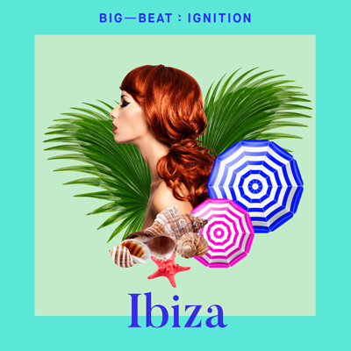

*BIG BEAT’s latest offering strikes a chord with travel and dance music enthusiasts alike. Their IGNITION series, a compilation that highlights “regionally relevant” dance music from places around the world.* ***–* NEST HQ**

*‘Free Room (Man Without a Clue Remix)’ which sees Chicago artist Ravyn Lenae in a dance music setting and brings the warm tropical feel into the DJ-setting, remixed courtesy of Man Without a Clue. The result encapsulates a drawing energy that can't be ignored, and we're in love with the power of this remixed track.* ***–* MAGNETIC MAG**

*If you swore of dance music shows or aren't really "in the mood" quite yet, "Leipzig" will take you out of your funk immediately – it certainly slapped some sense into us.* ***–* EARMILK**

Legendary dance music label **Big Beat Records** returnswith the third edition of their **Big – Beat: Ignition** compilation, a new series highlighting a selection of regionally relevant electronic and dance music from around the world. They’ve introduced us to tracks from **Amsterdam** and **Paris** and today sonically ignite your summer itch with the hottest sounds of **IBIZA**. Unequivocally the most globally embraced genre, dance and electronic music bring together cultures and people to create amazing shared experiences and lifelong memories.  **Big – Beat: Ignition** showcases this world while celebrating and highlighting some of our favorite music creators, from the up-and-coming to the established.

This month **Big Beat** puts the spotlight on **IBIZA**. Of the many stunning Balearic Islands off eastern Spain in the Mediterranean, none is a more influential home for house music in the world than the legendary island of Ibiza. House, tech, techno and progressive (sometimes with Spanish influence) music shine through as the pulse of the island, keeping revelers smiling on the beaches and in the clubs. Big Beat hand-picked some records for this latest installment of their **IGNITION** series, which they hope will transport you for a few moments, or at least make you smile. With house sounds from **Olin Batista & Vlada Asanin**, electro and progressive beats from **Gemellini & Cooperated Souls**, and tech tracks **from Lee Carter & Golf Clap**, this compilation will leave you wanting more. Big Beat wants people to keep a “souvenir” from this album, and is giving away a free download of the compilation so you can cherish these sounds and moments forever. All the tracks are brand new and unreleased, and will be available exclusively through this compilation.

**TRACKLIST**

1. Lefti – Haiti (Original Mix)
2. Ravyn Lanae vs Man Without a Clue - Free Room (Man Without a Clue Remix) (Original Mix)
3. Eyes Everywhere and Golf Clap - Own Myself (Original Mix)
4. Cache 22 - Cosmic Funk (Original Mix)
5. Luca Debonaire - Here We Go Now (Original Mix)
6. Jude & Frank, Havoc & Lawn – Ojos (Original Mix)
7. Olin Batista - No Good (Original Mix)
8. Vlada Asanin – Shakal (Original Mix)
9. Etienne Ozborne  - Velaa (Original Mix)
10. Cooperated Souls – Freak (Explicit Original Mix)
11. Josh Dean – Violin (Original Mix)
12. GVN - Rock The Disco (Original Mix)
13. A.V.A & Godlov – Tramonto (Original Mix)
14. Lee Carter – Leipzig (Original Mix)
15. Gemellini – Ciano (Original Mix)
16. Capetonian – Llandudno (Original Mix)

**Connect with Big Beat:**

<http://www.wearebigbeat.com>

<https://www.facebook.com/wearebigbeat>

<https://soundcloud.com/wearebigbeat>

**For more information please contact:**

Jordan Frazes (Head of PR): [jordan.frazes@atlanticrecords.com](mailto:jordan.frazes@atlanticrecords.com)

Catherine Corkery (Online): [catherine.corkery@atlanticrecords.com](mailto:catherine.corkery@atlanticrecords.com)